Dagobert Soergel ds@dsoergel.com 2021-08

Mindful Micro Information Architecture
Lessons in being considerate, being logical, formatting for comprehension, and paying attention

Questioning time-honored rules is the beginning of good writing.
Questioning does not mean abandoning, but using judiciously.

Contents
0 | Introduction | 2
1 | Inclusive language  Language is powerful. Use it wisely and with consideration for all people. | 3
2 | On writing well  Some common-sense principles for writing as simple as the complexity of the topic allows, avoiding unwarranted academese | 10
3 | The mechanics of language. Grammar and word choice  Against spreading bad habits and illogical constructions. | 13
4 | Document formatting  Use formatting that follows your meaning | 19
5 | Do sweat the small stuff that matters  Tips on how to make life easier for others and yourself by adopting some systematic habits. (By the way, employers appreciate attention to detail in job applications.) | 25
6 | Use software to advantage  Let the computer do the work, but always under your control.  Learn how to use Word. You are going to write for a lifetime. Free through Univ. IT  Use the Hemingway app to improve your writing http://hemingwayapp.com/ $20  Use Zotero as your personal research assistant and bibliography manager https://www.zotero.org/ Free unless you need extra online storage. | 30  30  31  32
 | Some writing help resources | 38

0 Introduction

While the focus of this document is on writing and text, most of the principles apply or can be generalized to any kind of presentation. So when the document says writing or text, the broader context is always implied.

A principle for writing and for life:
Use your judgment, avoid fool rules
"When I read some of the rules for speaking and writing the English language correctly...
I think--
Any fool can make a rule
And every fool will mind it."
Henry David Thoreau (1817-62), American writer and naturalist
Follow common usage when it is helpful, deviate when there is good reason.
Logic beats tradition and arbitrary pronouncements from often unknown rule makers.
For example, in a bibliography the title of the piece (whether a book or a journal article) is most important and should be highlighted; but this is contrary to common practice (such as the APA rules, which are widely used and drummed into students' heads). Unfortunately, many people suspend thought and follow conventions, no matter how illogical or lacking in usefulness.
Note: Sometimes rules imposed by publishers, organizational style manuals, or instructors leave you no choice.
Cardinal rule: Be clear.
By clear we mean:
- The reader / listener / viewer can understand and internalize the intended meaning.
- The presentation is concise.
- The presentation is formatted for quick comprehension.
If following a rule makes your writing clearer, do.
If following a rule makes your writing less clear, don't.

Again:
The main criterion for quality of writing is how easily and quickly it can be understood. A touch of elegance is icing on the cake
With all its inconsistencies and contra-logical elements
at its core language is a structured, logical system
for creating nuanced representations of meaning.
Always keep this in mind and use logical grammar rules correctly.

Note. English composition courses that focus on writing fiction are little help for scholarly writing.

1 Inclusive language
Language is powerful. Use it wisely and with consideration for all people.

The purpose of using inclusive (or bias-free) language is to consciously "avoid perpetuating demeaning attitudes and biased assumptions about people" that are ingrained in everyday language and to make everyone feel welcome, like the sign I saw at a store entrance We admit only everyone. (quote from https://apastyle.apa.org/style-grammar-guidelines/bias-free-language/historical-context).

Inclusive language is built on two interrelated principles:
1 People-first language (PFL) or person-first language. When interacting with or writing for or about a person (or group of persons), consider each person foremost as a complete individual. Do not define the person by their membership in a group or by a single characteristic, thereby reducing their full, multi-dimensional personality to an impoverished one-dimensional image. Examples:
Patron who is blind (as opposed to blind patron) emphasizes that we talk about a library patron with many interests and many professional and community roles who also happens to be blind and needs books on tape or in braille and tactile maps.
Student on the autism spectrum (as opposed to autistic student) emphasizes that we talk about an individual student, for example, a student who has strong interest and ability in mathematics, science, and music who also happens to have a form of autism and needs tailored support to let their ability bloom.
2 Respectful and encouraging language. To successfully interact with or write for or about a person (or group of persons), we need to know things about the person that are relevant in the context. To describe the relevant characteristics, use words and expressions that are respectful, value-neutral, and encouraging but still describe conditions whose knowledge is necessary for successful interaction and for providing good service. Avoid words and expressions that emphasize deficiency, reinforce stereotypes and prejudices, are judgmental, insulting, demeaning, or pejorative.
Project a strength-based model, not a deficiency model.

The following quote from Wikipedia states the case for inclusive language.
"People-first language (PFL),^{[1]} also called person-first language, is a type of linguistic prescription which puts a person before a diagnosis, describing what a person "has" rather than asserting what a person "is". It is intended to avoid marginalization or dehumanization (either consciously or subconsciously) when discussing people with a chronic illness or disability. It can be seen as a type of disability etiquette, but person-first language can also be more generally applied to any group that would otherwise be defined or mentally categorized by a condition or trait (for example, race, age, or appearance).
Person-first language avoids using labels or adjectives to define someone, using terms such as "a person with diabetes" or "a person with alcoholism", instead of "a diabetic" or "an alcoholic". The intention is that a person is seen foremost as a person and only secondly as a person with some trait. Advocates of person-first language point to the failure to mentally separate the person from the trait as reinforcing a sense that both the trait and the person are inherently bad or inferior, leading to discrimination whilst also implicitly reinforcing a sense of permanency even regarding issues that are likely to be temporary. For example, a person with a substance use disorder has a fair chance of achieving long-term remission—many years in which they are healthy and productive—but calling them a "substance abuser" reinforces an unspoken sense that they are inherently and permanently tainted and casts doubt on maintenance of remission." https://en.wikipedia.org/wiki/People-first_language

There are many, many guidelines for inclusive language, some comprehensive, some general, some for specific categories. The table below shows the categories often used, and the table starting on the next page shows guidelines and/or links to guidelines from three sources organized by category.

Categories used in inclusive language discussions and guidelines
Age
Gender and sexuality
Gender
Sexual orientation
Nationality
Race, ethnicity, and religion
Racial and ethnic identity
Spirituality, Religion + Atheism
Socioeconomic status
Appearance
Intersectionality
Ability and disability

On p. 9 is a list of some resources that looked helpful to me, but consider this just a smattering of examples.

For another consideration in promoting inclusion, see
Section 4 Document formatting > Formatting for inclusion

Brief guidelines for inclusive language
from https://content-guide.18f.gov/our-style/inclusive-language/
18F is a technology and design consultancy for the U.S. Government, inside the government.
https://18f.gsa.gov/
Several categories in column 1 added from
https://apastyle.apa.org/style-grammar-guidelines/bias-free-language
The APA manual has subsections on all the categories, available on the Web, linked from here
A few added from the Conscious Style Guide (CSG)
Categories that do not have source indication, such as (CSG) are in all three sources
Categories that have a subsection in the APA style guide are linked there.
Age | Avoid referring to someone’s age, unless it’s relevant to what you’re writing about (for example, when referring to benefits that are available to people of certain ages).  - Don’t use women or older relatives as substitute for novice or beginner. For example, don’t say something is so simple your mother can use it.  - We prefer older person or senior to elderly.
Gender and sexuality  APA separates  Gender  Sexual orientation | Make content gender-neutral wherever possible and strive to write in a gender-fair way. If you are writing about a hypothetical person or if you are unsure of the person’s pronouns, use they or them instead of he/she.  Avoid words and phrases that indicate gender bias, such as irrelevant descriptions of appearance.  Use descriptors of gender identity or sexual orientation as modifiers, not as nouns (for example, transgender person, cisgender person, or lesbian woman). Avoid guessing sex, gender identity, or sexual orientation. When in doubt, either reconsider the need to include this information or ask the person you’re referring to how they identify and what terms they prefer.  - Use different sex instead of opposite sex (because this recognizes gender as a spectrum, rather than a binary).  - We support using they or their as singular pronouns.  - Avoid guys as a way to refer to mixed-gender groups.  - Don’t make assumptions about marital or family relationships (for example, use spouse or partner instead of husband and wife; use parent instead of mother and father).  For more detailed guidance, see the  National Lesbian and Gay Journalists Association Style Guide or the  GLAAD Media Reference Guide.
Nationality | Avoid using citizen as a generic term for people who live in the United States. Many government programs serve non-citizens and individuals with a wide range of immigration and visa statuses.  - How you refer to the public is largely dependent on context. Feel free to choose from any of these words: people, the public, users, or folks.  - Be as specific as possible. Depending on the situation, you may want to say something like people who need healthcare or people who need to access government services online.  - Use citizens for information related to U.S. citizenship, for example, when describing who is eligible to vote in federal elections.  - Be careful with Americans or the American public. These terms are ambiguous and are often used as synonyms for citizens. In most cases, the public is equally clear and more inclusive. That said, referring to Americans or the American people can be useful if you want to inspire readers or take a more patriotic tone.
Race, ethnicity, and religion  APA  Racial and ethnic identity | Avoid using words, images, or situations that reinforce racial, ethnic, or religious stereotypes (even stereotypes that may appear to be positive). Avoid the term non-white, or other terms that treat whiteness as a default.  Don’t make assumptions: ask how people identify themselves, and be aware of complexities within racial, ethnic, and religious identities. For example, not all Arabs are Muslim, and many nationalities and ethnicities include various religious practices and traditions.  When referring to a person’s race or ethnicity, use adjectives, not nouns (for example, a Hispanic person, not a Hispanic).  Media style guides for race, ethnicity, and religion`  - National Association of Black Journalists Style Guide  https://www.nabj.org/page/StyleGuide paste into browser  - Native American Journalists Association Reporter’s Indigenous Terminology Guide opens as pdf  - Religion Newswriters Association’s Religion Stylebook
Socioeconomic status (APA, CSG)
Appearance (CSG)
Intersectionality (APA)
Ability and disability | Every person is a whole person — no matter how they interact with the world. Focus on what they need to do, what tools they use, and avoid making assumptions. If a person’s situation, medical condition, illness, or injury is relevant to the content, be as specific as possible and avoid inserting value judgements about their circumstance (for example, use has multiple sclerosis, not is afflicted with or suffers from).  Just like with language around race, gender, or other identities, it’s always best to ask people how they identify rather than assuming. For help finding appropriate or accurate language, see the Disability Language Style Guide from the National Center on Disability and Journalism.  - Avoid describing people as disabled, handicapped, or confined to a wheelchair.  - Avoid terms that contribute to stigmas around disability or mental illness: crazy, dumb, lame, insane, psycho, schizophrenic, or stupid.  - Avoid terms that contribute to stigmas around sensory disabilities: blind spot or tone deaf.  The next page shows some statistics indicating that 25% of adults in the US have some kind of disability.  It also has a table giving words to use and words to avoid when describing persons with disabilities.
The APA Style Manual also has subsections on
General principles for reducing bias (excellent, well worth reading)
Historical context (in analyses of past events or times or of historical figures how to deal with contemporary language)
Participation in research (how to describe research participants)

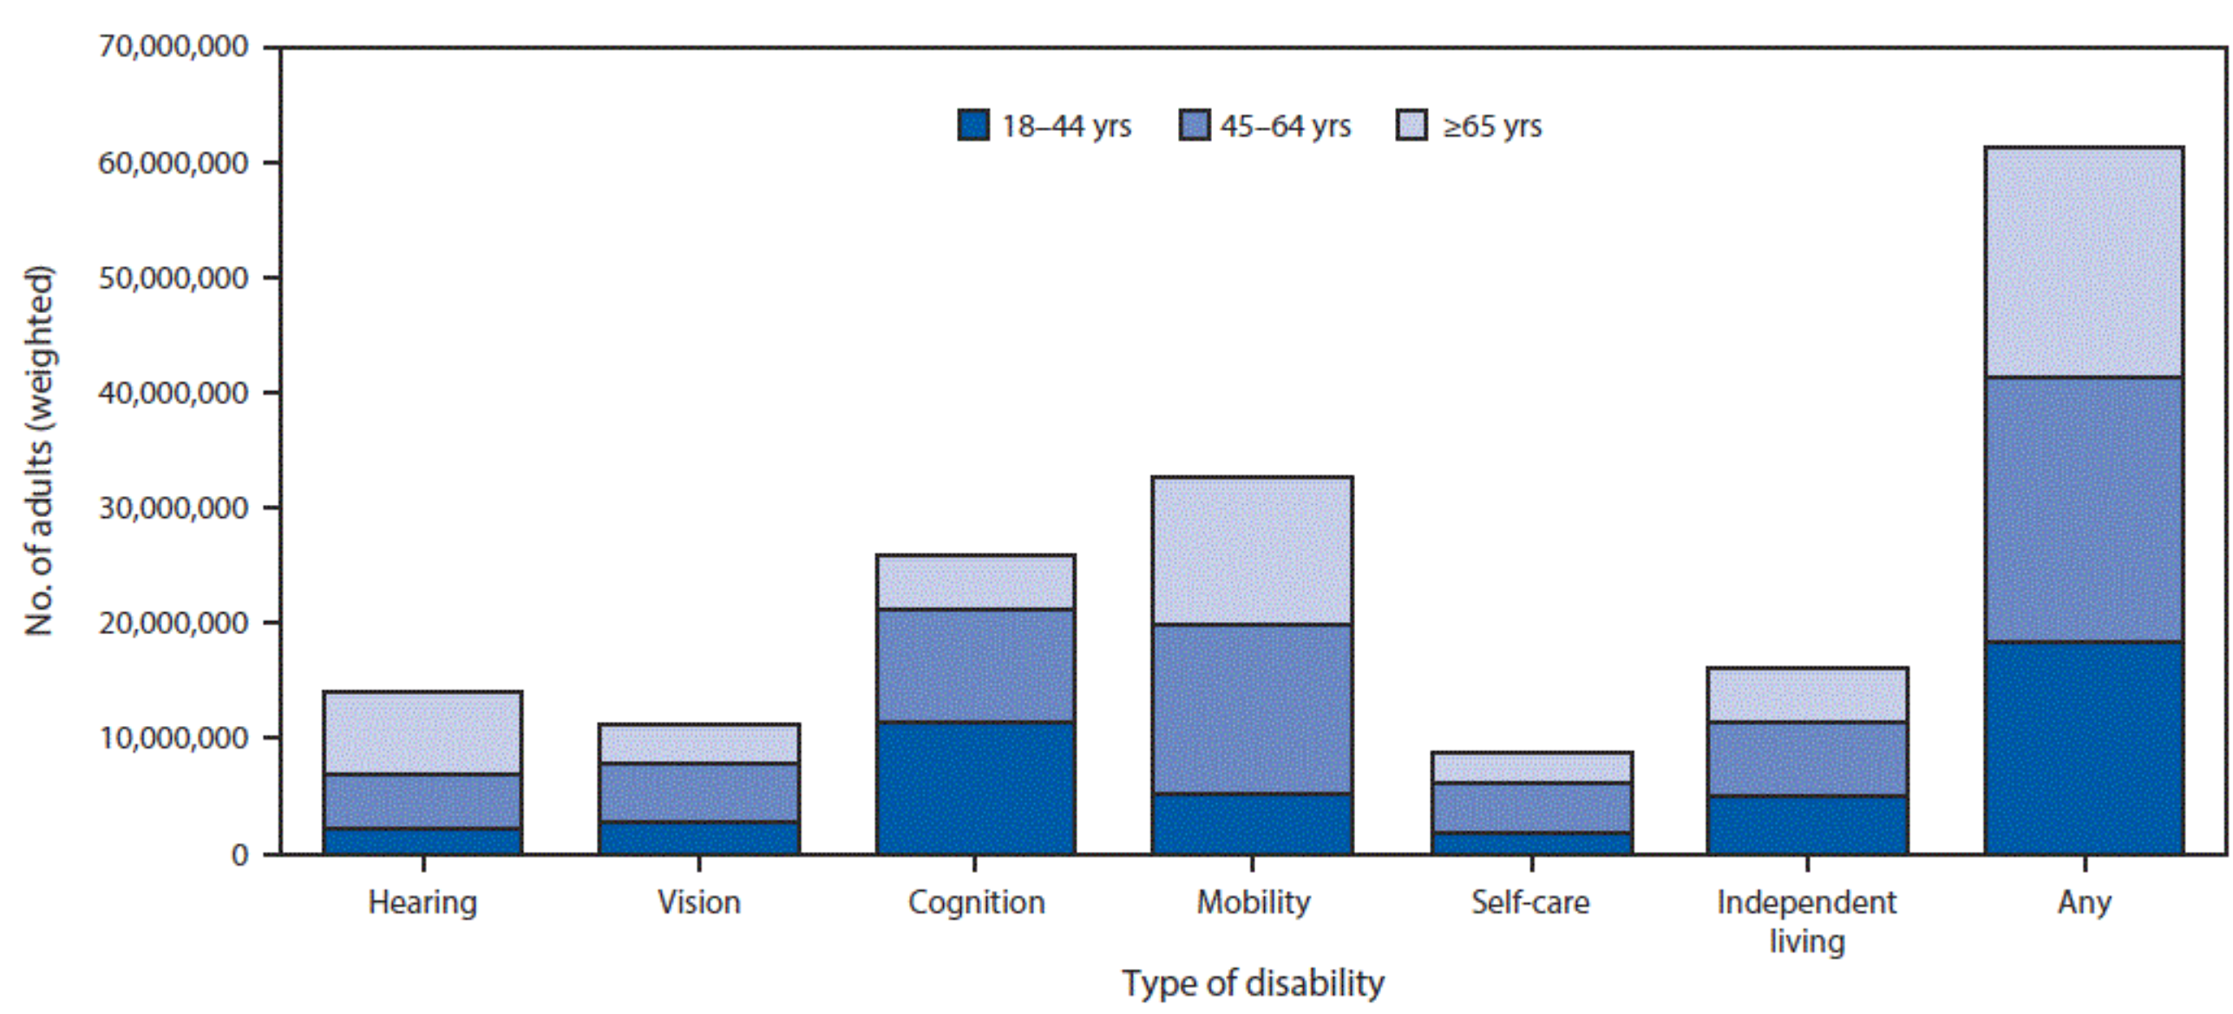
US population
240M adults
FIGURE. Estimated number of adults with any disability, by specific type of disability and age group — Behavioral Risk Factor Surveillance System, 2016. https://www.cdc.gov/mmwr/volumes/67/wr/mm6732a3.htm

Tips to communicate appropriately and respectfully with and about an individual with a disability
Tips | Use | Do not use
Emphasize abilities,  not limitations | Person who uses a wheelchair | Confined or restricted to a wheelchair, wheelchair bound
 | Person who has a communication disorder, is unable to speak, or uses a device to speak | Can’t talk, mute, dumb
Do not use language that suggests the lack of something  Person first language | Person with a disability | Disabled, handicapped
 | Person who is blind or has poor vision | The blind, visually impaired
 | Person who is hard of hearing | Hearing impaired, suffers a hearing loss
 | Person of short stature | Midget
 | Person with cerebral palsy | Cerebral palsy victim, CP victim
 | Person with epilepsy or seizure disorder | Epileptic
 | Person with Down syndrome | Mongoloid
 | Person with multiple sclerosis | Afflicted by multiple sclerosis
Emphasize accessibility, not the disability | Accessible parking or bathroom | Handicapped parking or bathroom
Do not use offensive language | Person with a physical disability | Crippled, lame, deformed, invalid, spastic
 | Person with an intellectual, cognitive, developmental disability | Retarded, slow, simple, moronic, defective, afflicted, special person
 | Person with an emotional or behavioral disability, a mental health impairment, or a psychiatric disability | Insane, crazy, psycho, maniac, nuts
Avoid language that implies negative stereotypes | Person without a disability | Normal person, healthy person
Do not portray people with disabilities as inspirational only because of their disability | Person who is successful, productive | Has overcome their disability,  is courageous
https://www.cdc.gov/ncbddd/disabilityandhealth/materials/factsheets/fs-communicating-with-people.html
with a few additions from https://www.pinterest.com/pin/389209592783124766, which is largely the same

Resources on inclusive language
Does not include resources linked from individual categories in the Table on p. 5-8

https://consciousstyleguide.com/ Used in the Table on p. 5-8
A comprehensive collection of links to inclusive language style guides and articles, well organized by categories. A good starting point for in-depth inquiry.
"an excellent resource for learning more about the conversations behind terms, categories, and concepts." (18F)

https://apastyle.apa.org/style-grammar-guidelines/bias-free-language Used in the Table on p. 5-8
Short subsections on most categories, linked from Table on p. 5. Very good to excellent

https://content-guide.18f.gov/our-style/inclusive-language/ Basis for the Table on p. 5-8

Diversity Style Guide
A large dictionary of terms with definitions "to help journalists and other media professionals cover a complex, multicultural world with accuracy, authority and sensitivity."

https://nasaa-arts.org/nasaa_research/inclusive-language-guide/ Mostly links

https://www.geneseo.edu/comm_mark/inclusive-language-guide Mostly links

https://collegian.com/wp-content/uploads/2018/11/Inclusive-Language-Guide_10_30_18.pdf
Includes an extensive word list.

https://www.usca.edu/diversity-initiatives/training-resources/guide-to-inclusive-language/inclusive-language-guide
Opens as pdf. Includes an extensive word list.

Sources specifically for disability

https://www.cdc.gov/ncbddd/disabilityandhealth/index.html

Disability Language Style Guide

Syracuse University Disability Cultural Center Language Guide

2 On writing well

2.1 Some guidelines for tightening up writing
These may seem obvious, but unfortunately, for many they are not.
(1) Make sure your paper flows coherently.
Write a paragraph that explains the structure of your paper.
(2) Do not to repeat a thought. Check your writing for repetition.
(3) Do not say the obvious.
Always ask yourself: Am I telling the reader something she does not already know?
(4) More broadly: Read every sentence carefully to determine whether it communicates something substantial. If not, delete it or replace it.
(5) "Omit needless words" (Strunk and White).
*The process to comply with the new regulation appears to be relatively simple.
►Complying with the new regulation appears to be simple.
►Complying with the new regulation is simple.
*We will go ahead, whether he agrees or not, as the case may be.
English is rich in possibilities for adding words that do not add substantive meaning. However, they may add emphasis or nuance, or elegance, or just give the reader a chance to rest their mind.
Section 3.2 has many suggestions for omitting needless words.
Also see https://sarneckalab.blogspot.com/2019/01/omit-needless-words.html
https://extension.harvard.edu/blog/cut-the-clutter-17-phrases-to-omit-from-your-writing-today/
https://thewritinghabit.blog/2016/04/04/omit-needless-words/
(6) More broadly: Think about how you can express the same idea with fewer words

2.2 Using "I" or "we" versus passive voice
The dictum
Never use " I " (or "we") in scholarly writing,
issued by the mindless style police, is a fool rule.

I suspect that whoever created the "do not use ' I ' " rule had in mind that the emphasis should be on the subject, not on the author; this is a valid principle (wish our politicians would follow it!). But (see https://wordcounter.net/blog/2016/10/26/102560_can-you-start-a-sentence-with-but.html)
following this principle mindlessly leads to many passive constructions. While passive voice has its place, it is often harder to understand than active voice, particularly in describing several steps of a procedure.
Example:
*"The t-test was used (or, as a pompous ignorant writer might say employed) to test for difference of the means of the two groups" versus
►"I used the t-test to ..."
But constant use of" I " can get tiring, so even better is an active construction that avoids " I ", such as
►"A t-test showed a difference of the means of the two groups (significance .05)".
(At this level of statistical significance there is a chance of 5% that the t-test shows a difference, even if in reality there is none.)
Another example of avoiding " I ":
*"In Section 5 I discuss ..." versus
►"Section 5 discusses …"
(a mindless purist will tell you that a section cannot act, so it cannot be the subject of an action verb, but this is perfectly understandable even for the purist). It all comes down to mindful judgment.

To repeat:
The main criterion for quality of writing is how easily and quickly it can be understood. A touch of elegance is icing on the cake.
If using "I" makes your text easier to read, use "I" regardless of the rules you may have been taught.

2.3 Avoid a (pompous) 50-cent word when a 25-cent word would do
Do not use utilize or employ when use would do. For example:
*"I utilized needle-nosed plyers to crack pistachio nuts" (it works quite well)
Here use would do and utilize is pompous.
Unfortunately, in academia students are often taught or learn from examples to write in "academese" (pedantic, pretentious, and often confusing academic jargon, https://www.dictionary.com/browse/academese), a style that uses many 50 cent (or even a dollar) words when a 25 cent word would do. There are texts where discipline-specific technical terms are needed to be precise. And then there are texts where many big words, perhaps intended to impress the reader, just cover up poor thinking.
Impress by big thoughts, not by big words.

Here is one of the rare cases when utilize is appropriate
►"The research capacity is not fully utilized for the benefit of society."
The writer wants to emphasize that only a fraction of the capacity is used.

2.4 Consistently use the same word for a given concept
In composition courses students are often taught not to repeat the same word or expression but rather to use synonyms to provide variety. This may be good for fiction, but in scientific and scholarly writing using different words for the same concept only confuses the reader.

2.5 Before submitting
- Make sure your document meets the formal criteria: Template used, which means
1" margins, 12 pt Times New Roman, legal outline, length requirement.
Can change margins and fonts and can use landscape when it improves formatting.
- Run a spell check (Function key F7).
- Find every occurrence of as (Ctrl-F as, click on More >>, check Find whole words only).
Make sure there is no dangling modifier. See Section 3.1.1)
Uncheck Find whole words only).
- Find every occurrence of only and make sure only is in the right place. (See Section 3.1.2)
- Find utilize and replace with use if that does not change the meaning. Same for employ.
- Find on*basis In the Find box, click on More >>, check Use wild cards.
Change the offending expression, such as on a daily basis. Repeat (See Section 3.2.2)
Uncheck Use wild cards.
- Proofread, paying particular attention to confusable words, homonyms, and needless words. Also make sure formatting is clear.
- Then read through the document once more for coherent flow, soundness of argument, completeness.

3 The mechanics of language. Grammar and word choice
Against spreading bad habits and illogical constructions

3.1 Common grammar errors: Five of the most annoying

* denotes examples that are wrong (a convention used in linguistics)
►denotes correct version
1 | Dangling Modifiers. Beginning clause ꟷ main clause subject mismatch  *As information professionals it is important to study user needs.  ►As information professionals we must study user needs.  ►For information professionals it is important to study user needs.  *As a future librarian, it will be helpful to understand how people in other professions think.  ►For me as a future librarian, it will be helpful to understand how people in other professions think.  ►As a future librarian I need to understand how people in other professions think.  *As an instructor of graduate courses, paying attention to students' writing skills is important, especially in a research methods course.  ►As an instructor of graduate courses, I must pay attention to students' writing skills, especially in a research methods course.  *To conduct research, it is necessary to know what question you want to answer.  ►To conduct research, you must know what question you want to answer.  *While walking on the beach, deep thoughts occurred to the philosopher.  ►While walking on the beach, the philosopher was lost in deep thought.  ►While she was walking on the beach, deep thoughts occurred to the philosopher.  *While studying grammar on the porch, the moon shone brightly.  ►While I was studying grammar on the porch, the moon shone brightly.  From the entry for as in Fowler's 4. ed.  2 as = 'in the capacity or role of. In this meaning as is a preposition, and its uncontroversial use appears in these examples: it is as a historian that he is best known; I hear you have found a job as a nanny. But the as-clause can spell two kinds of danger: (i) it may be in the wrong place in the sentence: As a voluntary, charitable project the Government is about to charge us some £30,000 VAT for extending our premises—letter to The Times, 1988. The government is not ‘a voluntary charitable project’. Similarly, in As a 32-year career law enforcement professional, you know that I do not like being forced to release prisoners from jail—Chicago Tribune, 1988, the 'law enforcement professional' is 'I', not 'you'. While both examples are easily understood, the grammatically dainty may turn their nose up at them, and it is a trivial matter to move the offending as-phrase to its correct position; (ii) a false antecedent is created, e.g. As a medical student his call-up was deferred—P. Fitzgerald, 1986. The 'callup' was not 'a medical student’, and the only solution is to recast the sentence: Because he was a medical student, his call-up was deferred.
2 | Misplaced only  In contemporary English writing there are many sentences in which only is misplaced. Many submissions I receive include this mistake.  For a good explanation, go to https://getitwriteonline.com/articles/placement-of-only/  In brief, only limits the choices for the word or clause immediately following only. From all possible choices the writer or speaker selects a subset (often just one) as specified by the expression following only. For example, consider the sentence  ►I only touched Jim.  There is a vast range of possible actions to choose from: touch, hit, push (down the stairs), stab, strike, …The speaker, perhaps defending himself against the accusation of having hit Jim, limits the choice from all these possible actions to touch.  Now consider the sentence  ►I hit only Jim.  There is a vast range of possible people to choose from: Jim, Barkha, Mary, Ed, Rhiannon, Zayana, Malachi, Kevin, Wei, … The speaker, perhaps defending himself against the accusation of having hit several people, limits the choice from all these possible people to Jim.  Therefore, only must be placed directly before the word that specifies the choice made.  Someone might say *"I only hit Jim." when they really mean ►"I hit only Jim."  The following examples illustrate the point. Analyze them.  *I could only find four research participants.  ►I could find only four research participants.  *Students can only reach their full potential if they are learning in an in-person classroom.  ►Students can reach their full potential only if they are learning in an in-person classroom.  *Hawaii could control the Corona virus because tourists only arrived in planes.  (Presumably they departed on foot.)  ►Hawaii could control the Corona virus because tourists arrived only in planes.  (They also departed only in planes.)  ►I only counted occurrences, I did not do more complex statistical analysis.  The author says: Of many possible statistical analyses, I did only simple counting.  *African American art only made up 1.2 percent of the 180-billion-dollar global art market.  ►African American art made up only 1.2 percent of the 180-billion-dollar global art market.  In this example, only is redundant; even placing only correctly does not save the sentence  *The study is only limited to the patron behavior of one public library  *The study is limited only to the patron behavior of one public library  While the only is now in the right place, there is still a problem. Limited implies only, so  ►The study is limited to the patron behavior of one public library
3 | The reason is because  *The reason I am late is because I had an accident.  ►The reason I am late is that I had an accident.  ►I am late because I had an accident.  There are two reasons why the reason is because is incorrect:  1. “Is” is a linking verb and must be followed by a predicate nominative (a noun or pronoun or a group of words used as a noun or pronoun); because I had an accident is not a predicate nominative.  2. In the intended meaning of the sentence, because is redundant.  We may want to express The reason for A is B because C:  The reason for (A) my lateness is (B) an accident because (C) my car was not drivable and I had to walk.
4 | The serial comma (Oxford comma)  This is the comma before the and that introduces the last element of a series of more than two elements. Some style guides recommend it, others do not.  In writings for this course, the Oxford comma is required.  ►Equity, Diversity, Justice, and Inclusion (EDJI)  or my version  ►Diversity, Inclusion and Respect, Justice, and Equity (DIRJE)  ►It is important to educate people about white privilege, persistent racism and other discrimination against people who are different, and settler colonialism.  For more than you ever want to know, see https://en.wikipedia.org/wiki/Serial_comma
5 | Cases in English, especially cases of pronouns  The short of it. I know it is a losing cause, but I still prefer  ►For whom the bell tolls not *For who the bell tolls  ►Whom shall we recruit for the survey? not *Who shall we recruit for the survey?  ►The director charged Tom and me with taking inventory. not  *The director charged Tom and I with taking inventory.  ►Tom and I went to the store not  *Tom and me went to the store.  For a quick refresher lesson on case, see the next page.

Case in English

From https://www.learnenglish.de/grammar/casepossgen.html (slightly edited)

On case in linguistics, see https://en.wikipedia.org/wiki/Grammatical_case
Case is the grammatical function of a noun or pronoun. There are only three cases in modern English: subjective (he), objective (him) and possessive (his), perhaps more familiar as nominative, accusative, and genitive. There is no dative case in modern English. Yippee!
First more good news. You cannot really go wrong here; in English discourse we got rid of most of our cases; as a result English is easier than many other languages because nouns and some indefinite pronouns (anyone, someone, everyone, and so on) have no inflectional forms to mark the subjective and objective cases; only for the possessive do they have a distinctive case form. There are a few remnants of old English though, and pronouns have distinctive forms in all three cases and should be used with a bit more care.
The pronoun cases are simple though. There are only three:
1. Subjective case: pronouns used as subject.
2. Objective case: pronouns used as objects of verbs or prepositions.
3. Possessive case: pronouns which express ownership.

Personal Pronoun
Subjective/Nominative | Objective/Accusative | Possessive/Genitive
Referring to the subject in a sentence | Referring to the object in a sentence | For nouns: The apostrophe form of the word ("Lynne's", "The writer's manual").
I | Me | Mine
You | You | Yours
He | Him | His
She | Her | Hers
It | It | Its
We | Us | Ours
They | Them | Theirs
Who | Whom | Whose
These pronouns, and who and its compounds, are the only words that are inflected in all three cases (subjective, objective, possessive). In nouns subjective and objective are indistinguishable; we speak of the common case. One result of this simplicity is that in English speakers the sense of case is almost lost, so English speakers make many mistakes when it comes to using the right form (subjective or objective) of a pronoun. With language use tending to grind down complexity over time, in the long case distinctions may be lost in pronouns as well, and "Who shall we hire?" and "Tom and me are going to the store." will be correct English.

3.2 On the use of words and expressions

3.2.1 Omit meaningless words and phrases
Words and phrases that can often be omitted without loss of meaning
It is of interest to note  In a sense  Interestingly  That said…  Clearly  Basically  Obviously  Of course | Draw your attention to  The fact that  Indeed  It goes without saying  As already stated  Simply  Just  Everyone knows

3.2.2 Words and phrases that can often be replaced by a simpler word or phrase

Instead of | Use
utilize [if not referring to % capacity] | use
employ [if not applied to staff] | use
has to | must
it is clear that | clearly (or just omit)
in the event that | if
prior to | before
at the present time | now
subsequent to | after
due to the fact that | because
due to circumstances that | because or since
in a careful manner | carefully
have an (unspecified) effect on | affect
in order to | to
on a daily basis | daily
on a regular basis | regularly
on a ... basis | find a better expression
In a timely manner | On time

For more phrases see https://web.uvic.ca/~gkblank/wordiness.html

3.2.3 Words that are often confused. Two examples

Affect vs. effect
affect verb | To influence or have an impact on something (broadly defined as including animate and inanimate objects, groups, organizations, etc.), state, process, or action.  Make a difference to some thing, state, process, or action.  ►The change to inquiry-based instruction affected students, parents, and teachers.  ►The change to inquiry-based instruction affected learning outcomes.  The nature of the impact or effect is not specified, just that there is at least the possibility of some kind of positive or negative impact or effect.
effect verb  Not very common | To bring something about, to cause, to have as a result – “to effect a (specified) change”. Use effect verb only if some change was actually produced, there actually was an effect noun.  *The change to inquiry-based instruction effected learning outcomes.  ►The change to inquiry-based instruction effected an improvement in learning outcomes.  *The change to inquiry-based instruction affected an improvement learning outcomes.  ►The change to inquiry-based instruction led to improved learning outcomes.
effect noun | A result or consequence. Cause and effect  ►The change to inquiry-based instruction had the effect of improving learning outcomes.  ►Effect size is a quantitative measure of the magnitude of the experimental effect. The larger the effect size the stronger the relationship between two variables.  https://www.simplypsychology.org/effect-size.html
affect noun  Same word, but different semantic field | Any experience of feeling or emotion, ranging from suffering to elation, from the simplest to the most complex sensations of feeling, and from the most normal to the most pathological emotional reactions. Often described in terms of positive affect or negative affect, both mood and emotion are considered affective states. Along with cognition and conation [the mental faculty of purpose, desire, or will to perform an action; volition], affect is one of the three traditionally identified components of the mind.  https://dictionary.apa.org/affect [] https://languages.oup.com/google-dictionary-en/
Note | A typo often results in the wrong word being used. A spell checker does not catch that.
Sources | https://www.dictionary.com/e/affect-vs-effect/  https://www.masterclass.com/articles/how-to-know-the-difference-between-affect-and-effect  https://www.merriam-webster.com/words-at-play/affect-vs-effect-usage-difference  https://grammar.yourdictionary.com/style-and-usage/affect-effect-grammar.html  https://www.merriam-webster.com/dictionary/affect  Fowler's 4. ed., entry "affect, effect"

Complement vs.  Compliment | A typo often results in the wrong word being used. A spell checker does not catch that.

4 Document formatting

Formatting for inclusion

People differ in
- sensory abilities,
- modes of information processing,
- knowledge of languages,
- reading levels,
- knowledge of vocabulary in different subjects,
- levels of interest and motivation

To reach different audiences it may be best to create different versions of a presentation. For example, full use of all colors may be great way to structure information for those who can see and are not color blind. One-size-fits all is not possible anyway; for example, there always need to be specially formatted presentations for people who cannot see or hear. One size fits most is the cheapest but not the best solution. For example, one can use color coding that works for all seeing people, including people who are color blind. But the resulting presentation cannot take full advantage of color coding that would be optimal for the 93% of seeing people who are not color blind, nor would it be optimal for the 7% who are color blind. So the best, but also the most expensive, solution, is to have a presentation in several formats, each optimized for a given audience.

Remember that technologies for some transformation of a presentation from one format to another are quite advanced:
- Digital text (a sequence of characters encoded in ASCII or Unicode) to speech
- Text on paper to digital text (optical character recognition, OCR)
- Speech to digital text
- Automated translation applied to digital text
- Digital text to text on paper, digital text to braille

This aspect of inclusiveness is discussed widely in the computer system (including the Web) usability literature, often under the label Universal Design. The discussion often aims at one-size-fits-all solutions. It is harder to find discussions on the design of print materials.

This is vast subject, treated in some IS courses, but also with whole curricula devoted to it. Here I just want to make sure you are aware of it and reinforce everyone's resolve to pay attention to this important issue. Here are three source I found useful:
https://www.usability.gov/
https://www.wix.com/blog/creative/2020/02/inclusive-design/
https://www.visionaustralia.org/services/digital-access/blog/12-03-2014/online-and-print-inclusive-design-and-legibility-considerations

The rest of this section focuses mostly on formatting of scholarly papers and other non-fiction writing with some notes on formatting for the Web and for slides.

1 Announce what your paper is about.
1.1 Devise a good title.
1.2 Start the paper with a one-sentence statement of purpose. Do not keep the reader guessing why she should read your paper. Give results or claims early.

2 Keep content logic and physical expression in sync.
  - Sections
    - Divide your paper into numbered sections.
    - Use legal outline numbering (1, 1.1, 1.1.1 …), International standard ISO 2145,
Do not use (I., A., 1., a), (1), (a) …) (mindlessly taught in English classes).
Legal outline numbers indicate the place of the current section in the document hierarchy, so the reader can always tell her place in the overall scheme of the document, a key user interface principle. Good running heads reinforce this effect. Other outline numbering systems give the user no such support; the user gets lost in the document space.
Roman numerals have been known to be inefficient for 2,000 years,
thanks to Indian mathematicians.
Nevertheless, the conventional outline numbering system is mindlessly passed down from generation to generation in composition courses and is equally mindlessly the default in many word processing programs.
    - Bold section headings.
  - When the information you want to convey can be divided into separate points, use a bulleted or numbered list; examples are stages of a process or reasons in an argument. Separated items can be taken in much faster by the reader.
Phrases like including or three reasons are tip-offs for using a bulleted or numbered list to present the elements included, the reasons, etc.
Note: White space is good; to save trees, use recycling not cramped presentation.
  - Arrange text in logical units (or blocks). Make each logical unit a physical unit.
    - For example, use a box to group the main points of an argument and set them off from the rest of the text (a box may look like a slide you would use for a talk). Preparing slides is a great way to crystallize the points you want to make. (While preparing the slides for her defense, a doctoral student discovered a very interesting way to analyze her data.)
    - Use boxes to set off examples and detailed explanations that are not necessary
for understanding the main line of your argument. A single-cell table makes a box.
    - Keep text that belongs together on the same page.
    - In slides and lists: Put line breaks at meaningful points; for example, do not break in the middle of a multi-word phrase. (In Word, Shift-Enter makes a new line without starting a new paragraph.) (See examples at end.)
    - Format text so that a logical unit, such as a research question, stands out as a physical unit; this will help readers to assimilate the text more quickly.
3 Miscellaneous formatting.

3.1 Left-justify text.
This avoids hard-to-read irregular spacing between words. Full justification gives the illusion of professionally typeset text, but quality typesetting distributes the spacing between words in a line evenly. Nevertheless, full justification is the default in many word processors and required by many journals and conferences.
3.2 Avoid quotation marks by using italics.
3.3 Avoid underlining (or use very sparingly). Use bold or italics instead.
3.4 Avoid using all caps. Use large and bold or such instead.
3.5 Do not center text other than headings. Several lines of centered text are hard to read. On websites, centered text is not recognized by readers scanning down the left side of the page. also bad for readers with poor vision.
3.6 Use running heads at the top of the page indicating the section. A lot of work, but it keeps the reader oriented.
3.7 In tables, avoid a cramped appearance by using top and bottom cell margins of .04 - 0.1 inches depending on the font size. In MS Word, right-click, select Table Properties > Options > Default cell margins, enter values.
3.8 In table and spreadsheet cells, align the content on top, text to the left and numbers to the right. The Excel default of Align Bottom is almost always bad.

4 For slides and Web pages (some apply only to one or the other)
Many slides presented at conferences violate the simple rules laid out here. Paradoxically, people specializing in human- computer interaction are often the worst offenders.
Why speakers want to show slides that nobody can read, I will never understand.
4.1 Avoid gimmicks, such as making titles "fly in" or making points of a list appear one at a time – all distractions. Animation used judiciously can be quite useful but avoid distracting gimmicks.
4.2 Use high contrast.
Black on white is best contrast, especially in a lighted room.
In a dark room, white on black or very dark blue can look quite elegant.

Avoid textured background at all cost.
To set off a block of text through a colored background, use a very light pastel color.

4.3 Use graphics to make a point, not as mere decoration.
Slides with graphics are more interesting.
Sometimes a diagram that shows how different ideas or concepts interrelate (such as a concept map) is easier to understand than discursive text.
4.4 Use Arial font, 20 or 24 point. Make the font big enough, particularly for a large room. 20 points is generally just large enough, but 24 is better.
4.5 In a bulleted list, put enough spacing between bullets (at least 0.6 lines). For sub-bullets, use somewhat less spacing, 0.4 or 0.3 lines.
The idea is to make logical divisions of the text visible through physical blocks.
4.6 Make sure the bullet has a good distance from the text (not glued on, not too far away) and make sure all text under a bullet is aligned properly (easy to do with the PowerPoint ruler).
4.7 Make the key points or phrases in each bullet bold (could be bold red or blue) to give structure to a text slide and let the reader pick up the main ideas quickly.
Distributing content from one cramped slide to three readable slides shortens the presentation.

4.1 More examples for the principle. Express logical units in separate physical units.

The original (actual examples) is given first, followed by the improved DS version.

* poor (convention from linguistics)
► good

Example for sensible line breaks. The title has three logical components, give each its own line.
Compare * | Expanding the possibilities of deliberation: the use of data mining for strengthening democracy with an application to education reform
With ► | Expanding the possibilities of deliberation:  the use of data mining for strengthening democracy with an application to education reform

Example for sensible line breaks. Avoid separating multi-word phrases .
Compare * | ERECTED BY THE CIVIL WAR ROUND  TABLE OF ALEXANDRIA
With ► | Erected by the  Civil War Round Table of Alexandria

Example Remove redundancy ("library" repeated many times, it is understood).

Have each separate element stand out on its own for ease of scanning.
Poor example: Result display in the catalog of the Montgomery County Public Libraries
using Sarsi Dynix www.montgomerycountymd.gov/libtmpl.asp?url=/content/libraries/find/findbooks.asp

Result display in a library catalog
*Montgomery County Public Libraries
using Sarsi Dynix www.montgomerycountymd.gov/libtmpl.asp?url=/content/libraries/find/findbooks.asp
J 599.789 BRE 2006
Giant pandas up close
Bredeson, Carmen.
24 copies available at Aspen Hill Library, Chevy Chase Library, Damascus Library, Davis Library, Fairland Library, Gaithersburg Library, Germantown Library, Kensington Park Library, Noyes Children's Library, Olney Library, Poolesville Library, Potomac Library, Quince Orchard Library, Rockville Library, Silver Spring Library, Twinbrook Library, White Oak Library, and Longbranch Library
►DS Reformat
J 599.789 BRE 2006
Giant pandas up close / Bredeson, Carmen.

24 copies available at
Aspen Hill | Davis | Germantown | Olney | Potomac | Silver Spring
Chevy Chase | Fairland | Kensington | Park Noyes | Quince Orchard | Twinbrook
Damascus | Gaithersburg | Longbranch | Poolesville | Rockville | White Oak

Each library name should be a link to the page that shows location and opening hours.

5 Do sweat the small stuff that matters
On the benefits of being careful, accurate, precise, in agreement with standards, and systematic.
Tips on how to make life easier for others and yourself by adopting some systematic habits. (By the way, employers appreciate attention to detail in job applications.)

File names | Use informative file names. The information you convey through the filename helps the receiver know what the file is and helps you to locate a file you want.  An example from a course illustrates the principle:  Midterm instructions in a course state that the file name must follow this format:  UBLIS571Midterm-SmithM (replace SmithM with your last name and initial)  Why is this important?  If everybody follows the file name instructions, the files in my folder for the UBLIS 571 midterm will be arranged by students' last names. If you follow this convention for all your course submissions in the program, your files will sort by course and within course by assignment.  In one semester, few students followed these instructions, so I decided. more elaboration is needed. On a job, if you are not careful to follow rules and instructions (such as rules for file names and data formats), you jeopardize your progress in the professional world.  Part 5.1 presents a more elaborate scheme for naming course files.
More tips on file names | - Make sure the file name is informative for the receiver.  The file name TermPaper may be clear to you, but if I get 15 of these, the file name does not tell me whose term paper it is.  The file name JobApplication may be clear to you but it tells Human Resources staff neither what job you are applying for (their first sorting criterion) nor who you are. Instead, use something like  HR7513JobApplication-SmithDana  (or follow specific instructions given in the job announcement).  - For files that recur over time, such as minutes of the Events Committee, include in the file name the committee name and the date. Write the date in the format given below so file names will sort in the correct chronological order:  EventsCommitteeMinutes2015-03-28  For another example: TimesheetSmithDana2015-03-28
Spell check | Always spell check a document before sending.  It would be very helpful if a word processor were to ask whether you want to spell check before you save, but I know of none that does.

Date format | Wherever correct sorting of dates or clarity is important, use this format:  2017-09-02 (for another example: 2016-11-25)  This format is the XML standard; it is also used by the US military.  This is the most logical format for writing dates; it is expandable to specifying time of day to the millisecond. It gets files sorted in chronological order.  https://www.w3schools.com/xml/schema_dtypes_date.asp  https://docstore.mik.ua/orelly/xml/schema/ch04_05.htm
email subjects | Example: In every message concerning UBLIS 575 I put UBLIS 575 into the subject. A filter in my email program then lets me file these messages into my UBLIS 575 mail folder with a single keystroke rather than using drag and drop.  Often an email exchange wanders from one subject to another.  Change the subject to reflect the change.
Cataloging and bibliographies | In cataloging and in creating the bibliography for a paper you submit to a journal, you need to be accurate and precise. In both cases bibliographic software can assist you and take some of the drudgery out of being precise.
Job applications | Just one careless mistake in your job application may send it to the recycle bin without further consideration. Organizations receive many applications, sometimes hundreds. Spelling mistakes, grammatical errors,  a cover letter that says "Insert institution here" are all easy ways to weed out applications that do not merit further consideration.

Larger issues – more serious consequences. Example: Electronic Health Records (EHR)
Codes for patient conditions, treatments, and test results must be entered accurately, following the standard established in the hospital or physician's practice, or else treatment errors or even death may result. There is an even broader problem: Different health systems often use different proprietary standards for diseases/conditions, for treatments, and for test results; when a patient goes from one health system to the next, this may also be a matter of life and death. Unfortunately, commercial interests of EHR system vendors block the most obvious solution, using a common standard in all EHR systems.

5.1 The Soergel course file naming system

See examples on the following pages.

A complete list of codes for type of materials (following $) is shown here.
Not all of these codes are used for every course.

$0 Syllabus and Calendar, other materials that apply to the entire course
$1 Reading
$2 Lecture
$2~ Lecture recording (for live lectures that have been recorded)
$3 Assignment
$3~ Assignment Answer Key
$4
$5
$6 Learning blog
$7
$8
$9

Anatomy of a file name in the Soergel course file naming system
Note well: This file naming system supports managing assignments; please adhere to it

UBLIS575DS-02.1$2-Lecture02.1ActionResearch.pptx
UBLIS575DS The course number, UB makes the course number unique outside UB, DS marks the course section
02.1 Week 02 and Part 1 or 2 within Week 02. Week is 02 so that weeks from 01 to 14 sort correctly
$2 The type of material ($1 Reading, $2 Lecture, $3 Assignment)
Lecture02.1ActionResearch.pptx The title of the file / document with the file type suffix (.pptx for PowerPoint file)

There is also $0, which is used for the syllabus, the calendar, and other materials that give information for the course as a whole.
These are stored in Week00.

UBLIS575DS-06.2$3-Deliverable3ResearchProposal.docx
UBLIS575DS The course number
06.2 Week 06 and Part 2 within Week 06.
$3 The type of material ($1 Reading, $2 Lecture, $3 Assignment)
Deliverable3ResearchProposal.docx The title of the file / document with the file type suffix
This is the template for Deliverable 3, which is assigned in Week 06.2
Retrieve this file from Box\575DS\Week06 (or, just for assignments, from Box\575DS\Assignments), then
immediately save it in a different folder on your computer, appending your name as shown on the next page

UBLIS575DS-06.2$3-Deliverable3ResearchProposal-MillerD.docx
UBLIS575DS The course number
06.2 Week 06 and Part 2 within Week 06
$3 The type of material ($1 Reading, $2 Lecture, $3 Assignment)
Deliverable3ResearchProposal The title of the file / document with the file type suffix
MillerD Last name and initial of the submitting student

UBLIS575DS-06.2$3-Deliverable3ResearchProposal-MillerD-DSComments-A.docx
UBLIS575DS The course number
06.21 Week 06 and Part 2 within the Week 06.
$3 The type of material ($1 Reading, $2 Lecture, $3 Assignment)
Deliverable2TopicDefinition The title of the file / document with the file type suffix
MillerD Last name and initial of the submitting student
-DSComments-A This is the file DS (Dagobert Soergel) returned with comments and, if applicable, a grade.

In rare cases, the name of the student may be followed by the part of the assignment / deliverable, for example
UBLIS575DS-03.2$3-Deliverable2TopicDefinition-MillerDTopic1.docx
Deliverable 2 requires the student to submit two topic definitions. This is the file the student submitted for Topic 1.

6 Use software to advantage
Let the computer do the work, but always under your control.

6.1 Get proficient with Word. You are going to write for a lifetime.
As an information professional you need to produce many documents ꟷ reports, flyers for the public, Web pages. Know how to produce documents that are laid out well and easy to read.

Features of Word that are especially important
- The quick access toolbar with often-used functions, customize in File > Options
- Layout > (or Alt-P), including margins, portrait / landscape
- Home > formatting, including indent, hanging, first line indent, spacing before and after (6 pt before is often good, this list uses 4 pt), keep text together
- Bulleted and numbered lists
- Tables are a great multi-purpose tool. Learn how to use them. Tables can be used to
- arrange text, put a border around text (easiest method, can use a single-cell table)
- Put images where you want them: Create a table, paste the image into a table cell; in the same table, put the image caption and other text you want to keep with the image.
To move the image around, just move the table.
- Dividing document into sections that can have separate Page setup, headers and footers
- Headers and footers. Very important for quick orientation of readers

Shortcuts save a lot of time
Know general Windows or Mac shortcuts. Windows Ctrl key ≈ Mac Cmd key or Option key. Examples:
Shift-Enter | Start a new line within a paragraph (for example, within the text under a bullet)
Ctrl-Enter | Start a new page
Alt-B | Section break, new page
Ctrl-PgUp | Go to top of previous page, Ctrl-PgDn top of next page  If instead you get the Find dialog box, press Ctrl-G to go to any page, then these shortcuts work again properly. (This is an entry for my envisioned blog Software follies.)
F7 | Spell check

More: https://www.howtogeek.com/357623/microsoft-word-keyboard-shortcuts-that-make-your-life-easier/
https://www.dummies.com/software/microsoft-office/word/word-2019-for-dummies-cheat-sheet/

Tutorials/guides:
https://edu.gcfglobal.org/en/word/
https://www.investintech.com/resources/articles/beginnersmsoffice/
http://media.news.health.ufl.edu/misc/training/Handouts/Basics/Beginner-Word.pdf
https://support.microsoft.com/en-us/office/word-for-windows-training-7bcd85e6-2c3d-4c3c-a2a5-5ed8847eae73?wt.mc_id=otc_home&ui=en-us&rs=en-us&ad=us
Get a book such as Word 2019 For Dummies (Paperback) by Gookin, Dan Amazon $15 (just one example)

6.2 Use the Hemingway app to improve your writing

Download from http://hemingwayapp.com/ $20

Helps you to cut dead weight from writing and write with power and clarity

Highlights writing problems, mistakes, and errors through color codes:
- hard to understand sentences
- very hard to understand sentences
- complicated words or phrases
- weakening phrases adverbs
- passive voice
- common grammar errors
The app also computes a readability grade (interpret with caution)

Many sentences that Hemingway labels hard to read or very hard to read are perfectly well constructed and easy to read. On the other hand, Hemingway will find sentences that can be improved. So use your judgment.

Another caveat: Following all of Hemingway's suggestions can lead to very dull prose.
All flair, elegance, and nuance may be forced out. So again, be careful, improve what makes sense, and use your judgment on what to keep.

You can import a Word document. You can also export to Word.
But if you import a document from Word, correct in Hemingway, and export to Word, much formatting will be lost.

One way to avoid this problem (with some extra work)
- Run Word on one half of the screen, Hemingway on the other half (or both full screen, still easy to switch back and forth).
- Import the Word document to Hemingway. Look through document in Hemingway. If you find something to change
(1) switch to Word and change there or
(2) change in Hemingway (gives immediate feedback), then copy and paste to Word.
When you open Hemingway, be sure to make it full-screen or scrolling will not work right.

6.3 Use the Zotero bibliography manager https://www.zotero.org/
I strongly recommend it
Your personal research assistant. Free unless you need extra online storage
Many useful features.
- One-click saving of Web pages with automatic download of a pdf linked from the page.
- Special functions for saving from Wikipedia, Amazon (under user control creates records for several items shown on the page), ResearchGate, and others.
- Imports records found in a database search, with special modules for correct import from many databases.
- Easy to add pdf files and Word files stored on your computer.
- In all cases creates metadata (a catalog record) automatically.
Extracts metadata from pdf files and Word files.
- You can take extensive notes on each item.
- More.
Good search features
Can store data online (access from anywhere, share with others) and on your computer (with the desktop app.) Automatic sync; if others add records to a shared library, the sync adds those records to your local storage managed by your desktop app.

See following pages for an introduction

Use the Zotero bibliography manager https://www.zotero.org/
Use Zotero as your personal research assistant. Free unless you need extra online storage.
It is quite amazing how you can create not just a bookmark but a full bibliographic record for a Web page with one click, how it downloads pdfs automatically and extracts metadata, lets you add existing pdfs and extracts metadata, creates bibliographic records from items you find through databases, special functions for saving from Wikipedia, Amazon, ResearchGate, and others, and much more. You can take extensive notes on each item.
Plugins for creating dynamic bibliographies in Word, LibreOffice, and Google Docs
https://www.zotero.org/support/word_processor_integration.
On the Web and desk top app, synchronized. Can share libraries.
Good search features

6.3.1 Zotero Installation guide.
Access LIS575DS Research Methods Zotero library in four easy steps.
Step 5 is highly recommended.

Step 1 | Receive an invitation to UBLIS575DS Research Methods.  Amy will send an invitation to your preferred email address. The invitation will come from Zotero.  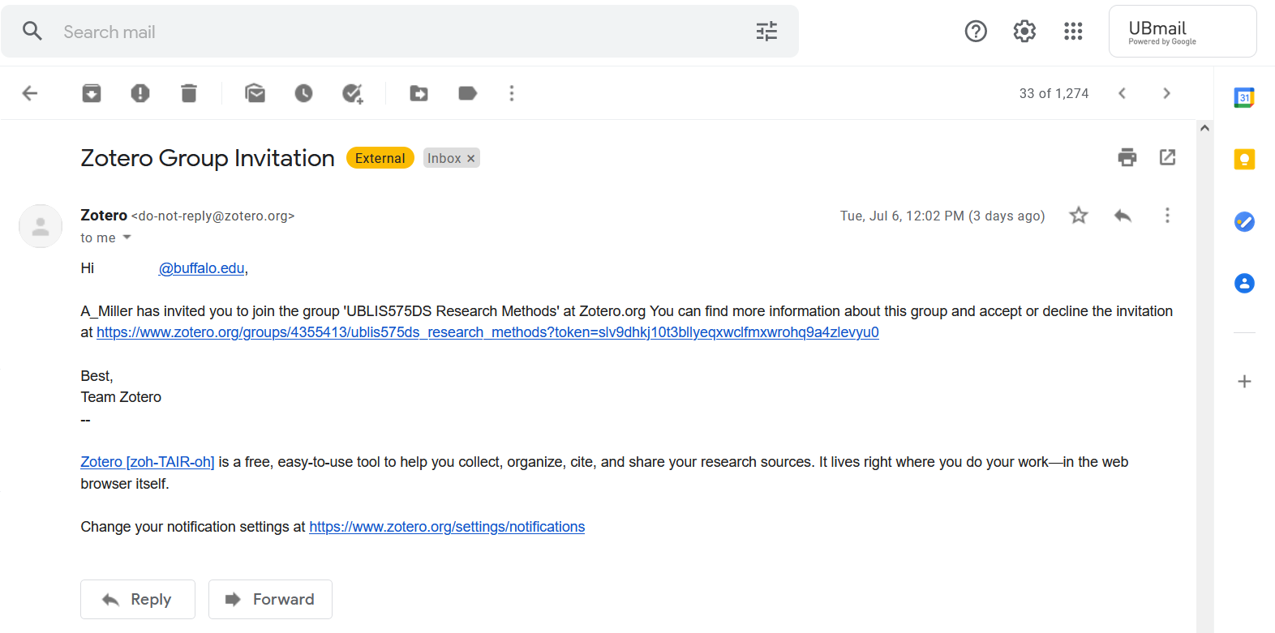  Click on the invitation link
Step 2 | Log in or register for Zotero.  When you click the link to the invitation you will be directed to the Zotero library.  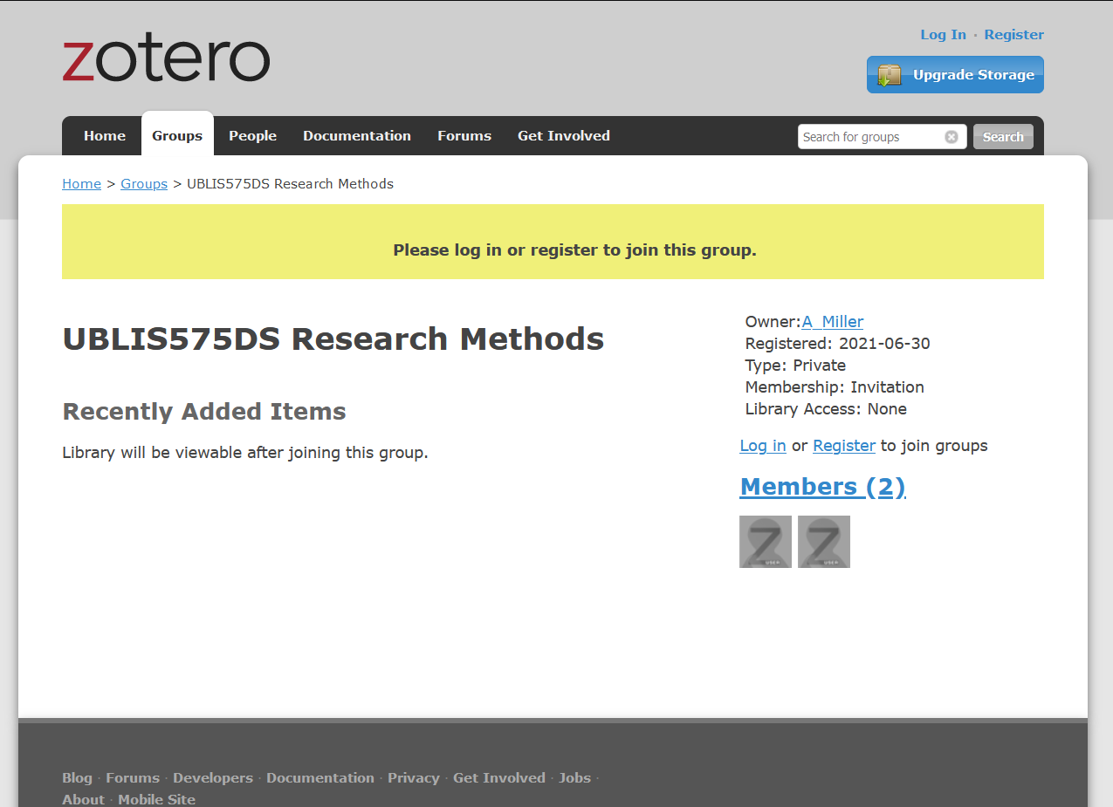  If you already have a Zotero account, click Log In in the upper right corner and enter your credentials. If you do not have a Zotero account, click Register in the upper right corner.
Step 2.1 | If you do not have a Zotero account, create one.
Step 3 | Join UBLIS575DS Research Methods after you have registered or logged in. Click Join  Receive confirmation that you are now a member of the library.
Step 4 | View Library, explore the library.  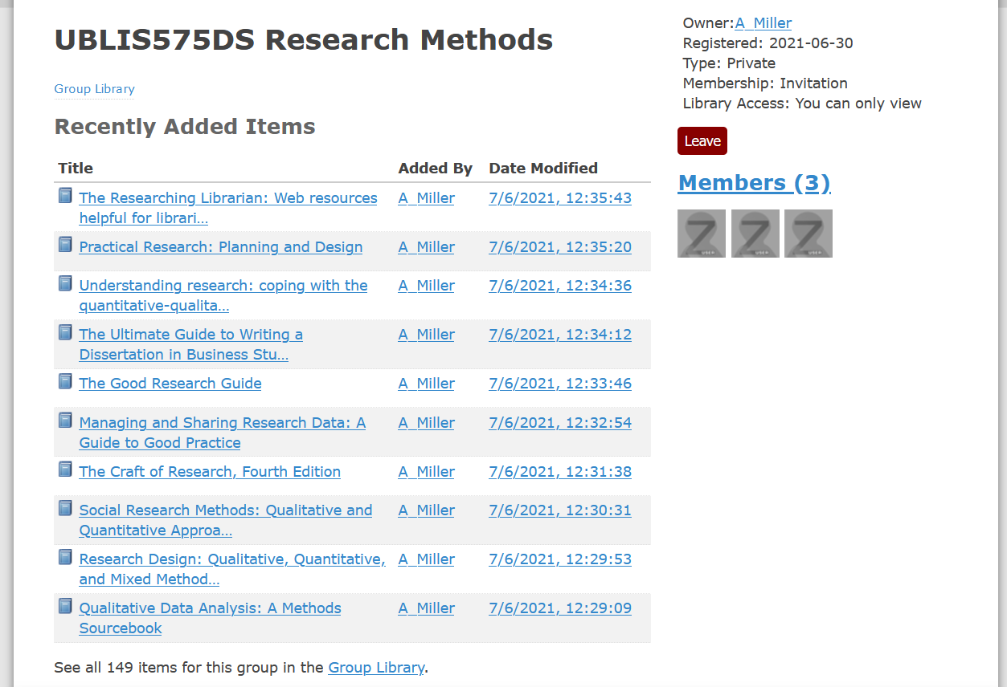
Step 5 | Download Zotero client  Provides better viewing options and interactivity with the materials:  https://www.zotero.org/download/  Information on downloading:  https://www.zotero.org/support/installation

6.3.2 Searching in Zotero.

Zotero has a robust search engine. To do an advanced search click the magnifying glass at the top of the screen:

Enter your search terms in the window and click “Search subcollections”. Be sure that the UBLIS575DS Research Methods library is selected. The search can also search full text of the PDF attachments of the articles.

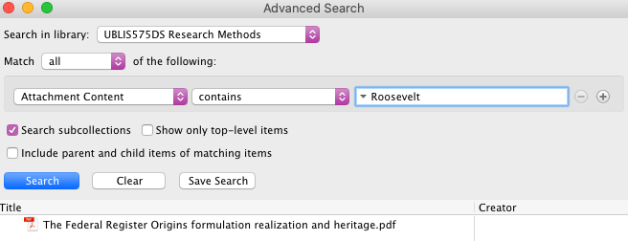

For more information on searching in Zotero: https://www.zotero.org/support/searching

Zotero Documentation: https://www.zotero.org/support/

Some writing help resources

This section is a work in progress. Feedback welcome.
- University writing help centers / websites, writing guides on the Web, and writing help software are all included based on encounters in Google search results and brief impressions, not a systematic review.

Books | Style: Lessons in Clarity and Grace.12th Edition  by Joseph M. Williams and Joseph Bizup  Pearson. 2017. 246 p. ISBN-13: 978-0134080413  https://www.pearson.com/us/higher-education/product/Williams-Style-Lessons-in-Clarity-and-Grace-12th-Edition/9780134080413.html  Fowler's Dictionary of Modern English Usage 4th Edition  Edited by Jeremy Butterfield  Oxford University Press. 2015. 928 p. ISBN-13: 978-0199661350  https://www.oxfordreference.com/view/10.1093/acref/9780199661350.001.0001/acref-9780199661350
University writing centers | Most colleges and universities have writing help centers accessible to their students for in-person, phone, or chat consultation. Many also have websites open to all that can be quite helpful.  University at Buffalo Center for Excellence in Writing  209 Baldy Hall, North Campus  Buffalo, NY 14260-0001.  Phone: (716) 645-5139 The Writing Lab Phone: (716) 645-0785  Email: writing@buffalo.edu  http://www.buffalo.edu/writing.html http://www.buffalo.edu/writing/writing-resources.html  The Center for Excellence in Writing (CEW) provides individual consultations to support you at any stage of your writing process. Friendly and relatable CEW consultants will help you at your individualized points of need or interest, whether it be devising an approach to an assignment, brainstorming, assistance with the research process, helping you to generate more material, assisting with citation practices, providing feedback on a finished draft, and more. The CEW also can be a great source of ongoing support for students who are not native speakers of English. The CEW’s main center is located in 209 Baldy Hall and an additional Writing Lab is in 128 Capen. Appointments can be made by dropping in, online at buffalo.edu/writing, or by calling 645-5139.  OWL Purdue - https://owl.purdue.edu/owl/purdue_owl.html  Ohio State University - https://cstw.osu.edu/writing-center/handouts  University of North Carolina at Chapel Hill - https://writingcenter.unc.edu/tips-and-tools/
Other guides | Writing Workshop. On writing and life in a cognitive science lab. https://sarneckalab.blogspot.com/  https://thewritinghabit.blog/  http://www.editorialwizard.com
Software | Whitesmoke - https://www.whitesmoke.com/ ($6.99/month)  ProWrittingAid - https://prowritingaid.com/ ($70/year)  After the deadline - https://www.afterthedeadline.com/ (Free)  Grammar Flip - https://www.grammarflip.com/ ($39.99/year)  No Red Ink - https://www.noredink.com/ (Free through June 2020)  Note: Grammarly is well-known and widely used, but I did find quite annoying for use with scholarly text. For example, items in bulleted lists are often by design not grammatically complete; having them all called out as needing change is a waste of time.  Online:  Spellchecker plus - https://spellcheckplus.com/en/  Grammar Check - https://www.grammarcheck.net/editor/  Language Tool plus - https://languagetoolplus.com/ (Free)  Requires login with Microsoft account

