Writing a Literature Review
https://ssrmc.wm.edu/literature-review-module/ With slight reformatting by D Soergel
The literature review is an essential part of any social science research endeavor. There is likely some type of written literature review in every social science article you have ever read. A broad definition of the literature review is a narrative argument that contains information, ideas, data, and evidence in order to illustrate how a topic has been investigated and researched in the past. A literature review is not simply a rehashing of old research, however, but is written from a particular perspective and conveyed thematically.

Introduction
Typically a literature review is conducted, and written, once a particular research idea, question, concept, or puzzle, has been generated. The aim of the literature review is to answer a number of questions about the initial research idea or concept:

  - What are the key theories and concepts associated with this idea?
  - What are the ways in which this idea has been studied from an epistemological and methodological perspective?
  - What are the main questions and problems associated with this idea that have been addressed to date?
  - How is knowledge on the topic structured and organized?
  - What are the major debates about the topic?
  - How have approaches to these questions increased our understanding and knowledge?
  - Are there any obvious “gaps” in the literature?

In the context of a paper or thesis the literature review typically follows the introduction and precedes a discussion of methodology or testing the argument.

Section | Aim
Introduction | To show the aims, objectives, scope, rationale and design features of the research. The rationale is usually supported by references to other works which have already identified the broad nature of the problem.
Literature Review | To demonstrate skills in library searching; to show command of the subject area and understanding of the problem; to justify the research topic, design and methodology.
Methodology | To show the appropriateness of the techniques used to gather data and the methodological approaches employed. Relevant references from the literature are often used to show an understanding of the data-collection techniques and methodological implications, and to justify their use over alternative techniques.

Planning to Review Previous Research
The first step in reviewing previous research is to make a plan for how the review will be conducted. You should keep in mind the aim of the review, which is to answer important questions about the topic being explored:

This review process should involve a number of different steps:

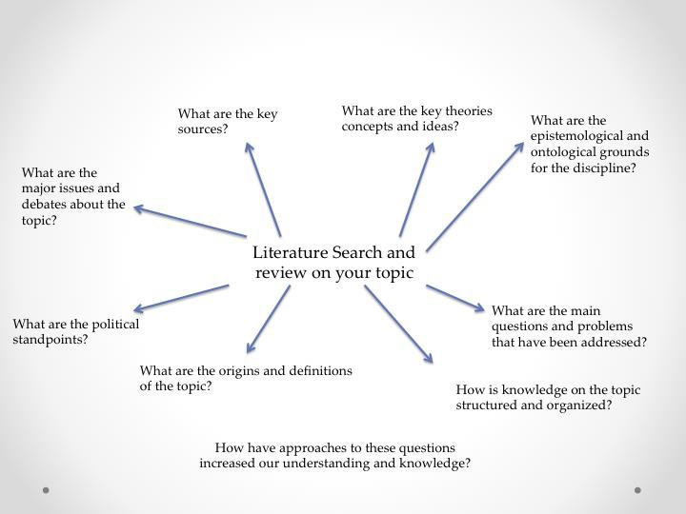

Define the Topic

Start with some general reading to familiarize yourself with the topic or idea of interest. Take notes on the concepts used and make a note of which authors are cited. Prepare a list of terms for further searching. Begin to think about the shape of the topic so that you can map it out at a later stage.

Think About the Scope of the Topic

Make a list of terms and phrases that are associated with this idea and might be useful to research regarding your topic. This is known as search vocabulary.

Think About Outcomes

Think about what it is you want to get out of the search and why you are undertaking a search in the first place. Your proposal for your research will have stated an aim pertinent to the search and review of the literature. You want to make sure that you have identified something that you are looking for, rather than just randomly searching.

Think About the Housekeeping

Design a means by which you will record what you find and how you will cross-reference materials. It is important to keep consistent records not only of what you have searched but how you searched. This is because you may need to go back to undertake further searches of the same source using different terms. Your search might also be required to be written up as part of the methods by which you did your research.

Plan the Sources to be Searched

Prepare a list of likely relevant sources of information such as indexes (e.g. Google Scholar) and library resources. An interview with the subject librarian can be useful at this stage. Also, use guides to the literature to identify relevant sources to be searched. They will guide you to the most relevant material.

Search the Sources Listed

Work through the list of sources you have made. Start with the general sources, then move on to abstracts and indexes. Be systematic and thorough, working on the abstracts and indexes by making consistent references as you go along.
Make notes on possible further leads and ideas to be followed up. As each source is searched, cross it off the list.

Classifying and Reading Research
As you begin to review existing research on your topic of interest, you will likely encounter a variety of different types of research in a variety of different scholarly and non-scholarly outlets. Though your focus should be on scholarly outlets such as journals, newspaper stories and some types of magazine (e.g. The Economist) articles will often have thoughtful takes on a particular issue and therefore are useful to review as well, particularly at the beginning of the research process.

As you read existing research it is often helpful to group the work into broad categories that represent the goal of the research. These include:

Exploratory

  - Questions focus on the how, what, when, and where. Studies tend to be small scale and often informal in structure. Typically found in newspaper or magazine articles.
  - Goals
    - To satisfy curiosity, provide better understanding or for general interest.
    - To examine the feasibility of further study by indicating what might be relevant to study in more depth.
    - To provide illumination on a process or problem.

Descriptive

  - Questions focus on the how and what. Studies tend to be small scale and qualitative.
  - Goal: to understand a common or uncommon social phenomenon by observing the detail of the elements that makes it a phenomenon in order to provide an empirical basis for a valid argument.

Explanatory

  - Questions focus on the why and aim to uncover regularities of a generalizable nature. Studies can be large or small scale and are may be associated with qualitative, quantitative, or both types of data.
  - Goals
    - To explain the cause or non-occurrence of a phenomenon.
    - To show causal connections and relationships between variables of the types ‘if A then B’
    - To suggest reasons for events and make recommendations for change.

Argumentation Analysis
Another critical aspect of classifying and reading research is assessing the quality of the arguments that you come across. There are a number of different points to keep in mind when you read previous research on a topic:

- Deduction vs. Induction? How is the author making his or her argument?
  - Deduction: A statement or theory whose truth or falsity is known in advance of experience or observation, referring to instances of reasoning in which the conclusion follows from the premises.
  - Induction: A statement whose truth or falsity is made more probable by the accumulation of confirming evidence, referring to instances of reasoning in which statements are made about a phenomenon based on observations of instances of that phenomenon.
    - It consists of arguing that because all instances of a so far observed have the property b, all further observations of a will also have the property b.
- Evaluation: is there (enough) evidence to support the claim?
  - Are you convinced by the data that is presented? What else could the author(s) have reasonably done to make a stronger case?
- Common logical (and other) fallacies to watch out for as you read:
  - Implied definition: Referring to something without clearly defining it.
  - Illegitimate definition: Closing down alternatives by giving a restrictive definition.
  - Changing meanings: Defining something as A, then using A in a different way, B.
  - Emotional language: Using value-loaded or ethically loaded terms.
  - Use of all rather than some: Using bland generalization to incorporate all variables and thereby minimize contradictory examples.
  - Ignoring alternatives: Giving one interpretation or example as if all others could be treated or categorized in the same way.
  - Selected instances: Picking out unusual or unrepresentative examples (see the module on case selection).
  - Forced analogy: Using an analogy without recognizing the applicability of other contradictory analogies.
  - Similarity: Claiming there is no real difference between two things even when there is.
  - Mere analogy: Use of analogy with no recourse to examples from the real world.
  - False context: Giving examples out of context or using nothing but hypothetical scenarios.
  - Extremities: Ignoring center ground positions by focusing only on the extreme ends of a spectrum of alternatives.
  - Tautology

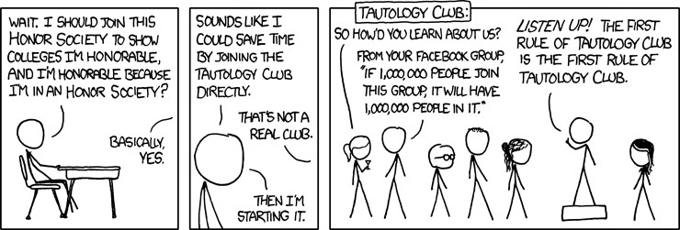

Organizing and Expressing Ideas
After reading a significant amount of literature you will likely find that it needs to be synthesized and structured in some way. This typically involves rearranging the elements derived from the analysis to identify relationships or show main organizing principles or show how these principles can be used to make a different phenomenon.

Mapping a topic can be useful to acquire sufficient knowledge of the subject to develop the necessary understanding of methodology and research techniques, to comprehend the history and diffusion of interests in the topic, and to undertake an analytical evaluation of the main arguments, concepts, and theories relevant to the topic in order to synthesize from the analysis a unique analysis and synthesis.

A variety of map types can be created:

  - Feature maps
This method entails recording the key features of an aspect of a study to produce a summary schemata of the argument proposed by that study and to locate any similarities and differences between other studies on the topic.
  - Tree Constructions
This method constructs different types of subject relevance trees. A subject tree aims to show the different ways in which a major topic has developed sub-themes and related questions. It can show how a topic has branched out.
  - Taxonomic Maps
Maps that aim to show how a range of things can be placed into a general class. They also show differences between objects within the general class.
  - Citation Maps
Collating citations from across different sources into citation indexes to indication subject relationships between the current article and previous publications.

- Concept Maps
A map that is constructed to show the relationships between ideas and practice and include, if necessary, reference to relevant examples:

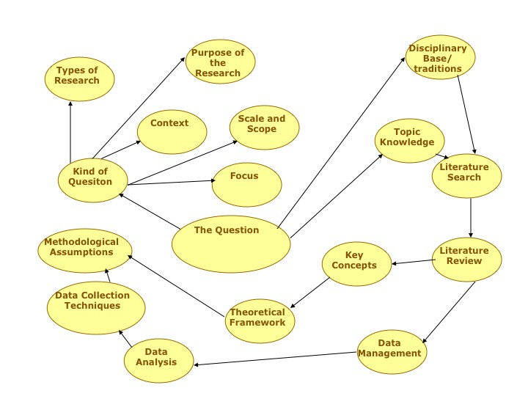
- Author Maps
Visual of authors and traditions connected with a particular topic:

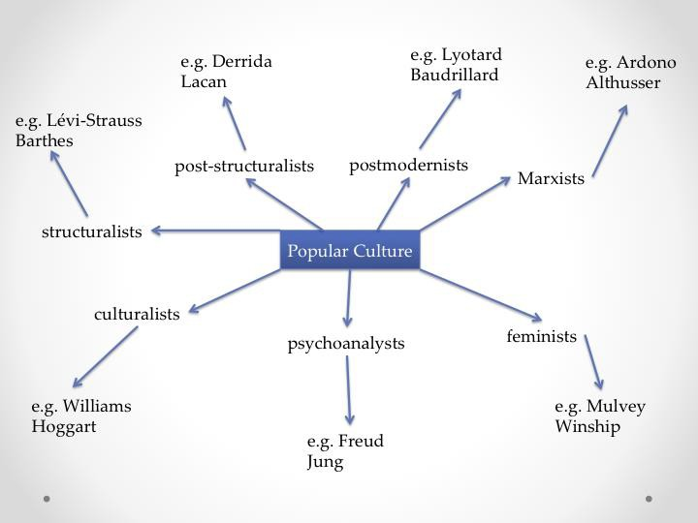

Writing the Review
The written literature review itself should be a structured argument that, in its simplest format, achieves the following elements:

- Identification of knowledge-based elements
  - A description of previous work on the topic, identifying leading concepts, definitions, and theories
  - Consideration of the ways in which definitions were developed and operationalized as solutions to problems seen in previous work
  - Identification and description of matters other researchers have considered important.
  - Analysis of gaps in the literature and description of remaining questions and outstanding debates
- Argumentation elements
  - A description of what you find wrong in previous work on the topic
  - A proposal for action that might solve the problem: your research
  - An explanation of the benefits that might result from adopting the proposal
  - A refutation of possible objections to the proposal

Two different styles of writing

Deductive Structure for Writing | Inductive Structure for Writing
Introduction: theory and thesis statement | Introduction: Particular examples given
Key questions from the theory and thesis. Particular illustrations and examples given to show the reason for the questions. | Tentative interpretation on relationships between examples posed as questions.
Definition of key concepts: discussion.  Elimination of possible alternatives: discussion. | More examples given and classified according to questions. Statements developed and reiterated.
Data-collection technique employed. Specifics of data: discussion. | More examples given and classified to test degree of fit and usefulness of categories. Statements developed further and reiterated.
Findings related to hypothesis and theory: discussion | Main conclusions on patterns and suggestion of plausible theory to account for the relationships in the pattern

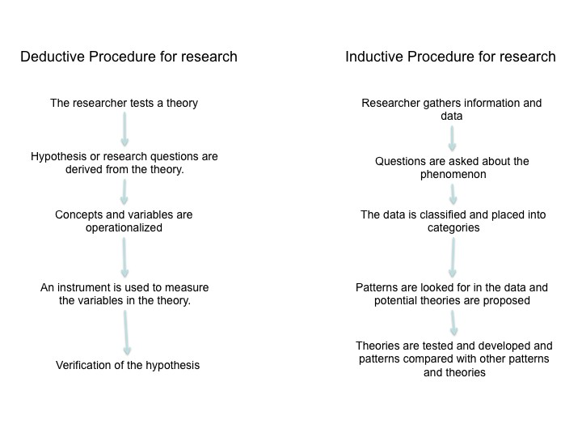
Adapted from Chris Hart’s (1998)
Doing a Literature Review: Releasing the Social Science Research Imagination (London, UK: Sage Publications)

Second edition of this
Hart, Chris. 2018.
Doing a Literature Review: Releasing the Research Imagination. Second Edition.
Thousand Oaks, CA: SAGE Publications Ltd. 334 p.
An altogether excellent book. The second edition, 20 years after the first, has major revisions

