UBLIS 575DS Topic Definition and Research Proposal Guide
This guide can be searched by section numbers, such as Ctrl+F ~3.1
Note ~A2 Appendix 2. An example research proposal. Ctrl+F ~A2

Contents
Summary from the Syllabus: 5.3 Deliverable 3. Research Proposal | 2
UBLIS575 Research Proposal word count / page length | 3
0. Introduction to the guide | 4-5
1 Introduction and background. Purpose statement | 6-27
2 Literature review and synthesis | 28-38
General | 28-35
The outline of Section 2 mirrors the outline of Sections 3 - 6 | 36-38
3 Theoretical / conceptual framework, variables, and research questions | 39 - 50
3.0 Overview | 39
3.1 Theories that might be helpful in studying the topic | 39-43
3.2 Major variables for your study | 44-49
3.3 Foreshadowing questions, research questions, hypotheses | 50
4 Research design. Research methods | 52 - 47
4.1 Participants. Population. Participant selection. Sampling | 52-53
4.2 Time period covered by your study. Cross-sectional vs. longitudinal | 53
4.3 Data collection methods and instruments | 53
4.4 Time frame and effort for data collection | 53-54
4.5 Data analysis methods | 55
4.6 Limitations | 55
4.7 Difficulties, barriers, problems that might arise during the conduct of the study | 55
4.8 Cost-benefit analysis. Ethics. Approval of studies with human or animal subjects | 56
5 Results. Findings [Not in the proposal] | 58
6 Conclusions and implications. Applications (to design, to policy)  [Possibly in the proposal, short] | 58
6.1 Action implications [include in proposal] | 58
7 Appendices | 58
8 References | 58
9 Administrative sections (not for UBLIS 575DS, but important in real proposal) | 59-60
A1 Appendix 1. A collection of causal models / causal maps / influence diagrams | 62-72
A2 Appendix 2. An example research proposal | 73-103

Summary from the Syllabus: 5.3 Deliverable 3. Research Proposal

Your research proposal will differ from the standard in that it will include not only the methods you propose but also discussion of many other methods.
You will work at several sections simultaneously, putting pieces of text in the appropriate section of the template as you encounter ideas in the textbook and in the literature review for your topic. This produces version 0 of your proposal. Then you do a next pass of editing and writing to produce version 1.
As you add pieces to your proposal, share and discuss with your critic. Every other week submit to the instructor indicating changes from the last submission.
Assigned 03-10, Draft due 04-14
Final due 05-19 (somewhat flexible deadline, but linked to the date grades are due)
Evaluation criteria
1 Is the topic statement clear and convincing?
2 Does the literature review give a coherent presentation (analytical synthesis) of important ideas gleaned from the literature, including
- discussion of the importance of the topic and application of expected findings
- theoretical framework and variables
- research methods appropriate for the topic
- results from similar prior studies
3a Is there a discussion of possibly applicable theories and selection of a theory or theories (if any) that could help frame the study?
3b Are the important independent and dependent variables introduced and well defined?
Is there a rationale for each variable? Is the unit of analysis to be studied well defined and justified?
4 Are the research methods (selection of individual instances from the population of all units of analysis, data collection, data analysis) well chosen and is there execution described in sufficient detail? Is there a discussion of research methods considered and a rationale for using the research methods finally selected?
5 Is there a discussion of the expected contributions and what these contributions add to the knowledge base of the information field?

Overall:
- Is the research proposal as whole and each section well written?
- Are points well argued and supported with evidence?
- Is the research proposal as a whole and each section coherent ? Does it flow in a logical and meaningful sequence? Does it make sense for the reader?
Note: "Is there …?" is used for simplicity, but read this as "To what degree is there …?"
UBLIS575 Research Proposal word count / page length

Preface
When writing requirements for assignments, I tend to focus on substance and let the length follow from that. But some length indications are needed to guard against submissions that are
- so short that they could no possibly meet the requirements
- overly long and go into more detail than required.

In assignments, word counts indicate length expectations, so students know how much to write. A request for proposal (RFP) from a funding agency specifies a maximum length in pages (often maximum lengths for individual sections) to force proposers to make their points in a limited space and protect the time of the reviewers. Journals and conferences put an upper page limit on submissions because they have limited physical space in paper publications. This forces authors to focus on what is most important, which protects the time of the readers.

Length recommendations
The word count is the important number. Page counts for letter size, 1" margins, 12pt Times New Roman.

Again, it is the substance that counts. If even after an exhaustive search you find only a few references on your topic or that could support your topic, three pages may be too much for the literature review, but Section 3 may need to a bit longer.

Write concisely; omit vacuous sentences. Fluffing up your text to meet length expectations does not help your case. On the other hand:
- For the course deliverable do not spend extra effort on going through your text to shorten it. The recommendations do not imply a maximum length. I will read what you write.
- For a real proposal you must fit what you have to say into the maximum length.

Section | Words | Pages
1 Introduction and background. Purpose statement | 500- 1,000 | 1 - 2
2 Literature review | 1,500 - 2,500 | 3 - 5
3 Theoretical / conceptual framework, variables, and research questions | 1,000 - 1,500 | 2 - 3
4 Research design. Research methods | 1,500 - 2,000 | 3 - 4
5 Findings |  | N/A
6 Conclusions and implications. Applications (to design, to policy) | max 500 | max 1
7 Appendices | variable | variable
8 References | variable | variable
9 Admin. sections (not for UBLIS 575DS, but important in real proposal) | optional | optional
Total | 5,000 - 7,500 | 10 - 15

~0. Introduction to the guide
Deliverable 2, Topic Definition, is logically the first step of Deliverable 3, Research Proposal. As you develop your research proposal, use your work and your words from the topic definition but also refine the topic definition. This guide covers both Deliverable 2 and Deliverable 3.

This research proposal guide and the template go well beyond of what is required in UBLIS 575DS. Keep it as a reference for when you develop a proposal for an actual study, possibly for a directed study or for funding. Parts that are not required are so marked. You may still want to put some sketchy notes if it does not take much effort.

This guide draws on multiple sources. Occasionally the same thought was expressed by two different sources in different but both very good ways. In that case, I kept the duplication; sometimes repetition is good.

The sections of your research proposal interact. So you need to go back and forth between sections.

The guide takes you through the sections of the research proposal template. The topic definition template is a subset.

~Name and email address
~Title | The title should answer the question: What is your research about? It should be a short, concise phrase.  It should describe the content and direction of your project.
~Abstract (max 300 words) | Start with the topic sentence. Continue with the topic, aims of your study, who will be involved in the research, the methods and the timeframe. It is usually concluded with a statement that explains the relevance of the research (why it is needed). Abstracts for proposals are generally in the future tense (you outline what you intend to do).  For more information on writing abstracts see abstract

~1 Introduction and background. Purpose statement.
Note: In this research proposal template, the Background section is part of the Introduction. In some research proposals Background is a separate main section.

Write or revise much of this section after you completed the literature review.

~1.0 General introduction to developing a topic / research question

This is a long section. It includes
- A journal paper Formulation of Research Questions – A Stepwise Approach (10 p.)
- A Yale University handout on what makes a good research question.
- Three diagrams showing the steps in formulating a research question – three slightly different approaches

Simmi K. Ratan, Tanu Anand, and John Ratan2019
Formulation of Research Question[s] – [A] Stepwise Approach
Journal of Indian Association of Pediatric Surgeons. 2019 Jan-Mar; 24(1): 15–20
Skip the box
doi: 10.4103/jiaps. JIAPS_76_18: 10.4103/jiaps.JIAPS_76_18
PMCID: PMC6322175 PMID: 30686882
https://www.ncbi.nlm.nih.gov/pmc/articles/PMC6322175/ downloaded 2021-02-16
I did a little reformatting but did not edit the English.

Simmi K. Ratan, Tanu Anand,¹ and John Ratan²
Department of Pediatric Surgery, Maulana Azad Medical College, New Delhi, India
¹Department of Community Medicine, North Delhi Municipal Corporation Medical College, New Delhi, India
²Department of Pediatric Surgery, Batra Hospital and Research Centre, New Delhi, India
Address for correspondence: Dr. Simmi K. Ratan, Department of Pediatric Surgery, Maulana Azad Medical College, New Delhi, India. E-mail: moc.oohay@immisnhojrd
Received 2018 Aug; Accepted 2018 Sep.
Copyright : © 2018 Journal of Indian Association of Pediatric Surgeons
This is an open access journal, and articles are distributed under the terms of the Creative Commons Attribution-NonCommercial-ShareAlike 4.0 License, which allows others to remix, tweak, and build upon the work non-commercially, as long as appropriate credit is given and the new creations are licensed under the identical terms.doi: 10.4103/jiaps. JIAPS_76_18: 10.4103/jiaps.JIAPS_76_18
PMCID: PMC6322175 PMID: 30686882
https://www.ncbi.nlm.nih.gov/pmc/articles/PMC6322175/ downloaded 2021-02-16
I did a little reformatting but did not edit the English.

Simmi K. Ratan, Tanu Anand,¹ and John Ratan²
Department of Pediatric Surgery, Maulana Azad Medical College, New Delhi, India
¹Department of Community Medicine, North Delhi Municipal Corporation Medical College, New Delhi, India
²Department of Pediatric Surgery, Batra Hospital and Research Centre, New Delhi, India
Address for correspondence: Dr. Simmi K. Ratan, Department of Pediatric Surgery, Maulana Azad Medical College, New Delhi, India. E-mail: moc.oohay@immisnhojrd
Received 2018 Aug; Accepted 2018 Sep.
Copyright : © 2018 Journal of Indian Association of Pediatric Surgeons
This is an open access journal, and articles are distributed under the terms of the Creative Commons Attribution-NonCommercial-ShareAlike 4.0 License, which allows others to remix, tweak, and build upon the work non-commercially, as long as appropriate credit is given and the new creations are licensed under the identical terms.

Abstract
Formulation of research question (RQ) is an essentiality before starting any research. It aims to explore an existing uncertainty in an area of concern and points to a need for deliberate investigation. It is, therefore, pertinent to formulate a good RQ. The present paper aims to discuss the process of formulation of RQ with stepwise approach. The characteristics of good RQ are expressed by acronym “FINERMAPS” expanded as feasible, interesting, novel, ethical, relevant, manageable, appropriate, potential value, publishability, and systematic. A RQ can address different formats depending on the aspect to be evaluated. Based on this, there can be different types of RQ such as based on the existence of the phenomenon, description and classification, composition, relationship, comparative, and causality. To develop a RQ, one needs to begin by identifying the subject of interest and then do preliminary research on that subject. The researcher then defines what still needs to be known in that particular subject and assesses the implied questions. After narrowing the focus and scope of the research subject, researcher frames a RQ and then evaluates it. Thus, conception to formulation of RQ is very systematic process and has to be performed meticulously as research guided by such question can have wider impact in the field of social and health research by leading to formulation of policies for the benefit of larger population.

Introduction
A good research question (RQ) forms backbone of a good research, which in turn is vital in unraveling mysteries of nature and giving insight into a problem.[1,2,3,4] RQ identifies the problem to be studied and guides to the methodology. It leads to building up of an appropriate hypothesis (Hs). Hence, RQ aims to explore an existing uncertainty in an area of concern and points to a need for deliberate investigation. A good RQ helps support a focused arguable thesis and construction of a logical argument. Hence, formulation of a good RQ is undoubtedly one of the first critical steps in the research process, especially in the field of social and health research, where the systematic generation of knowledge that can be used to promote, restore, maintain, and/or protect health of individuals and populations.[1,3,4] Basically, the research can be classified as action, applied, basic, clinical, empirical, administrative, theoretical, or qualitative or quantitative research, depending on its purpose.[2]
Research plays an important role in developing clinical practices and instituting new health policies. Hence, there is a need for a logical scientific approach as research has an important goal of generating new claims.[1]

Characteristics of a good research question
“The most successful research topics are narrowly focused and carefully defined but are important parts of a broad-ranging, complex problem.”
A good RQ is an asset as it:
- Details the problem statement
- Further describes and refines the issue under study
- Adds focus to the problem statement
- Guides data collection and analysis
- Sets context of research.
Hence, while writing RQ, it is important to see if it is relevant to the existing time frame and conditions. For example, the impact of “odd-even” vehicle formula in decreasing the level of air particulate pollution in various districts of Delhi.

A good research is represented by acronym FINERMAPS[5]
- Feasible
- Interesting
- Novel
- Ethical
- Relevant
- Manageable
- Appropriate
- Potential value and publishability
- Systematic.

Feasible
Feasibility means that it is within the ability of the investigator to carry out. It should be backed by an appropriate number of subjects and methodology as well as time and funds to reach the conclusions. One needs to be realistic about the scope and scale of the project. One has to have access to the people, gadgets, documents, statistics, etc. One should be able to relate the concepts of the RQ to the observations, phenomena, indicators, or variables that one can access. One should be clear that the collection of data and the proceedings of project can be completed within the limited time and resources available to the investigator. Sometimes, a RQ appears feasible, but when fieldwork or study gets started, it proves otherwise. In this situation, it is important to write up the problems honestly and to reflect on what has been learned. One should try to discuss with more experienced colleagues or the supervisor so as to develop a contingency plan to anticipate possible problems while working on a RQ and find possible solutions in such situations.

Interesting
This is essential that one has a real grounded interest in one's RQ and one can explore this and back it up with academic and intellectual debate. This interest will motivate one to keep going with RQ.

Novel
The question should not simply copy questions investigated by other workers but should have scope to be investigated. It may aim at confirming or refuting the already established findings, establish new facts, or find new aspects of the established facts. It should show imagination of the researcher. Above all, the question has to be simple and clear. The complexity of a question can frequently hide unclear thoughts and lead to a confused research process. A very elaborate RQ, or a question which is not differentiated into different parts, may hide concepts that are contradictory or not relevant. This needs to be clear and thought-through. Having one key question with several subcomponents will guide your research.

Ethical
This is the foremost requirement of any RQ and is mandatory to get clearance from appropriate authorities before stating research on the question. Further, the RQ should be such that it minimizes the risk of harm to the participants in the research, protect the privacy and maintain their confidentiality, and provide the participants right to withdraw from research. It should also guide in avoiding deceptive practices in research.

Relevant
The question should of academic and intellectual interest to people in the field you have chosen to study. The question preferably should arise from issues raised in the current situation, literature, or in practice. It should establish a clear purpose for the research in relation to the chosen field. For example, filling a gap in knowledge, analyzing academic assumptions or professional practice, monitoring a development in practice, comparing different approaches, or testing theories within a specific population are some of the relevant RQs.
Manageable (M): It has the similar essence as of feasibility but mainly means that the following research can be managed by the researcher.
Appropriate (A): RQ should be appropriate logically and scientifically for the community and institution.
Potential value and publishability (P): The study can make significant health impact in clinical and community practices. Therefore, research should aim for significant economic impact to reduce unnecessary or excessive costs. Furthermore, the proposed study should exist within a clinical, consumer, or policy-making context that is amenable to evidence-based change. Above all, a good RQ must address a topic that has clear implications for resolving important dilemmas in health and health-care decisions made by one or more stakeholder groups.
Systematic (S): Research is structured with specified steps to be taken in a specified sequence in accordance with the well-defined set of rules though it does not rule out creative thinking.
Example of a RQ:
Does topical skin application of oil as a skin barrier reduce hypothermia in preterm infants?
This question fulfills the criteria of a good RQ: feasible, interesting, novel, ethical, and relevant.

Types of research question
A RQ can address different formats depending on the aspect to be evaluated.[6] For example:
- Existence: This is designed to uphold the existence of a particular phenomenon or to rule out rival explanation, for example, can neonates perceive pain?
- Description and classification: This type of question encompasses statement of uniqueness, for example, what are characteristics and types of neuropathic bladders?
- Composition: It calls for breakdown of whole into components, for example, what are stages of reflux nephropathy?
- Relationship: Evaluate relation between variables, for example, association between tumor rupture and recurrence rates in Wilm's tumor
- Descriptive—comparative: Expected that researcher will ensure that all is same between groups except issue in question, for example, Are germ cell tumors occurring in gonads more aggressive than those occurring in extragonadal sites?
- Causality: Does deletion of p53 leads to worse outcome in patients with neuroblastoma?
- Causality—comparative: Such questions frequently aim to see effect of two rival treatments, for example, does adding surgical resection improves survival rate outcome in children with neuroblastoma than with chemotherapy alone?
- Causality–Comparative interactions: Does immunotherapy leads to better survival outcome in neuroblastoma Stage IV S than with chemotherapy in the setting of adverse genetic profile than without it? (Does X cause more changes in Y than those caused by Z under certain condition and not under other conditions).

How to develop a research question
- Begin by identifying a broader subject of interest that lends itself to investigate, for example, hormone levels among hypospadias
- Do preliminary research on the general topic to find out what research has already been done and what literature already exists.[7] Therefore, one should begin with “information gaps” (What do you already know about the problem? For example, studies with results on testosterone levels among hypospadias
- What do you still need to know? (e.g., levels of other reproductive hormones among hypospadias)
- What are the implied questions: The need to know about a problem will lead to a few implied questions. Each general question should lead to more specific questions (e.g., how hormone levels differ among isolated hypospadias with respect to that in normal population)
- Narrow the scope and focus of research (e.g., assessment of reproductive hormone levels among isolated hypospadias and hypospadias those with associated anomalies)
- Once question has been framed, one should evaluate it. This is to realize if these would be effective RQs or if they need more revising
  - Is RQ clear? With so much research available on any given topic, RQs must be as clear as possible in order to be effective in helping the writer direct his or her research
  - Is the RQ focused? RQs must be specific enough to be well covered in the space available
  - Is the RQ complex? RQs should not be answerable with a simple “yes” or “no” or by easily found facts. They should, instead, require both research and analysis on the part of the writer
  - Is the RQ of interest to the researcher and potentially useful to others? Is it a new issue or problem that needs to be solved or is it attempting to shed light on previously researched topic
  - Is the RQ researchable? Consider the available time frame and the required resources. Is the methodology to conduct the research feasible?
  - Is the RQ measurable and will the process produce data that can be supported or contradicted?
  - Is the RQ too broad or too narrow?
- Create Hypotheses: After formulating RQ, think where research is likely to be progressing? What kind of argument is likely to be made/supported? What would it mean if the research disputed the planned argument? At this step, one can well be on the way to have a focus for the research and construction of a thesis. Hs consists of more specific predictions about the nature and direction of the relationship between two variables. It is a predictive statement about the outcome of the research, dictate the method, and design of the research[1]
- Understand implications of your research: This is important for application: whether one achieves to fill gap in knowledge and how the results of the research have practical implications, for example, to develop health policies or improve educational policies.[1,8]

Brainstorm/Concept map for formulating research question
- First, identify what types of studies have been done in the past?
- Is there a unique area that is yet to be investigated or is there a particular question that may be worth replicating?
- Begin to narrow the topic by asking open-ended “how” and “why” questions
- Evaluate the question
- Develop a Hypothesis (Hs)
- Write down the RQ.

Writing down the research question
- State the question in your own words
- Write down the RQ as completely as possible.
For example, Evaluation of reproductive hormonal profile in children presenting with isolated hypospadias)
- Divide your question into concepts. Narrow to two or three concepts (reproductive hormonal profile, isolated hypospadias, compare with normal/not isolated hypospadias–implied)
- Specify the population to be studied (children with isolated hypospadias)
- Refer to the exposure or intervention to be investigated, if any
- Reflect the outcome of interest (hormonal profile).

Another example of a research question
Would the topical skin application of oil as a skin barrier reduces hypothermia in preterm infants? Apart from fulfilling the criteria of a good RQ, that is, feasible, interesting, novel, ethical, and relevant, it also details about the intervention done (topical skin application of oil), rationale of intervention (as a skin barrier), population to be studied (preterm infants), and outcome (reduces hypothermia).

Other important points to be heeded to while framing research question
- Make reference to a population when a relationship is expected among a certain type of subjects
- RQs and Hs should be made as specific as possible
- Avoid words or terms that do not add to the meaning of RQs and Hs
- Stick to what will be studied, not implications
- Name the variables in the order in which they occur/will be measured
- Avoid the words significant/”prove”
- Avoid using two different terms to refer to the same variable.
Some of the other problems and their possible solutions have been discussed in Table 1.

Table 1. Potential problems and solutions while making a research question
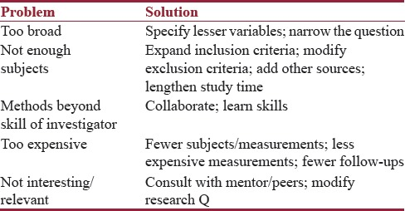

Going beyond formulation of research question–the path ahead
Once RQ is formulated, a Hs can be developed. Hs means transformation of a RQ into an operational analog.[1] It means a statement as to what prediction one makes about the phenomenon to be examined.[4] More often, for case–control trial, null Hypothesis is generated which is later accepted or refuted.
A strong Hypothesis should have following characteristics:
- Give insight into a RQ
- Are testable and measurable by the proposed experiments
- Have logical basis
- Follows the most likely outcome, not the exceptional outcome.
A null hypothesis often states the absence of the effect the researcher is interested in. If the data found are highly unlikely if the null hypothesis were true, the researcher rejects the null hypothesis and assumes there is an effect.

Examples of research question and hypothesis

Research question-1
- Does reduced gap between the two segments of the esophagus in patients of esophageal atresia reduces the mortality and morbidity of such patients?

Hypothesis-1
- Reduced gap between the two segments of the esophagus in patients of esophageal atresia reduces the mortality and morbidity of such patients
- In pediatric patients with esophageal atresia, gap of <2 cm between two segments of the esophagus and proper mobilization of proximal pouch reduces the morbidity and mortality among such patients.

Research question-2
- Does application of mitomycin C improves the outcome in patient of corrosive esophageal strictures?

Hypothesis-2
In patients aged 2–9 years with corrosive esophageal strictures, 34 applications of mitomycin C in dosage of 0.4 mg/ml for 5 min over a period of 6 months improve the outcome in terms of symptomatic and radiological relief. Some other examples of good and bad RQs have been shown in Table 2.

Table 2. Examples of a few bad (left) and a few good (right) research questions
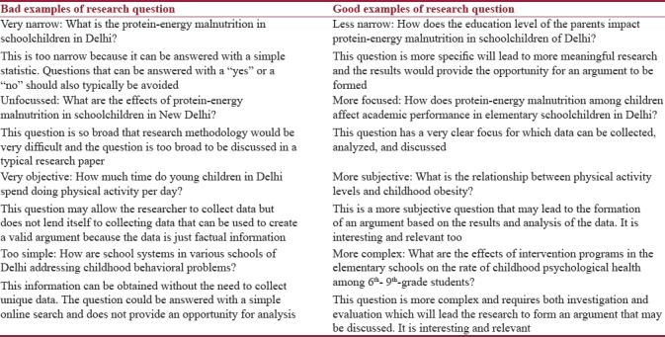

Research question and study design
RQ determines study design, for example, the question aimed to find the incidence of a disease in population will lead to conducting a survey; to find risk factors for a disease will need case–control study or a cohort study. RQ may also culminate into clinical trial.[9,10] For example, effect of administration of folic acid tablet in the perinatal period in decreasing incidence of neural tube defect. Accordingly, Hs is framed.
Appropriate statistical calculations are instituted to generate sample size. The subject inclusion, exclusion criteria and time frame of research are carefully defined. The detailed subject information sheet and pro forma are carefully defined. Moreover, research is set off few examples of research methodology guided by RQ:
- Incidence of anorectal malformations among adolescent females (hospital-based survey)
- Risk factors for the development of spontaneous pneumoperitoneum in pediatric patients (case–control design and cohort study)
- Effect of technique of extramucosal ureteric reimplantation without the creation of submucosal tunnel for the preservation of upper tract in bladder exstrophy (clinical trial).
The results of the research are then be available for wider applications for health and social life

Conclusion
A good RQ needs thorough literature search and deep insight into the specific area/problem to be investigated. A RQ has to be focused yet simple. Research guided by such question can have wider impact in the field of social and health research by leading to formulation of policies for the benefit of larger population.

Financial support and sponsorship. None

Conflicts of interest There are no conflicts of interest.

References
1. Kishore J, Vasundhra S, Anand T. Formulation of a research question. Indian J Med Spec. 2011;2:184–8.
2. Kishore J. A Dictionary of Public Health. New Delhi: Century Publications; 2007. pp. 769–71.
3. Alvesson M, Sandberg J. Generating research questions through problematization. Acad Manage Rev. 2011;36:247–71.
4. Bryman A. The research question in social research: What is its role? Int J Soc Res Methodol. 2007;10:5–20.
5. Hulley SB, Cummings SR. Conceiving the research question. In: Hulley SB, Cummings SR, Browner WS, Grady D, Hearst N, Newman TB, editors. Designing Clinical Research. Baltimore: Williams & Wilkins; 2007. pp. 17–25.
6. Walk K. Asking an analytical question. [Class handout or worksheet]. Princeton University. In: White P, editor. Developing Research Questions: A Guide for Social Scientists. New York: Palgrave McMillan; 2009.
7. Jones R. Choosing a research question. Asia Pac Fam Med. 2003;2:42–4.
8. Frenk J. Balancing relevance and excellence: Organizational responses to link research with decision making. Soc Sci Med. 1992;35:1397–404. [PubMed: 1462179]
9. Cresswell JW. Research design: Qualitative, quantitative and mixed method approaches. Can J Univ Contin Educ. 2009;35:121–3.
10. Punch KF. Introduction to Social Research – Quantitative and Qualitative Approaches. London: Sage; 2005. pp. 82–114.

Articles from Journal of Indian Association of Pediatric Surgeons are provided here courtesy of Wolters Kluwer -- Medknow Publications

End of paper

https://guides.library.yale.edu/ld.php?content_id=16173156
Jana Krentz Formulating a Research Question

All research begins with a question derived from a general topic that piques your interest, often through general reading, topical discussion, lectures, family experiences, etc. In many cases the general topic is set by your Instructor.
Note DS: The advice focuses on indirect research, such as term papers that are based on literature, but much of it is quite useful for direct research as well.

Generally, the question should be:
- Relevant
The question should have some bearing on the topic and remain within the limits that were set beforehand.
- Interesting
Choose a topic that interests and stimulates you otherwise searching could become tedious.
- Focused and specific.
The question should not be too broad or vague. You can however begin with a broad question and then narrow it down to be more specific. You can narrow the question down by:
DS. These are good criteria for narrowing, but they do not always simplify a study conceptually.
- a particular aspect, e.g., economic, psychological
- a particular time period
- a particular event e.g., 9/11, rape, divorce
- a geographical area
- gender
- age group

The result should be a question for which there are two or more possible answers. The following examples illustrate how to narrow broad topics to create focused research questions.

Broad topic | Narrowed topic | Focused topic | Research Question
Women’s health | Women and cancer | Women smokers and breast cancer | Is there an association between cigarette smoking and breast cancer risk?
Computer games | Computer game violence | Computer game violence and children | How does violence in computer games affect children?
Eating disorders | Teenagers and eating disorder | Teen peer pressure and bulimia | What role, if any, does peer pressure play in the development of bulimia among teens?

- Researchable.
- You should get a feel for what materials will be available to you. Know what the Library has to offer in the way of books and standard reference sources, indexes/databases, and services to acquire resources that are not in-house.
- Sometimes your question seems doable at first but when you begin your research, it turns out not to be the case. Because most often you are doing a literature search for the results of previous research (as opposed to original research), it is recommended that you do a preliminary search to test if you can get enough material, and then, if necessary, revise your question.

From University of Guelph
https://learningcommons.lib.uoguelph.ca/item/developing-research-question-worksheet
Developing A Research Question
Your research question guides your project from beginning to completion. Unlike your topic, which may be fairly general, your research question will define the specific scope of your project. In other words, the research question tells readers what you’re trying to find out.

Develop your research question

Define the topic area
In a sentence or two, describe your broad topic or area of research. (Example: “Smoking cessation.”)

Describe the problem
In a sentence or two, describe a problem that could be addressed in your topic or area of research.
(Example: “Smokers often relapse because of complex physical and psychological factors.”)

Specify the gap & justify the investigation
What is unknown or unresolved? Why should we bother investigating it? (Example: We don’t know what combination of physical and psychological factors is most often associated with smoking relapse.)

Create the research question
  - Brainstorm as many questions as you can think of that relate to your research topic/problem/gap.
Try starting questions with what, why, when, where, who, and how; in general, avoid questions that will result in only “yes” or “no” answers.
  - Draft a primary question: Do you see one main question emerging from the list above? If not, try doing some additional reading or thinking, or talk to your supervisor or instructor (Example: How do the physiological and psychological effects of smoking make it difficult for young adults to quit smoking?)
  - Draft secondary research questions: What information do you need to gather to answer your primary question? (Example: Before we can answer the question of “how” physiological and psychological effects make it difficult to quit smoking, we need to identify what the key effects are.)

Assess & refine
Evaluate your research question. Ask yourself the following questions: will readers understand it on first reading? Is it feasible given your time and resources? Does it contribute to a wider academic conversation?
Tighten your focus. Look at every word in your question. Replace as many as you can with more specific language or ideas (e.g., instead of “students,” say “Grade 9 students in Ontario”).
Talk it over. Use this worksheet to talk with your supervisor or instructor about the scope and direction of your research plan.
Revisit often! Keep your research question in mind throughout the research and writing process.
You may find that you need to adapt your research question as you learn more.
lib.uoguelph.ca

This work is licensed under a Creative Commons Attribution
NonCommercial-ShareAlike 4.0 International License

Good content, poor graphics

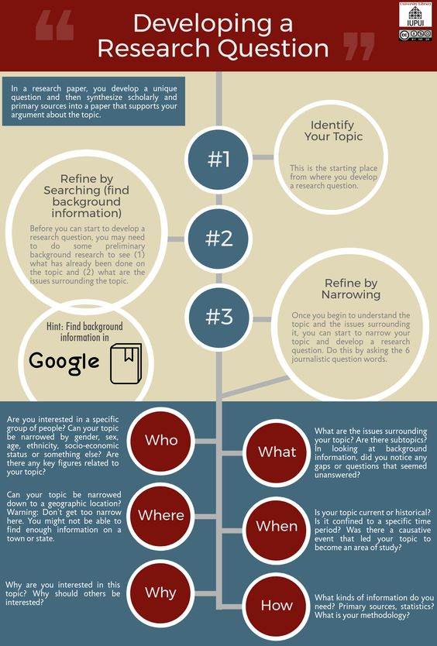
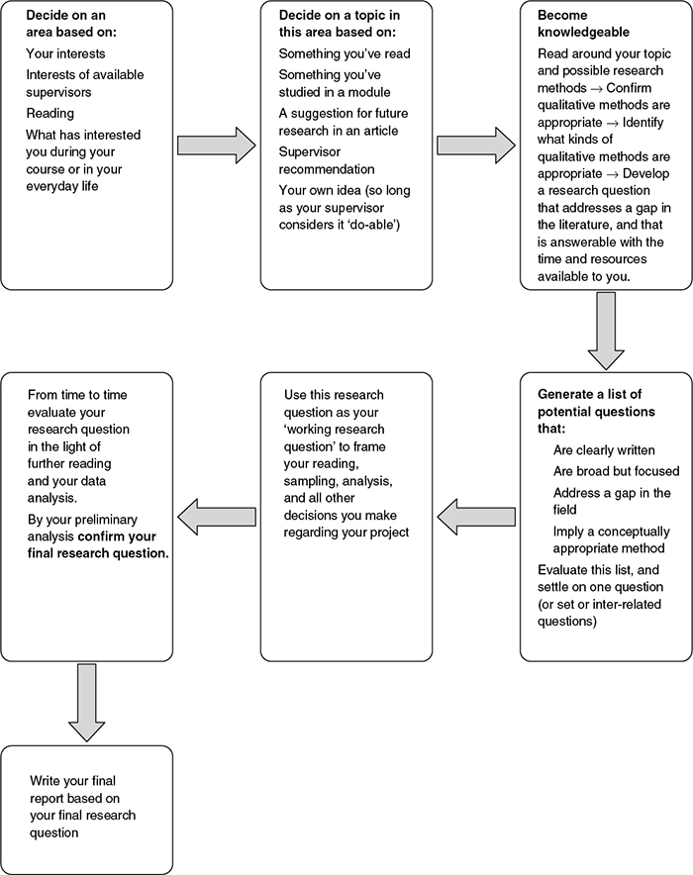

~1.1 One-sentence purpose statement (very important, required).
In this one sentence (it may be a long sentence if it flows well) state what your proposed study does (for a completed study: what it has accomplished) and why it is important or how its results can be used. This sentence must convince the reader that it is worth their time to read on.
The first sentence is so important because it creates a first (and often lasting) impression in the reviewer's mind and it colors their reading of the rest of the proposal.
This is a research proposal, so at lease the first part of the purpose statement must succinctly state the purpose of the research, what you find out. Then you could mention some action that could be assisted by the findings:
I want to find out X in order to assist with Y.
From a poor statement to a good statement

Poor. This paper will examine how the Museum of Modern Art should display works by BIPOC artists so as to include them into their art narrative.
This statement addresses what the Museum should do, not what the study aims to find out.

Good. This study will examine how the placement and presentation of artworks by BIPOC artists in the Museum of Modern Art affects visitors’ engagement with these works
in order to make recommendations on how to display these works so as to include BIPOC artists in the Museum's art narrative and to increase visitors' engagement with their works.

More examples.

Huang, Xiaoli; Soergel, Dagobert( 2013)
Relevance: An improved framework for explicating the notion
We propose a unified and detailed conceptual framework that clarifies the notion of relevance, the many components, variables, criteria, and situational factors that come into play in its definition, as well as the variables that influence its measurement.
This is the purpose statement of a concept paper, not a research study paper.

Zhang, Peiling; Soergel, Dagobert. (2016),
Process Patterns and Conceptual Changes in Knowledge Representations During Information Seeking and Sense making: A Qualitative User Study
This paper explores the sensemaking process ꟷ steps people take and recurring sequences of steps and information people seek out and how it advances there thinking ꟷ to produce specific insights that support (1) the design of systems that assist in sensemaking and (2) education in intellectual techniques for sensemaking.

~1.2 Statement of the problem, aim or purpose of the research.
Topic / Research questions / foreshadowing questions (aspects of the topic)
Can include hypotheses; for each give reasons for your belief that the hypothesis is plausible.
Continue with a statement of the problem. What is the research question you are trying to answer? This can also be termed as the aim or purpose of the research. Think about how you finish this statement: “The purpose of this research is …”. The statement here should give the overall research question, detail in Section 3.

Put differently: What do you want to know, analyze, test, investigate or examine in your research? List your project aims in a logical sequence. In requests for proposal (RFP), funding agencies often ask for a general aim and specific aims to be stated up front.

This part must mention the unit of analysis about which your study will produce new knowledge. There could be more than one unit of analysis; for example, a study might investigate the impact of the Corona virus on persons, companies, and events. See Section 4 Research Methods for elaboration.

An important note on the goal of research: Not prove but test impartially.
The goal of research must not be to prove something but to impartially ascertain the truth with the highest level of certainty possible. So a researcher may have a hypothesis on the effects of X on Y, which may correspond to the outcome the researcher hopes for, but the research itself should be completely neutral. Research should be open to any kind of outcome. In your topic definition / research question, do not state an outcome you prefer but state a hypothesis you are going to test. Then you need to act as a neutral researcher who is testing the hypothesis without any preference for an outcome.

To drive the point home with an analogy: The prosecuting attorney aims to prove that the defendant is guilty, the defense aims to prove that it is not so, but the judge and the jury (the researcher) must be disinterested and neutral, weighing the evidence in pursuit of the truth. If the judge or a member of the jury have a pre-formed opinion on the defendant's guilt or have been personally affected by the crime, or have a financial or other interest in the outcome of the trial, they are disqualified. The same applies to researchers.

Negative results. Unfortunately, studies that show no evidence of an effect are often considered failures and may be less likely do get published. This where the importance of good research questions comes in. If you investigate Whether the sea is boiling hot? or Whether pigs have wings?, negative results are not very interesting. So if negative results can be ascribed to testing an implausible hypothesis, a study may not find much interest. But if you test a hypothesis such as
The Moderna vaccine is 90% effective against the South African variant of the Corona virus,
a negative result (meaning the hypothesis is not borne out) is very interesting (if not favorable to the vaccine maker). In medicine knowing that treatment X is not effective in treating disease Y is very important. So if you have a hypothesis for which either positive or negative results are plausible, either result is of interest and, if of wide scope, is publishable. This principle applies to testing individual patients, but since the scope is very narrow, the results are not publishable (unless the patient is the US President or a famous actor). Note that in testing patients negative results are often good news.

Similarly, many studies proclaim as there aim a proof of concept. The researchers set out to prove that a system based on some principle indeed works so that they can apply for money to build a bigger system or market a drug. The proper aim is a test of concept, a test whether a proposed system design or a new drug works and how well.

Counterpoint: Thinking out of the box may pay off. A hypothesis that if stated broadly (The sea is boiling hot) is patently implausible may not be so dumb if narrowed considerably. So someone thinking out of the box may come up with the idea that since there are hot springs on land, there may be hot springs on the ocean floor. So in limited places the sea my indeed be boiling hot, When researchers looking into this narrow hypothesis and discovered hot springs on the ocean floor it attracted a lot of interest. These hot springs are called hydrothermal vents; the water can reach up to 350°C (662°F) (http://www.waterencyclopedia.com/Ge-Hy/Hot-Springs-on-the-Ocean-Floor.html) and provides an environment for chemosynthetic bacteria, a form of life not known before. Likewise, looking at the hypothesis in a different context (for example, on a different planet) may lead to interesting results.

~1.3 How did you come upon this topic? What prompted your interest in the topic?
In a short paragraph, describe experiences and/or goals that motivated you to choose this topic

~1.4 Background.
Set the scene for your specific research. What is already known? What is unknown but would be interesting / important to know? How does your study relate to previous research (literature)?
- replicate a previous study to see whether its finding hold up,
- replicate a previous study for a different population,
- do something entirely new.
Briefly state what is already known about your topic and what your study adds. What is new? Write this after the literature review.

~1.5 Can the research question be answered by research? How? Or why not?
Can outcomes be measured?
Do outcomes appear within the time frame of the study? Or are there "sleeper outcomes" that take a long time to appear?
Can factors other than those being investigated be ruled out or controlled?
Can the data needed be collected?

(1) Descriptive study examples:
The issue is: Can we get the data needed for describing a case
(1.1) Equity audit of a school system. Are the data needed available? Could missing data be collected?
Data such as test scores, grades, # students being held back a grade, disciplinary actions broken down by race/ethnicity are usually available, but for LGBTQ students perhaps not.
What about data on
- the reasons for disciplinary actions and their relationship to cultural background of students,
- race/ethnicity of students involved in bullying incidents,
- level of comfort of students from underrepresented groups or LCGBTQ students
- how students from underrepresented groups or LCGBTQ students perceive the expectations teachers have of them?
Very important data may be missing

(1.2) How are characters from underrepresented groups represented in books in a library's fiction collection

(2) Explanatory study example:
(2.1) A research question that cannot be answered
Hypothesis: If a two-year old chains two or three cars together into a train, it prepares their mind for inference, chaining two propositions together to arrive at a conclusion when they are older.

It is not feasible to test this hypothesis by research, the question cannot be answered.
- The postulated outcome, can a ten-year old make inferences to arrive at conclusions, can be measured, but
- This is a "sleeper outcome", it takes years to appear.
- There are many factors that influence the ability of a 10-year old to draw inferences.
It is not feasible to hover over a child for 8 years and observe their every move and information input, much less 50 children if that is our sample.

~1.6 Impact / significance ꟷ why do this study? (not to be confused with statistical significance)
What are its expected contributions to the general knowledge base of the topic's discipline and beyond and/or to the knowledge about a specific case?
How important are these contributions? How can they be used to improve practice?
Why do you care? Why will other people care? Why should a funding agency give you money?
Establish the importance of your research by highlighting its originality or why it is worth pursuing. Highlight the expected benefits or innovative applications of knowledge.
To convince your reader of the significance and validity of your research, communicate enthusiasm and confidence for the research, arguing clearly as to the contribution it will make to theory and practice in the subject area and the discipline in general. This is sometimes a separate section; in other instances it forms part of the introduction or background
This topic is revisited in Section (or Chapter) 6 Conclusions.

~1.6.1 Theoretical contributions.
Changing belief in existing theories. Suggesting modifications. Suggesting new theories.
Basis for gaining more knowledge, relationship to other results, basis for generalization.
Theoretical implications
Think about how your study could help in elaborating any of the theories mentioned above or how your results might strengthen our belief in some of these theories.

~1.6.2 Practical contributions

~1.6.3 Importance of the study for the decision on a specific action or design question
Choose a specific action or a specific design question and consider what information is needed to make a good decision. Now discuss the importance of getting an answer to the research question and other knowledge gained from the study for making a good decision.
Do we need the study? Is the study worth doing?
Research is often undertaken to provide information that helps in deciding whether a given action should be taken. The factors to be considered are
- Upsides ꟷ benefits or harm avoidance or savings
- Downsides ꟷ (potential) harm
- Cost of the action
Some of this we may know already; if we know enough to make a decision, we do not need a study. If not, what else do we need to know? That defines what the study needs to find out.
In relation to the importance of the decision on the action, is the cost of the study justified?

There are two decisions we need to make:
(1) Decision on the action: Should the action be taken (or what design alternative should be chosen).
This is the main decision.
(2) Decision on the study: Does the proposed study produce information for making a better main decision or reduce the risk of the action we decide on? Again, is the cost of the study justified?
Below is a simplified framework for determining whether the study is worth doing.
►Action considered:
 | What do we know about the action?
 | Without the study | When study completed
Upsides ꟷ benefits or harm avoidance or savings from the action?
Downsides ꟷ (potential) harm of the action
Cost of the action
Decision on the action
Cost of the study
Decision on the study ꟷ discuss

Example 1 (for more context, see Appendix 2.1, example 1)
Much is unknown here, so the analysis just gives the way of thinking needed.
►Action considered: | Replacing textbooks with tablets/laptops
 | What do we know about the action?
 | Without the study | When study completed
Upsides ꟷ benefits or harm avoidance or savings from the action? | Not enough is known about benefits. | Study results will shed light on benefits.
Downsides ꟷ (potential) harm of the action | May do harm. Some initial studies show that the comprehension of larger texts suffers when the student reads on the computer screen or a tablet or a cell phone. | Will have better evidence of how the action affects students' reading comprehension and learning outcomes, differentiated by student characteristics
Cost of the action | The cost of providing laptops and paying for copies of digital textbooks vs. paying for paper textbooks (which can be re-used several times)  The cost may be significant, particularly if high-quality equipment is needed to be satisfactory. | Study might show whether quality of the devices (screen size, resolution) has an effect on learning. This helps determine cost for acquisition of satisfactory equipment.
Decision on the action | Not enough information for a decision supported by evidence. If the cost is high, taking this action without proper evidence is not wise. | With the study results, can make a decision supported by evidence
Cost of the study | There are several component studies. Need a longitudinal study, so significant cost.
Decision on the study ꟷ discuss | Need actual numbers on cost of the action and cost of the study.  Need to consider that the study is one-time, but the cost of laptops over textbooks is ongoing.

Example 2
►Action considered: | Make sure that Duplo sets given to two-year-olds include at least two, better three cars that can be connected into a train.  In this case, research cannot give us guidance on whether to enrich Duplo building sets with additional cars. However, all is not lost, as the following table shows:
 | What do we know about the action?
 | Without the study | When study completed
Upsides ꟷ benefits or harm avoidance or savings from the action? | Increased play value. Through observing some children coupling several cars into a train, we can strengthen our belief that children have fun doing this. | If feasible, study might show cognitive benefits.
Downsides ꟷ (potential) harm of the action | None. (Not trivial. For example, adding sharp objects that are also hypothesized to contribute to mental development would have the potential of causing great harm). | Study would not contribute.
Cost of the action | Minimal | Study would not contribute.
Decision on the action | Do it. Increased play value alone justifies minimal cost. Hypothesized cognitive benefit would be icing on the cake. So even without knowing any more about the hypothesis (which is plausible in light of considerable literature supporting the idea of embodied cognition), we still add cars since the known benefits alone justify the small cost, and we still have reason to hope that even better things will come. In other words, in this example we can decide based on what we know without a study. That is a good thing, because the study could not be done anyhow (which is a pity, because the results would be interesting).
Cost of the study | Not applicable. Study cannot be done.
Decision on the study ꟷ discuss | Not applicable. Study cannot be done.

If you wish, you can informally apply this kind of thinking to some additional examples to prepare your mind for the formal analysis in your research proposal

Action: Use hypnosis in schools to improve attention and learning
Hypothesis to be tested: Hypnotizing a student in the proper way increases the student's attention and consequently learning.

Action: Invest in a patient portal that is easy to use and provides customized medical information
Hypothesis to be tested: A user-friendly and informative patient portal attracts use and improves patient knowledge and ultimately health.

Action: Let a student with poor math grades study math individually using software X instead of participating in the classroom lesson/activity.
Hypothesis to be tested: Students doing poorly in math learn better from good software than from classroom instruction. (For example, virtual reality software could bring math concepts to life.)
Note: Action may have high cost for hardware and software. If the assumption is wrong, the student will learn less (harm done)

~2 Literature review and synthesis

The outline of this section mirrors the outline of the proposal, especially of Sections 3 and 4.
In each subsection, synthesize what you found in the sources you use.
Think of each of these subsections as a source of thoughts and advice that help you write these sections for your own research proposal ꟷ Sections 1, 3, and 4.
Some subsections are structured into tables to support clarity.
Do discuss here the theories, variables, research questions you find in the literature
Do not discuss here theories, variables, research questions you propose for your research; that comes in Sections 3 and 4.

This section gives extensive guidance on how to write a literature review. If you need still more, you can consult one or both of the entirely optional papers listed here (two good examples from the large literature on the topic):
UBLIS575DS-06.2$3-Deliverable3Reading-Writing-a-Literature-ReviewDSReformat.docx
UBLIS575DS-06.2$3-Deliverable3Reading-VanWeeHowToWriteALiteratureReviewPaper.pdf

They are available in Box\575DS\Week00 and in Box\575DS\Week06

"How to write a literature review [for a thesis or dissertation] https://www.scribbr.com/dissertation/literature-review/ (2020-10-30)
Published on February 22, 2019 by Shona McCombes. Revised on October 13, 2020.
A literature review is a survey of scholarly sources on a specific topic. It provides an overview of current knowledge, allowing you to identify relevant theories, methods, and gaps in the existing research.

Writing a literature review involves finding relevant publications (such as books and journal articles), critically analyzing them, and explaining what you found. There are five key steps:
- Search for relevant literature
- Evaluate sources
- Identify themes, debates and gaps
- Outline the structure [You will use the research proposal template, Section 2.]
- Write your literature review
A good literature review doesn’t just summarize sources – it analyzes, synthesizes, and critically evaluates to give a clear picture of the state of knowledge on the subject."

DS comment on one student's literature review:
The literature review is a series of well-written abstracts, often with some evaluation of the contribution. It is not the analytical review requested (looking at the topic, variables, methods to help you with your study), nor an aggregate list of findings, and no overall assessment of the state of this literature.
Your literature review is organized as a series of well-written abstracts that give the key ideas of the paper reviewed. The best literature reviews are organized around issues and draw on the literature to discuss each issue.

As the review starts out, it still reports on one paper at a time describing this one paper's conceptual framework and variables (if clearly stated), methods, and findings. There are many literature reviews written this way, but it is better to organize by topic. You did go a step beyond your previous submission and do the report on the first reference more analytically and list the findings separately. So that helps me to explain better what you should do, using the Findings section of the literature review as an example.
In the Findings section list the findings from paper 1. Then add the findings from the other papers and organize all findings into one well-structured list. Now your reader learns what has been found so far and where there is a gap in knowledge. After each finding reference all papers that found this (maybe only one paper, maybe five). For simplicity, reference each paper as Author Year. To understand the usefulness of this approach, think about a medical article that reviews the literature on a given disease and effectiveness of various treatments.

Then do the same for methods

The literature review for your research proposal is not as comprehensive as implied here. Sources are generally journal articles, not books. Do not use newspaper articles and Web pages as sources, except in the rare case that such a source is clearly authoritative and the information given is not found elsewhere.

The literature review helps inform and set up your theoretical framework, methodology and research design. In a PhD or Master thesis, the literature review can demonstrate that the author has read widely in the literature of the research topic and the wider context around it.

Should you include the search strategy for locating references (databases searched, where Google is a legitimate database; query formulations used)?
You may if you wish. Not usually done for the literature review in a paper or even in a thesis, but a must for a paper is a literature review that gives a picture of the research in a given subject, the theoretical basis, methods used, and findings. Such papers may have hundreds of references, and the reader wants to be assured that no important source was omitted.

Literature Review (from the final course synthesis essay by Micaela Carignano, spring 2020)
A literature review often refers to a particular kind of publication, or to a section within a published research study, where the author gives an overview of the broad state of the field on a particular subject by amassing all the known (or at least all the significant) publications that relate to that topic. The literature review should not just list publications, as a bibliography, but also give a critical analysis of the broad picture of the academic conversation on the chosen topic, by making connections and distinctions between the different kinds of arguments and methods that have been used. Even when a scholar is not writing a literature review article, doing this kind of “library research” is crucial to the process of designing a research study (Creswell & Creswell, 2018, Chapter 2). Here I write not so much about crafting a formal literature review, but of this necessary process of gathering, reading, and analyzing sources more generally.
We are fortunate in LIS to have actually studied and described this research process extensively, so that there are many models at our disposal to understand how it works. Kulthau’s (2004) Information Search Process (ISP) model is the one that most resembles the way I work. To vastly simplify, the model involves two separate steps of gathering sources. The first involves a very broad search of general sources, when the researcher may not yet know exactly what they are looking for or how to find it. [This is called exploratory search] Perusing these sources allows a narrowing of the topic of interest, so that the second step involves a much more focused search for everything that relates to a very specific idea. These sources are read and reread more attentively, their own citations are mined for further sources, and their content can uncover new paths of research or new, more appropriate search terms (see also Wildemuth, 2017, pp. 157–160 for an in-depth description of this process). Also, by using online databases it is now possible (in some fields) to do a fairly exhaustive search of the later publications that have cited the source in question, so that a researcher can expand their web of interconnected sources both forward and backward in time.
The initial narrowing step of the search process is important in crafting a good research question because an overly broad question will often fail the requirement of answerability. A question that is too big cannot be answered by a single study. Or, if the researcher insists on asking big questions, these should be accompanied by other narrower and more attainable questions as well. The second source-gathering stage of library research is important for a wide variety of reasons. As this reading and searching process progresses, researchers can:

1. Build up their expertise in an area,
2. Get a sense of the state of the field on a topic,
3. Ensure the research questions will be relevant to other scholars,
4. Discover datasets, methodologies, and analytical techniques to use in their own study,
5. Find gaps in the existing research that they could address, and
6. Find difficulties faced by other researchers that they can work to avoid.
Clearly, a good literature review contributes to all facets of the research process. It ensures that the research question will be relevant to readers and it leads to better study design. Many of the models used in LIS to describe information gathering stress the non-linear, repetitive nature of the activity. This certainly applies in designing a research study. While a researcher has to have some idea of the direction of the study from the outset, this idea must be flexible enough to change in light of the information acquired in the literature review. Furthermore, altering the research design, or encountering difficulties in its execution may prompt more library research to look for solutions or new directions. In this way, the research question, methodology, and literature review inform each other throughout the research process.

Quotes are from
Hart, Chris. 2018. Doing a Literature Review: Releasing the Research Imagination. Second Edition. Thousand Oaks, CA: SAGE Publications Ltd. 334 p. An altogether excellent book, includes also advice about conducting research in general. The second edition has major revisions.
The purpose of a literature review is to "analyse ideas, find relationships between different ideas and understand the nature and use of argument in research". "Analyse other people's ideas, those ideas that constitute the body of knowledge on the topic of your research".

"A review of the literature is important because without it you will not acquire an understanding of your topic, of what has already been done on it, how it has been researched, and what the key issues are. In your written project you will be expected to show that you understand previous research on your topic. This amounts to showing that you have understood the main theories in the subject area and how they have been applied and developed, as well as the main criticisms that have been made of work on the topic. The review is therefore a part of your academic development — of becoming an expert in the field."

On the quality of literature reviews: "Many reviews, in fact, are only thinly disguised annotated bibliographies. Quality means appropriate breadth and depth, rigour and consistency, clarity and brevity, and effective analysis and synthesis; in other words, the use of the ideas in the literature to justify the particular approach to the topic, the selection of methods, and demonstration that this research contributes something new."

In the literature review analyze what are the issues in the area of your research topic and provide a synthesis of what you find. The literature review should NOT be a series of abstracts, but a fluent text or, as in your research proposal, a highly structured text synthesizing theories used in the literature and variables and methods that will be useful for your research proposal.

For a PhD thesis: Demonstrate that you have read broadly on the topic and its wider context. A PhD thesis should include an overview of the landscape of the literature in the broad area of the topic, considering issues such as the ones listed below. LIS575DS this is not required, but a brief section can be included in Section 2.0.
- Research areas within the literature related to your research topic. Trends. methodology, theoretical approaches and findings.
- Types of study (broad studies looking at the overall picture or, for example, studies that look at individual students to account for personal characteristics as variables, descriptive vs. explanatory studies)
- Geographical areas studies focus on
- What subjects / participants are prevalent (for example, psychology students)
- Are there any countries or organizations that are heavy contributors to research in this field.
- General trends in the literature in this field

In each subsection of the literature review, synthesize what you found in the references you use. Think of each of these subsections as a source of thoughts and advise that help you write these sections for your own research proposal, especially Sections 1, 3, and 4.

Outline some of the limitations and/or gaps in the literature that you have identified (a critique). Draw on your literature review to justify your own research. Indicate the gaps your research is addressing and note the original contribution it will make to the field in general.

How many sources? Start with 10 - 12 selected to cover different aspects of your topic, including
- what has been done (so some review articles will be helpful)
- what variables, esp. dependent variables, were used and how they were measured,
- what methods were used,
- what problems arose.
You may find some gaps or some new aspects, so you may need to add a few sources.
A PhD thesis literature review needs many more references (50 is on the low side, could be as much as 200) and requires several months of work.

Structure of the literature review specifically for the UBLIS 575DS Research Proposal

The literature view subsections correspond to the main outline of the Research Proposal (therefore Section 2.2 is blank). The purpose of this arrangements is to optimize the usefulness of the literature review for writing the corresponding main proposal section. So follow this structure.

Important. In each subsection of the literature review, synthesize what you found in the sources you use. Think of each of these subsections as a source of thoughts and advise that help you write these sections for your own research proposal, especially Sections 1, 3, and 4. In each subsection of the literature review, present a well-organized synthesis of the ideas you found in the literature and for each idea reference the source(s) were it is discussed. For some subsections the template provides tables that help you structure the information extracted from sources.

For example, in Section 2.3 Theoretical / conceptual framework, variables, and research questions
- create a well-organized discussion of the theories mentioned in one or more of your sources, and for each theory give the source(s) that used that variable
- make a well-organized list of the variables used in one or more of your sources and for each variable give the source(s) that used that variable.
In Section 2.5 Results. Findings
- make a well-organized list of the findings reported in one or more of your sources, and for each finding give the source(s) that used that variable

What not to do
Do not, for example, in Section 2.3 make a list of your sources and then under each source list the theories it discusses or the variables it uses. Such a list does not give the synthesis that is the hallmark of a good literature review. Such a list may be a stepping stone to the ultimate product. As you read each source, extract theories, variables, methods, and findings as the raw material for your synthesis.

Style of in-text references: Author Year
Do not say "In Cummins' study⁸, they looked at"
Instead say "Cummins 2014 looked at".

Template for analyzing sources (use optional)
See the next page.
Using this template will put the information needed for each section of the literature review at your finger tips. On the other hand, while useful for a literature review prepared for a thesis, for the much shorter Deliverable 3 this may be overkill. It is up to you to use this template or not. Alternatively, as you read one of your sources, you can put information directly into the appropriate section of the literature review.

The template is one table. Just copy and paste into a different document. You can include collected document analyses at the end of Deliverable 3.

Document analysis template
Not all rows apply to all documents
Author, year
Title
Purpose
3 Theoretical / conceptual framework, variables, and research questions
3.1 Theories
3.2 Major variables
3.3 Research questions
4 Research design. Research methods
4.1 Participants. Sampling
4.2 Time period covered
4.3 Data coll. time frame & effort
4.4 Data coll. methods s
4.5 Data analysis methods
4.6 Limitations
4.7 Difficulties, barriers, probl.
4.8 Cost-benefit analysis. Ethics. IRB

~2.0 Overview of and introduction to the literature review
Give here a list of the sources you used in your literature review (which may be a subset of all your references) in this simplified format (full citation is in Section 8 References)
Rupp, E. (2010).
Updating Circulation Policy for the 21st Century.
Journal of Access Services., 7(3), 159–175. [This information optional]
Keep all sources on one page, if possible. Use 11 point font if necessary. This is non-standard but useful for the reader who can see right here what the sources are without having to back and forth between the literature review and the References section.
You can give a brief overview of the "landscape" of the literature on your topic, as discussed above.

~2.1 Discussion of the topic area, specific topic, and motivation

~2.2 Blank

~2.3 Theoretical / conceptual framework, variables, and research questions (as found in studies reviewed) (No text under this heading. Put text into the appropriate subsection)
For elaboration on theories, see Section 3.

~2.3.1 Theories that might be helpful in studying the topic (as found in studies reviewed)
~2.3.2 Major variables (as found in studies reviewed)
Just a heading, nothing is entered here. Fill in only the tables that apply.
Add rows as needed.
This is a list of variables that are identified as variables in one or more of your source. It is not the list of variables you are going to use in your study; that goes in Section 3.2
For descriptive studies, fill in the table
- Descriptive variables ()Important characteristics for describing a case
For explanatory studies, fill in the tables
- Independent variables (causal factors),
- Dependent variables (effects),
- Other variables as needed (Mediating v., control v., or variables not in a causal relationship)

Check this against the table
The theoretical background section should discuss what variables to measure, the methods section how to measure them.

~2.3.3 Foreshadowing questions, research questions, hypotheses (found in studies reviewed)
Present as a list, giving the source(s) for each.

~2.4 Research design. Research methods (as found in studies reviewed)
Any text under this broad heading is optional. Text goes into the appropriate subsection. May include here a very brief statement reminding readers of the topic definition and/or a very brief summary of the methods used.
For elaboration on research design and research methods, see Section 4.

Most of the subsections should not need further explanation. If you have questions, ask.

~2.4.1 Participants. Population. Participant selection. Sampling (in studies reviewed)

~2.4.2 Time period covered by the study reviewed
For each study reviewed, enter a brief description in the appropriate table row, with source

Cross-sectional study
Longitudinal study. Indicate whether
(a) retrospective or prospective and
(b)repeated cross-sectional (different samples
or panel study (same sample)
(c) data collection frequency.

In the brief description of each study, give the (approximate) start date and end date. Remember that a two-months study of circulation and library fines is considered cross-sectional, so is the evaluation of a new approach to teaching division be fraction that goes over one semester with a one-time test of students at the end. For a longitudinal study, the end date may be open.

For an explanation of the three pieces of information (a), (b), and (c) for longitudinal studies see the Course Notes for Week 07.

~2.4.3 Time frame and effort for data collection (as found in studies reviewed)

~2.4.4 Data collection methods and instruments (as found in studies reviewed)
For complex variables, explain how they are measured, what data enter into determining the values of these variables.

~2.4.5 Data analysis methods (as found in studies reviewed)

~2.4.6 Limitations (as found in studies reviewed)

~2.4.7 Difficulties, barriers, problems that might arise during the conduct of the study (as found in studies reviewed)

~2.4.8 Cost-benefit analysis. Ethics. Approval of studies with human or animal subjects
(as found in studies reviewed)
~2.5 Findings from studies reviewed
Compile findings from all studies. Helps identify gaps in previous research. You can then design your own study to fill one or more of these gaps or to replicate a previous study to corroborate or contradict the results. Add more rows as needed
Finding | Source(s)

This section summarizes findings from all studies. It helps you identify gaps in previous research. You can then design your own study to fill one or more of these gaps or to replicate a previous study to corroborate or contradict the results.

How to compose this section:
In the table, list the findings from paper 1, each in a separate row. Then check the findings from paper 2 and either add paper 2 as a source to a finding already in the table or put a new finding in the table. Repeat for the other source papers. Then arrange the findings in a meaningful order; in particular, if two findings are contradictory, put them next to each other. (It is easy to move rows around in a table.) Now your reader learns what has been found so far and where there is a gap in knowledge. To understand the usefulness of this approach, think about a medical article that reviews the literature on a given disease and effectiveness of various treatments.

For a list of findings (if not done in a table as when using the template) use this style:
Some families stopped attending integrated programs due to the sensory overload for their children, but quieter events do provide a source of entertainment and a learning environment for them (Prendergast 2016). Even children with severe disabilities are capable of learning literacy, indicating that every child should be given the opportunity to improve their literacy abilities (Kliewer et al. 2004). Play can be used to improve literacy of young children (Ralli & Payne 2016).

~2.6 Things learned from the literature review for the decision or action discussed in 1.6.3
Optional

~2.7 Things learned from the literature review for the research proposal
Focus on issues of theory, variables, research questions, and methods.
Also consider issues that need further investigation: Findings that should be checked, gaps in knowledge that need to be filled.

~3 Theoretical / conceptual framework, variables, and research questions
Theories used, independent and dependent variables,
Research questions and, if applicable, hypotheses.

~3.0 Overview
This section builds on the Topic Definition, you may want to review Lecture 03.2.

Drawing on the different theories you have identified in the literature review, make a list of the theories you consider. Say something about each theory. You may need to add a key paper explaining the theory (even a good Wikipedia article) to your bibliography. Then explain which theoretical approach (or approaches) you will use and why.

From this develop variables and research questions and hypotheses.

Example of a research topic: Gender differences in working in mathematics and science

Example of research questions (in a narrow meaning, really questions)
- Is there a difference between males and females in innate ability for mathematics and science?
- What other factors explain that mathematics and science have more men than women.

Examples of hypotheses. Here the researcher suspects what is true but still leaves the question open what is actually true. That is, if the researcher suspects what is true, her goal should not be to prove what she suspects (that would bias the study) but rather test the truth of what she suspects.
- There is no difference between males and females in innate ability for mathematics and science.
- Differences in representation of men and women in mathematics and science can be explained by factors of upbringing and culture.

~3.1 Theories that might be helpful in studying the topic
A theory postulates variables and relationships between variables that together aim to explain what happens in the "world" (construed very broadly). Put differently, a theory defines variables that might be useful in understanding a phenomenon and (causal) relationships between variables. These relationships may or may not have been examined to see whether they actually explain what is observed in the world. Theories arise from an interplay of conceptual analysis of a phenomenon and collecting and analyzing data on that phenomenon. Looking at related phenomena may lead to a more general and more widely applicable theory. A theory can be used for explanation and for prediction.

Table 2.3. The four elements of a scientific theory and their characteristics
Van Dijk, J. A. G. M. (2019). The Digital Divide. Medford, MA: Polity
Element | Characteristic
Theoretical statements | A coherent number of statements or axioms containing basic  concepts and their relationships, perhaps to be portrayed in a  model, which provide the so-called hard core of a theory
Basic concepts and operational definitions | Concepts with definitions for empirical research
Empirical statements | Statements that have been tested and supported in empirical  investigations
Heuristics or preferred method | A method of research appropriate to the statements
https://www.google.com/books/edition/The_Digital_Divide/6DvKDwAAQBAJ?hl=en&gbpv=1&dq=%22a+coherent+number+of+statements+or+axioms%22&pg=PT26&printsec=frontcover

When you define a specific study, a theory can give you guidance on variables to use, data to collect, and analyses to perform. In the other direction, if the findings of the study indicate that in the specific situation a causal relation postulated in the theory holds, belief in the theory is strengthened. If the findings indicate that a variable that is not in the theory plays a major role, the theory should be amended or called into question. This feedback from studying a specific situation to views of a general theory is the theoretical impact of a study.

Some example theories
- A theory that musical talent and mathematical talent often go together. This theory could be tested by taking a large sample of people, measure both variables, and see whether there is a correlation. One could go a little deeper and think about why this is happening. Check whether the same regions in the brain are activated when someone plays music and when someone solves a mathematical problem. On an abstract level, analyze the structure of music and the structure of mathematics to see whether there are similarities.
- Learning theory looks at the factors that facilitate or hinder learning. That is quite complex. For a good reading see
Picciano, A. G. (2017). Theories and frameworks for online education: Seeking an integrated model. Online Learning, 21(3), 166-190. doi: 10.24059/olj.v21i3.1225
Box\575DS\Week03\UBLIS75DS-03.1$1-TheoriesOnlineEducationEJ1154117.pdf
- A theory of library work would elaborate on purposes of the library, services it should provide to different parts of the population served, intended/hypothesized effect of these services, and more. It looks at the library's internal workings and external services as a system. It includes library marketing and its effects. Broader theories that might be helpful are, among others
- Theories of the role of information in work and daily life activities,
- Theories of the role of information in society, including politics and public health,
- Theories of information behavior,
- Theories of persuasion.
- Diffusion theory
Diffusion theory concerns with the spread of an innovation through a population. Researchers in diffusion theory have developed analytical models for explaining and forecasting the dynamics of diffusion of an innovation (an idea, practice, or object perceived as new by an individual) in a socio-technical system.
https://www.sciencedirect.com/topics/computer-science/diffusion-theory

For more examples of theories, see
UBLIS575DS-06.2$3-Deliverable3Reading-TheoriesOnlineEducationEJ1154117.pdf

Effects you find may be in line with a theory or not; either way they would contribute to strengthening believe in the theory or suggest changes.

The variables and their relationships specified in a theory can be represented succinctly in a causal map (influence diagram), a special case of a concept map that allows for many types of relationships, such as the relationship between musical ability and mathematical ability postulated above. For many examples see ~A1 Appendix 1

A theory is or should be general. For example, there is a theory of choice and decision making, which can be applied to the specific case of document selection. We would be less likely to talk about a theory of document selection; such a theory would have very limited application.

To find a theory that might apply to your problem, look for your problem but also find a broader class of problems and then find a theory at that broader level.
For example, Herbert Simon advanced the theory that in choice and decision making people often stop when they found a satisfactory solution (a behavior he calls satisficing) rather than expending a lot more effort to find the optimal solution. Stop when you found a satisfactory statistics textbook rather than spending four more hours on finding more titles and reviews to find the best statistic textbook for your purposes.
https://en.wikipedia.org/wiki/Satisficing

To search for applicable theories, Google
Theory ([your topic] OR [broader topic 1] OR [broader topic 2] OR …)
Same search, with theory replaced with ("Concept map" OR "causal map" or "causal diagram" OR "causal network" OR "causal model" OR "influence diagram" OR "influence network" OR "graphical model")
Looking at the images might be especially illuminating

More definitions of theory (to provide multiple perspectives, optional)
www.merriam-webster.com/dictionary/theory
a {plausible or scientifically acceptable} general principle or body of principles offered to explain phenomena.
I would omit the text in {} to make the definition broader. I also use [] to show text I would add.
merriam-webster.commerriam-webster.com
Definition of PLAUSIBLE
superficially fair, reasonable, or valuable but often specious; superficially pleasing or persuasive; appearing worthy of belief… See the full definition
www.vocabulary.com/dictionary/theory
a well-substantiated explanation of some aspect of the natural world; an organized system of accepted knowledge that applies in a variety of circumstances to explain a specific set of phenomena.
Which I revise to
a {well-substantiated} explanation of some aspect of the {natural} world [the natural world, the social world, the cultural world, including language, the mind]; an organized system of {accepted} knowledge that applies in a variety of circumstances to explain a specific set of phenomena.
https://en.wikipedia.org/wiki/Theory is a pretty good reading, just the first two paragraphs are useful.
"Theory
A theory is a contemplative and rational type of abstract or generalizing thinking about a phenomenon, or the results of such thinking. The process of contemplative and rational thinking often is associated with such processes like observational study, research. Theories may either be scientific or other than scientific (or scientific to less extent). Depending on the context, the results might, for example, include generalized explanations of how nature works. The word has its roots in ancient Greek, but in modern use it has taken on several related meanings.
In modern science, the term "theory" refers to scientific theories, a well-confirmed type of explanation of nature, made in a way consistent with scientific method, and fulfilling the criteria required by modern science. Such theories are described in such a way that scientific tests should be able to provide empirical support for, or empirically contradict ("falsify") it. Scientific theories are the most reliable, rigorous, and comprehensive form of scientific knowledge, in contrast to more common uses of the word "theory" that imply that something is unproven or speculative (which in formal terms is better characterized by the word hypothesis). Scientific theories are distinguished from hypotheses, which are individual empirically testable conjectures, and from scientific laws, which are descriptive accounts of the way nature behaves under certain conditions.
Theories guide the enterprise of finding facts rather than of reaching goals, and are neutral concerning alternatives among values. A theory can be a body of knowledge, which may or may not be associated with particular explanatory models. To theorize is to develop this body of knowledge. The word theory or "in theory" is more or less often used erroneously by people to explain something which they individually did not experience or tested before. In those instances, semantically, it is being substituted for another concept, a hypothesis. Instead of using the word hypothetically, it is replaced by a phrase: "in theory". In some instances the theory's credibility could be contested by calling it "just a theory" (implying that the idea has not even been tested). Hence, that word "theory" is very often contrasted to "practice" (from Greek praxis, πρᾶξις) a Greek term for doing, which is opposed to theory. A "classical example" of the distinction between "theoretical" and "practical" uses the discipline of medicine: medical theory involves trying to understand the causes and nature of health and sickness, while the practical side of medicine is trying to make people healthy. These two things are related but can be independent, because it is possible to research health and sickness without curing specific patients, and it is possible to cure a patient without knowing how the cure worked."
https://twut.nd.edu/PDF/Summary_Diffusion_Theory.pdf
a good short exposition of a theory of innovation. Might be useful to read this as an example

~3.2 Major variables for your study See Lecture05.1 Variables and Measurement
To complete this section, complete the appropriate tables. The table structure is shown here.
In the tables add rows as needed. Delete tables that are not needed.

Variable | Brief definition.  How measured? Using what data? | Sample values (separate by ;)

Descriptive variables. Mainly for descriptive studies. Important characteristics for describing a case

Independent variables (causal factors). For explanatory studies

Dependent variables (effects). For explanatory studies

Other variables. For explanatory studies: Mediating variables, control variables, variables not in a causal relationship

Pay attention to variable names.
The information How measured? Using what data? comes from Section ~4.3.
Sample values go a long way to making clear how a variable is defined.
When you list a variable, you need to ask yourself: What are the values? How can the variable be measured?
If you cannot answer these questions, you do not have a good variable.
Subsections 3.2.1 and 3.2.2 give further guidance, elaborating on Lecture 05.1
3.2.1 Discussion of what a variable is and how variables can be defined. Examples
3.2.2 The roles of variables in a research study

~3.2.1 Discussion of what a variable is and how variables can be defined. Examples
A variable is a quantity or concept or characteristic (or, to use a very general term, entity type in a given relationship to the unit of observation), which for a given unit of observation has a certain value which can be determined by some process of measurement. Measurement is defined very broadly to include:
- finding a quantitative value, often using some instrument, and
- finding a categorical value, for example, for status by abode, by asking people or by observation.

See the examples in the following table

Variable | Brief definition.  How measured? Using what data? | Sample values (separate by ;)
Person's weight | On a scale | pounds, to nearest whole pound
Person's eye color | By visual inspection | 1 Amber  2 Blue  3 Brown  4 Gray  5 Green  6 Hazel  from https://en.wikipedia.org/wiki/Eye_color#Eye_color_chart_(Martin_scale)
Reading level of a text | The lowest grade level for which an average student could read and understand the book independently. In the US pegged to US schools.  Operationalized through many formulas, such as Flesch–Kincaid or SMOG.  The reading level computed by each of these formulas could be considered its own variable under the umbrella reading level. | Whole grade level or fraction within a grade level
Reading ability of a person  Note: The relationship between this and Reading level of a text is somewhat circular. Complex topic. | “a cognitive ability which a person is able to use when interacting with texts”(Urquhart & Weir, 1998)  Can be measured by the score on some reading test, possibly converted to a reading age level, the age at which the average student can read and understand texts with a given reading level. | Age in whole years or fraction.
Monthly income of a person or an organization | Economists and tax laws have several definitions of what is included in income; for example, there is Gross income and Net income. | In dollars (or some other currency), perhaps rounded to the nearest hundred or thousand or given as a range.
Status by abode of a person | The nature of the place or environment where a person lives, especially over night. Measured by asking people or by observation.  I used to call this residency status, but that has several different connotations. Naming is important. | Fixed abode (could subdivide by quality of the abode); no fixed abode (could subdivide by on the street and in a homeless shelter)
Whether a library or other institution has areas for special populations | A group of variables that could be measured as Yes/No or quantitatively (square feet, capacity as number of people) | - children's area,  - teen area,  - area for visually handicapped,  - area for LGBT.  For a hospital, the population groups would be different.

Examples of what are not variables (from 575DS Research Proposals)

Not a variable | Comments
Does providing a special area for teens bring more teens into the library? | This is a research question, not a variable. The implied variable is  Count of teens in the library per month
Context for the following examples. Title of the study
The Empathic Effect of Own Voice Fiction on 10th Grade Students
Novels: One by a White author about a White protagonist, one by a Black author about a Black protagonist, and one by a White author about a Black (or presumed Black) protagonist | The novels given to students to read are a treatment, and in that sense they could be considered a variable. However, the actual variables being investigated are  Written in authentic voice (Y/N) (derived from race/ethnicity of the author and the race/ethnicity of the protagonist)  Protagonist characteristics match reader characteristics (Y/N)  (derived from race/ethnicity of the student reader and the race/ethnicity of the protagonist)
Empathy Test: Toronto Empathy Questionnaire | Not a variable, a data collection instrument.  The variable is  Score on the Toronto Empathy Questionnaire  Perhaps also various sub-scores, even each question in the questionnaire
Reflective Student Essay | Again, a data collection instrument. The essay is analyzed to gauge the student reader's empathy or components thereof. Need to define some variables that capture that.

~3.2.2 The roles of variables in a research study

~3.2.2,1 Variable roles in a descriptive study: Descriptive variables
In a descriptive study, all variables serve to describe some entity (person, organization, etc.), situation, (social) setting, (social) phenomenon, event / history / development / happening, or relationship (units of analysis).
All variables have the same role. The only question is which variables are useful for
- describing a given unit of analysis
- distinguishing between different instances of a unit of analysis.
We may be interested in seeing patterns of correlation between variables, but not in causation.

~3.2.2,2 Variable roles in an analytic / explanatory study: Independent and dependent variables
In an analytic or explanatory study, we are interested in finding cause-effect relationships. Now the variables are taking different roles. Some variables may define a cause (independent variables), others an effect (dependent variables).
Again: An independent variable is the presumed cause or contributing factor in changing one or more dependent variables. A dependent variable is expected to change as a result of a change of on or more independent variables. In an experiment, the independent variable(s) are manipulated by the researcher to study the effect on dependent variables under controlled conditions, but experimentation is not the only way to study causality.

The following diagrams elaborate on variable roles in analytic / explanatory studies.

Variable Type  Role Taken by the Variable | Key Characteristic | Example
Independent  Variable | Presumed to cause changes to occur in another variable (causal variable) | Amount of studying (IV) affects test grades (DV)
Dependent  Variable | A variable that changes because of another variable (effect or outcome variable) | Amount of studying (IV) affects test grades (DV)
Mediating Variable (Intervening Variable) | Comes in between other variables, helps to delineate the process through which variables affect one another  Causal chains | Amount of studying (IV) leads ^{c} to input and organization of knowledge in long-term memory (mediating variable) which affects test grades (DV)
Moderator  Variable | Delineates how a relationship of interest changes under different conditions or circumstances | Perhaps the relationship between studying (IV) and test grades (DV) changes according to the different levels of use of a drug such as Ritalin (moderator variable)

The next image has almost the same information, a bit more detail.

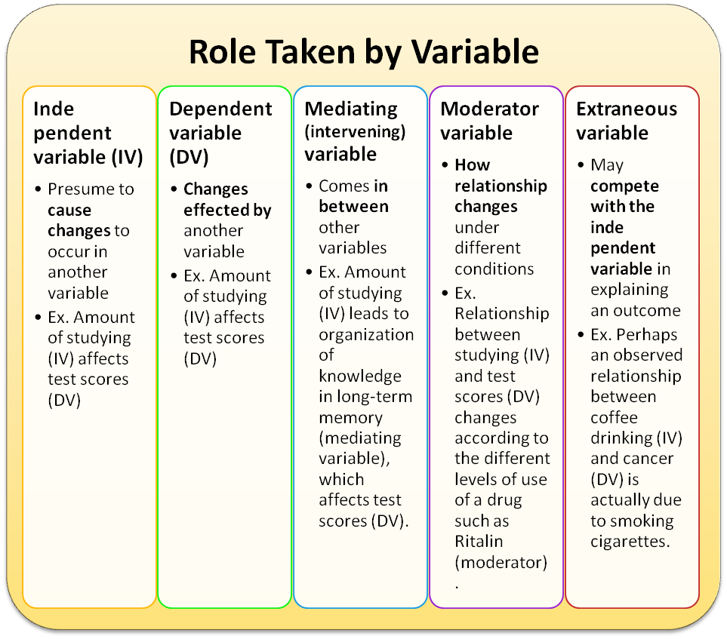

https://www.pinterest.com/pin/350858627198367389/

wgu-nx.acrobatiq.com

May not need variables in every role in one study.

Thinking about mediating variables and moderator variables may help clarify the topic.

~3.3 Foreshadowing questions, research questions, hypotheses
Foreshadowing questions are more general questions or issues you want to pursue without being able to formulate more specific research questions or hypotheses yet. For example, you might say
I want to investigate the role of the public library in improving health literacy in the community.
Foreshadowing questions are often used in exploratory studies, especially in exploratory studies using qualitative methods.

Research questions are more specific and are formulated ideally in terms of your variables.
For example, as the director of a public library, you might ask
Thanks to our health insurance information campaign, how many people in the target area of the public library who are not covered by employer health insurance have improved their understanding of health insurance options from
Not or only vaguely aware of health insurance options to
Fully aware of health insurance options and able to select a suitable policy
As a hypothesis, you could state
Among the people who are not covered by employer health insurance we have increased the percentage who are knowledgeable about their health insurance options from 10% to 40% or more.
Present you questions / hypotheses in the template table
Add or delete rows as needed.

# | Research question or hypothesis

blank page

~4 Research design. Research methods

Some proposals distinguish between methodology (the why you plan to use certain methods to gather your data) and the methods or research design (how you will gather your data). In any case, give a rationale for / justification of all aspects of your research methods.

In discussing the methodology, draw on reviewed literature and consider the different methodological approaches used. Your methodology may include your research paradigm and epistemologies that underpin your research and your rationale for this.

As with the theoretical framework, demonstrate that you have read other studies in your area of research. Address the strengths and limitations of the methods in similar research and justify why you have chosen the methods that you have. Put differently, it is not enough to discuss the research methods you propose, you must also discuss alternative methods and give a rationale why you have chosen the proposed method.

Discuss each step in the research design in some detail.

Discuss mechanisms to assure the quality of the study-e.g. control of bias.
See also Section 4.6 Limitations.

~4.0 Overall study design (optional)

An overview of your study design.

~4.1 Participants. Population. Participant selection. Sampling`
Unit of analysis is
Unit of analysis is the unit about which you want to answer questions ꟷ some entity (person, organization, etc.), situation, (social) setting, (social) phenomenon, event / history / development / happening, or relationship, such a person, a school (building level), a course, a course offering (specific course section in a specific semester).

Do not confuse with unit of observation, more precisely. the unit about which we collect data by observation or any other data collection method, such as interviewing or testing persons or getting data about persons from documents. Examples are
- answering questions about schools (building level) using student data;
- answering questions about grocery stores using data from observing or interviewing customers.

In the simplest case, there is one unit of analysis, often person, and this unit is also the unit of observation. Or we can have one unit of analysis and a different unit of observation, as in the examples in the previous paragraph. Or one unit of analysis and two units of observation:
- In studying schools (building level) we can use
- data about the school (such as the environment of the school, the architecture of the school, the state of maintenance, equipment available) and
- data about students.

How do you select units of analysis to be covered by your study?
Wildemuth Chapters 14 - 16

Ideally you would know the total population of the units of analysis or at least how many there are, for example,
- all adults living in the service area of a library branch;
- all schools (building level) in a state.
In a study where persons are both the units of analysis and the units of observation, the persons selected are often called participants.
What is your sample size?
When there is a unit of observation different from the unit of analysis, we may have a two-step sampling problem: First select a sample of schools to study, then for each school select a sample of students to collect data about.
`
~4.2 Time period covered by your study. Brief description in the appropriate table row.
Cross-sectional study
Longitudinal study. Indicate whether
(a) retrospective or prospective and
(b)repeated cross-sectional (different samples
or panel study (same sample)
(c) data collection frequency.

This is discussed in Wildemuth Chapter 9 and the Course Notes for Week 07.

~4.3 Data collection methods and instruments
For complex variables, explain how they are measured, what data enter into determining the values of these variables.
`How will you go about collecting data about the units of observation (surveys, experiments, interviews)? In this context, "instrument" usually refers to tests, questionnaires, interview guides, and such. But "instrument" could also refer to any equipment or instruments used to collect data, for example eye-tracking equipment.

Data used could be existing statistical data sets or data specifically collected.
Data collection methods and instruments must be specified in either case.

Note well: Do not confuse (1) survey and (2) questionnaire/interview/data collection form
A survey is a type of study or data collection effort within a larger study,
a questionnaire is a data collection instrument that may be and often is used in a survey.

A survey is conducted by a researcher,
questionnaires are distributed, filled out by participants, and returned (or not).

The term survey is used quite often to mean questionnaire. Do not do that.

Elaboration:
Many surveys use questionnaires that are filled in by the participants, but surveys can use other data collection instruments, such as in-person or telephone interviews.
While survey usually carries the connotation of individuals being the unit of data collection, the units could be organizations or even artifacts, such as buildings in a city, in which case data would be collected by an observer, possibly using instruments (such as a device using infrared for measuring distance) or, in the example, asking the people who worked on the construction or live in the building.

For every data collection process, relationship to variables should be stated. In particular, if you use questionnaires or interviews, the questions should relate to variables. For each question list the variable(s) it relates to. A question could ask for information on an independent variable or it could it probe for the value of a dependent variable. Sometimes a questionnaire question relates to a variable you have not thought of in Section 3.2. If the variable is important, add it in 3.2 If the variable is not important, omit the question.

Be mindful of the safety of data collection. People as participants can be harmed in subtle ways. See Section 4.5 Ethics. Approval of studies with human or animal subjects.

~4.4 Time frame and effort for data collection
- how long will data collection take? For example
- If you do a survey, how long do you allow for responses coming in?
- If you observe several people performing a task in a natural setting, what is the time period for completing all observations?
- What is the effort for data collection, for example, time for one interview, time for one observation, how many people are involved in data collection, how man person-hours / person-days

~4.5 Data analysis methods
Describe and discuss the methods for analyzing the data. Qualitative, quantitative, both? There are many books on research methods. Include any tools you will use to assist you with analysis (e.g., software, models). Indicate how analyzing the data in this way will answer your research questions. If applicable, statistical planning must be fully addressed, or provide evidence that statistics are not required.

~4.6 Limitations
Examine your methodology and consider any weaknesses or limitations that may occur as a result of your research design. Address the limitations by indicating how you will minimize them.

The section on limitations is often included in the Conclusions rather than under Methods (where it logically belongs) to drive home to the reader that before using the findings one should carefully consider the study's limitations.

~4.7 Difficulties, barriers, problems that might arise during the conduct of the study
For example:
- Cannot recruit enough participants from underrepresented groups.
- Low return rates (for mailed or Web questionnaire), participants not reachable or do not show up (telephone or in-person interviews).
- An organization being studied withdraws their agreement in the middle of the study
- During data collection or data analysis it becomes clear that there population studied has problems that were not anticipated by the researcher but about which data are needed to properly answer the research questions.
- An essential collaborator becomes unavailable.

How do guard against such difficulties?
Are there contingency plans in place to deal with such difficulties if the arise in spite of all precautions?

~4.8 Cost-benefit analysis. Ethics. Approval of studies with human or animal subjects
Almost all research must consider ethics, especially ethical consideration of how the data will be collected. Outline your awareness and understanding of ethical issues associated with your research proposal. Consider the rights of those being researched (including informed consent), your responsibility, and how the data will be collected, stored and disposed of. Indicate whether your proposal will require approval from an ethics committee and, if so, which one.

In the US, universities and other organizations conducting research must have an Institutional Review Board (IRB). The IRB reviews studies with human or animal subjects to consider whether the benefits of a study outweigh any possible harm to study subjects and approves or rejects a study accordingly.

This is also a place to discuss costs and benefits of the study.

Costs in the broad sense include resources required to conduct the study and any harm the study may cause to the participants, to the research team, to others, to organizations, or to society at large.

Benefits include benefits to the participants, to the research team, to others, to organizations, or to society at large.

For more information about research and ethics at UB visit
http://www.buffalo.edu/research/research-services/compliance/irb.html
www/research/pdf/Compliance/BRO/UB Click IRB Step by Step Guide.pdf
http://www.buffalo.edu/research/research-services/compliance/irb/sbro/irb-protocol-development-assistance.html

Blank page

~5 Results. Findings [Not in the proposal]

This section will be empty. Just put here so you have a complete thesis outline

You can put here the types of findings your study is intended to produce

~6 Conclusions and implications. Applications (to design, to policy)
[Possibly in the proposal, short]

This section can be in the research proposal in a general way, elaborating the uses and impact of your expected results. Or you can have discussion of this in Section 1 to help the reader the importance of your research and why it should be funded

~6.1 Action implications
Can include here some general discussion. Also refer to the more targeted Section 1.6.3.
See Section
It could also be here.

~7 Appendices

This may include copies of letters seeking participants, consent forms, draft questionnaires, detailed information about cases that have been analyzed.

~8 References

It is important to include all references you have used when writing your proposal. This demonstrates that you are serious about your research and have invested both time and thought into the process.

~9 Administrative sections (not for UBLIS 575DS, but important in a real proposal)

You can skip this altogether of look over it to get an idea/

~9.1 Personnel for the study

List all personnel and their roles. With names, if known. Attach CVs using the funding agency's format and instructions.

~9.2 Resources required. If applicable, Budget. Very important in an actual proposal,

- For a larger project: Personnel cost.
- Cost of survey design and questionnaire printing (unless questionnaires are administered online, in which case there may software costs), transcribers, software, special equipment.
- Is travel or fieldwork required? If so, where to, how long and at what intervals?

Often proposals for funded research include a budget to indicate where funds will be allocated. A budget may include the items listed above. Also overhead to the university (often 50% or more).

~9.3 Timetable. Very important in an actual dissertation proposal or funding proposal

A timeline that estimates how long each task will take helps determine the scope of your research and whether it is achievable within a given timeframe. Include times needed for
1 Preparation
1.1 detailed literature review,
1.2 completing the rest of the proposal
1.3 approval from ethics committee,
1.4 reviewing or testing of research design, pilot study
2 Conducting the study
2.1 developing system (computer software, revamping an organization) to be tested, if applicable
2.2 data collection
2.3 data preparation (such as transcribing audio recordings) and analysis
3 Writing up the report (or thesis), focusing on the findings.
4 Preparing conference and journal papers

Be realistic with the timeframe; consider if you are able to dedicate full-time work to the research, if it is to be conducted while you are studying other courses, working part time or full time, or have family commitments.

~9.4 Data management plan

This includes
- Keep confidential data safe (very strict rules for patient data).
- Clean the data to take out errors before data analysis.
- Delete data after a period set in the IRB approval.
- Preserve data physically and making sure they are readable when technology changes.
- Make data accessible for re-use while adhering to IRB-approved rules (for example, anonymized data). Format and index data so other researchers can use them. Publicize the availability of data sets and the conditions of use. Deposit data in an appropriate repository. Some funding agencies require data sharing.

Note: There is a job here for you: Data librarian.

~9.5 Communicating the results

How will you share the information you discover with the wider (research/academic) community? With practitioners who could use your findings to improve their practice. In most cases, a written document (report, research paper, thesis or journal article, conference presentation, preferably with a printed version in the conference proceedings) is an appropriate means of communicating your findings. If your research is intended to assist a broader audience (for example specific members of the community), other forms to disseminate your knowledge could include workshops, pamphlets, musical/theatrical performance, film or general media articles.

~Credits

http://owll.massey.ac.nz/assignment-types/research-proposal-structure.php

THE RESEARCH PROPOSAL TEMPLATE. Florida International University.
https://www.slideshare.net/lizzywolf/research-proposal-template

More such documents at
https://www.pinterest.com/ssohail849/writing-a-research-proposal/

RESEARCH PROPOSAL. GUIDE FOR HDR CANDIDATES
The University of Newcastle, Australia
UON Graduate Research - The University of Newcastle |
NIER Block C Room G30, Callaghan, NSW, 2308 AUSTRALIA Phone: +61 02 4921 6537 |
Email: graduate-research@newcastle.edu.au | CRICOS Provider 00109J

~A1 Appendix 1.

A collection of causal models / causal maps / influence diagrams

Moving from the simple to the complex

I selected the examples based on clear display rather than by subjects.
But even with the variety of subjects, all should be easily understandable for educated lay persons.

Some of the diagrams are quite complex. You can get the gist of them without following every detail.

You might find it very helpful to draw a causal map, by computer or by hand, whatever is easier. Causal maps are particularly helpful in identifying variables and their roles. A Google search for
(causal OR influence) (model OR map OR diagram) [your topic]
may find useful examples.

Including a causal map is highly recommended, but not required. I f you draw one or find one that is helpful, please include it. It may help your critic.

Causal maps are a special case of Concept Maps or Visual Knowledge Graphs
There are many tools to create these types of diagrams,
One that is widely used and free: Cmap https://cmap.ihmc.us/

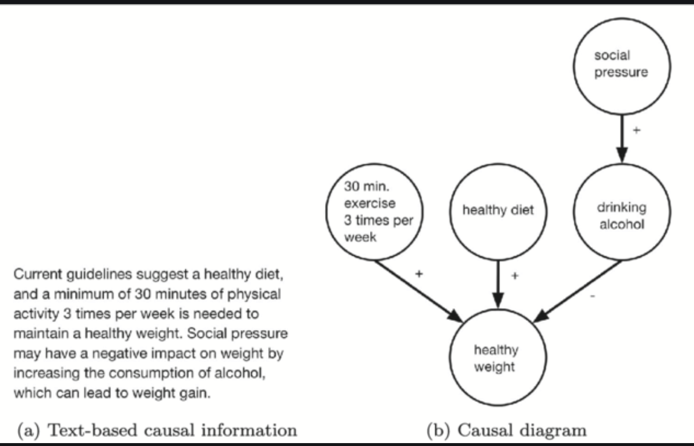
Fig. 1 Causal information used in (a) text and (b) diagram conditions of Experiment 1
How causal information affects decisions
Min Zheng; Jessica Kelly Marsh; Jeffrey V. Nickerson; Samantha Kleinberg
Cognitive Research Principles and Implications 5(1) November 2020
10.1186/s41235-020-0206-z. License CC BY
https://www.researchgate.net/publication/339247614_How_causal_information_affects_decisions

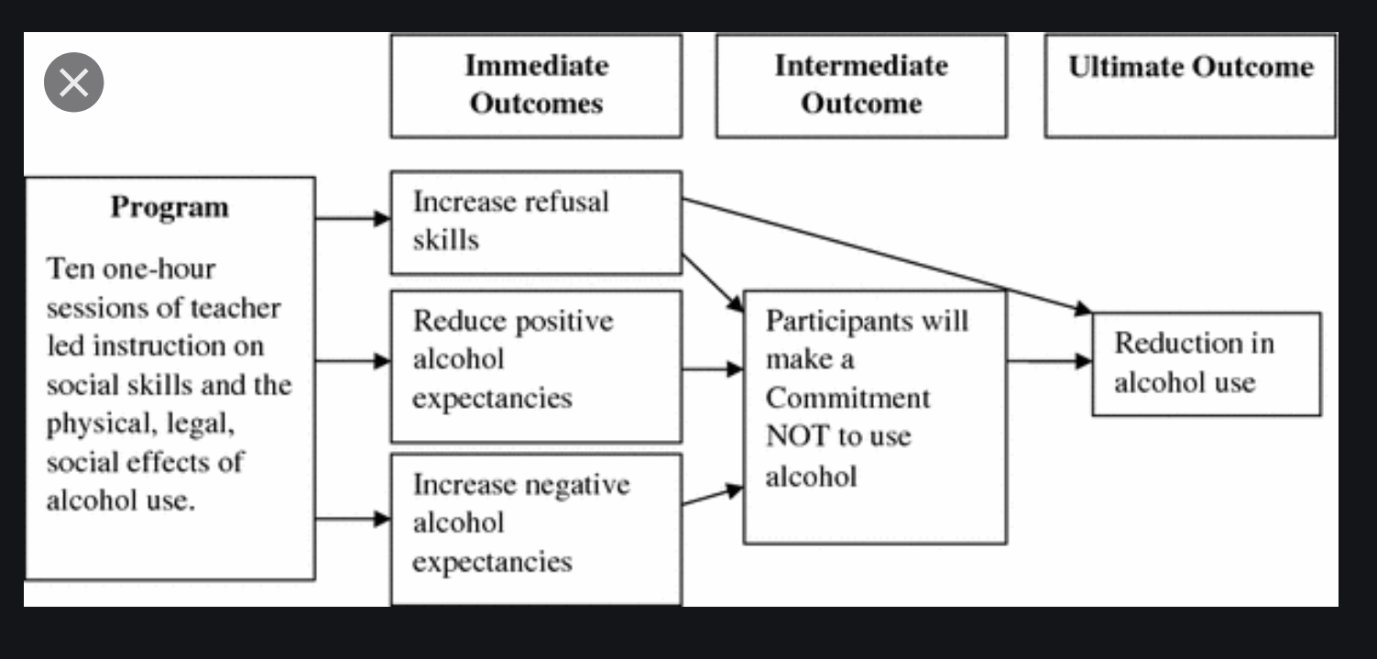
Stephens P., Sloboda Z., Kenne D. (2017) Evaluation of Substance Abuse Prevention and Treatment Programs. In: VanGeest J., Johnson T., Alemagno S. (eds) Research Methods in the Study of Substance Abuse. Springer, Cham. https://doi.org/10.1007/978-3-319-55980-3_20
https://link.springer.com/chapter/10.1007/978-3-319-55980-3_20

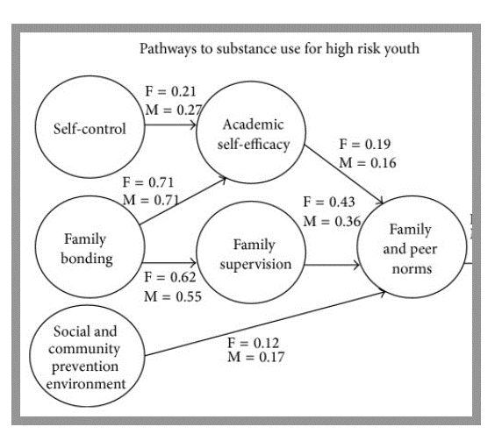
Family-based interventions for the MMM prevention of substance abuse and other impulse control disorders in girls.^^^^
|Kumpfer K
ISRN Addiction, 02 Mar 2014, 2014:308789
DOI: 10.1155/2014/308789 PMID: 25938121 PMCID: PMC4392980
https://europepmc.org/article/med/25938121

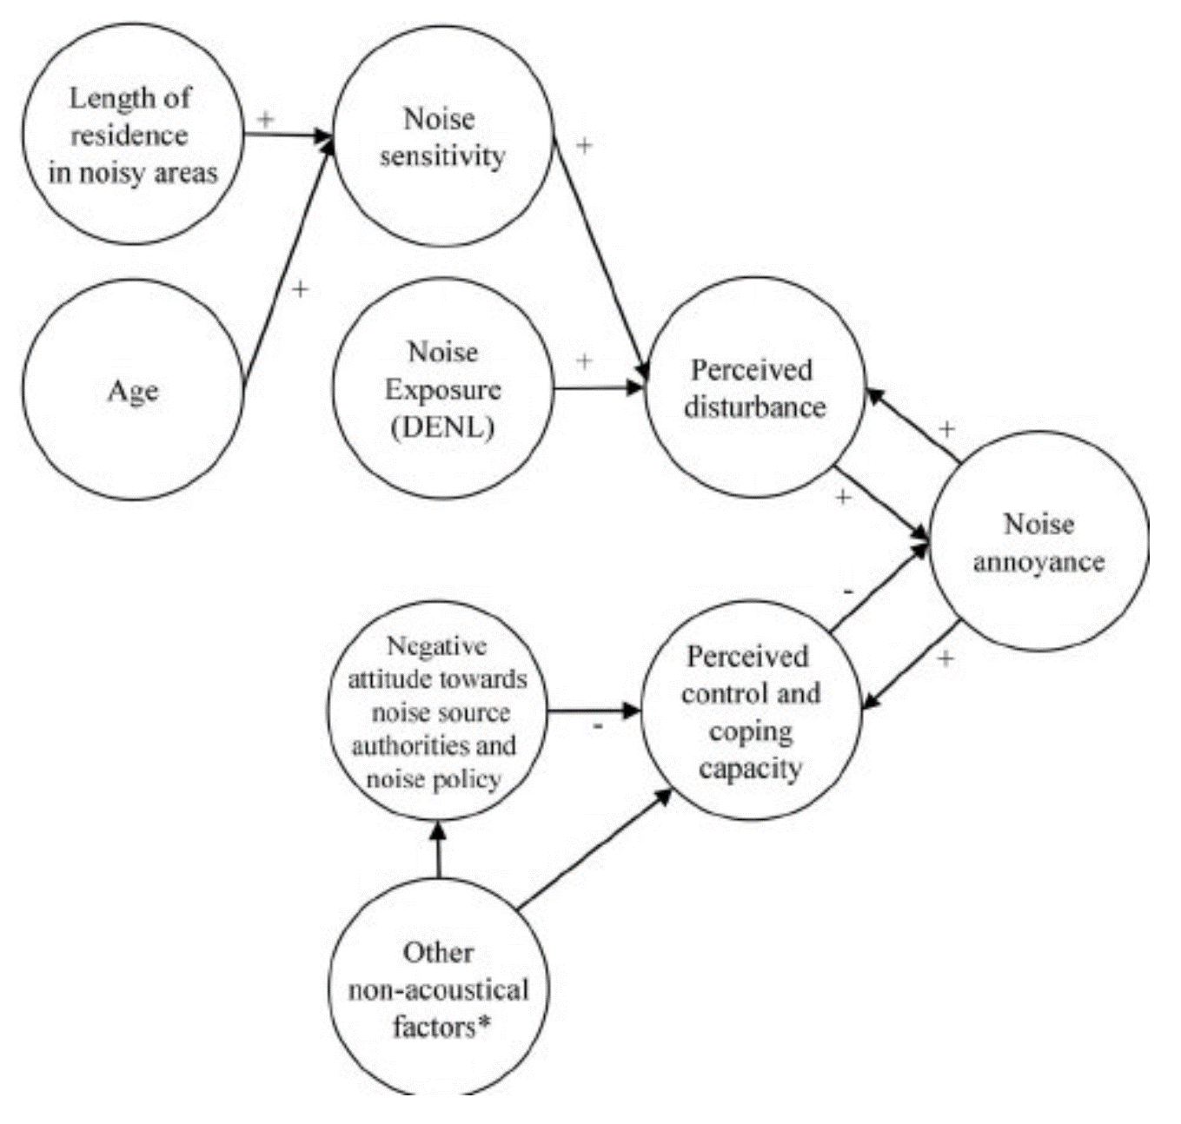 | Included nonacoustical factors are the following. ͑  1. Belief noise can be prevented ͑  2. Positive social evaluation of the noise source  3. Negative expectations related to noise development ͑  4. Personal dependency on noise source ͑  5. Concern about negative health effects of noise and pollution ͑  6. Annoyance by non-noise effects ͑ i.e., vibrations, dust, and odor  7. Fear related to noise source  8. Concern about property devaluation
FIG. 2. The developed causal model of aircraft noise annoyance.
Testing a Theory of Aircraft Noise Annoyance: A Structural Equation Analysis.
https://www.researchgate.net/publication/5318892_Testing_a_theory_of_aircraft_noise_annoyance_A_structural_equation_analysis Accessed September 25, 2020

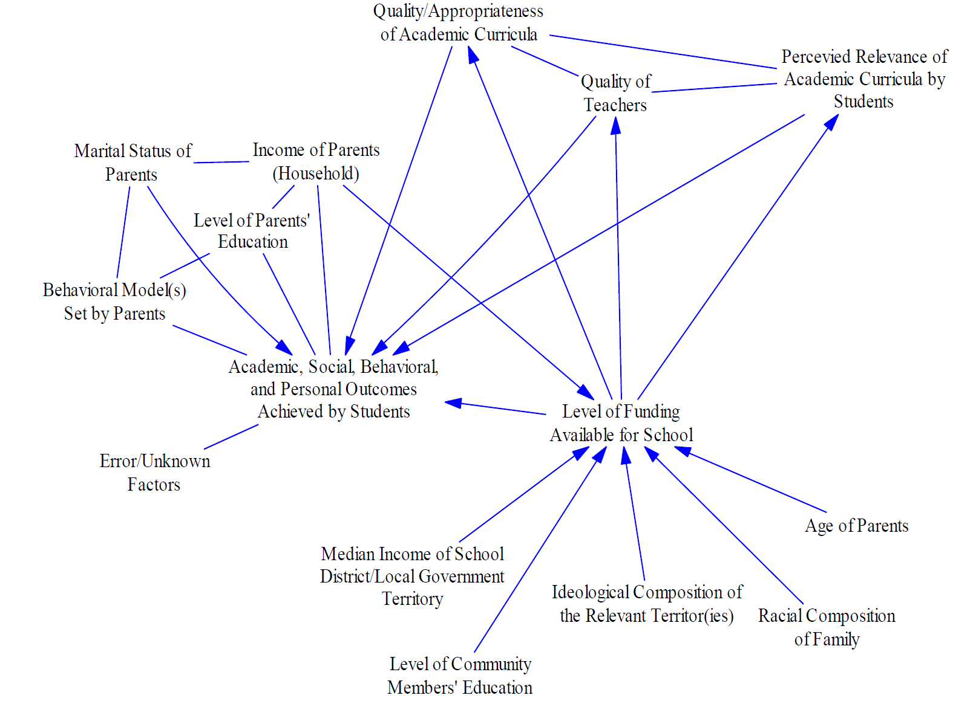
Figure 4. An example causal graph for hypotheses concerning outcomes in education.

Levine, Eli, and J. Butler. “Causal Graphs and Concept-Mapping Assumptions.” Applied System Innovation 1, no. 3 (July 24, 2018): 25. https://doi.org/10.3390/asi1030025.

Favorable regulations and incentives for industrial agriculture

Lack of availability of healthy food (farmers markets, etc.)

Lack of accessibility
to grocery stores

Food Deserts
Comfort and convenience
Taste benefits (child)
Economic gains (Food Inc.)

Industrial agricultural production, distribution, and marketing

Lack of economic resources

Malnutrition
(Convenience food)

Low density urban structure

Access to parks and recreation
(perceived critical safety issues)
Low walkability

Values of convenience, comfort, and safety

Lack of exercise
(everyday activities, sports)
Overweight and obese
children

Figure 4. Childhood obesity causal map. Radically simplified from Foley, R. (2012.): Obesity - Causal Diagram. https://prezi.com/rsn0kbwpjg0g/copy-of-copy-of-obesity-causal-diagram/
Negative impacts on:
Health
Confidence
Social relations
…

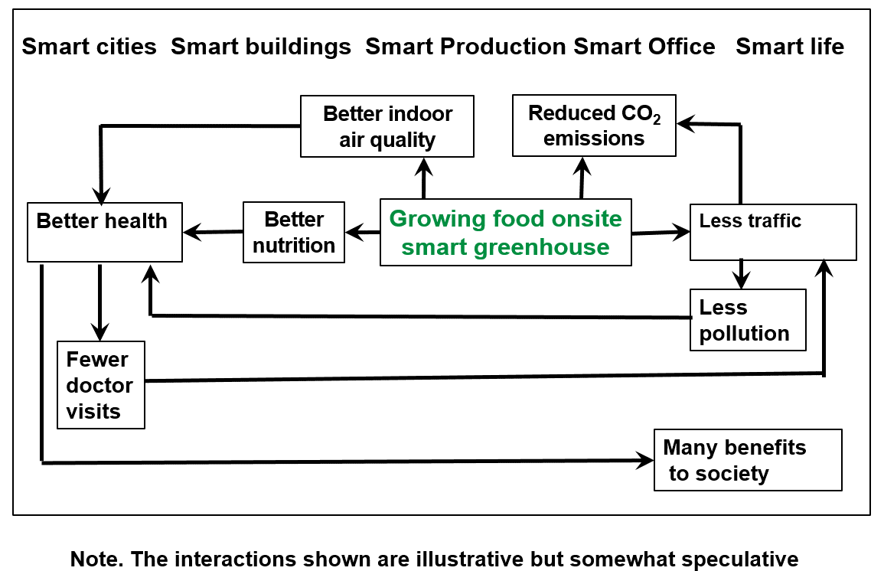
Figure 1a. Small segment of an ecosystem model

Soergel, D. & Baracho, R., Mullarkey, M. (2020)
Toward a Comprehensive Smart Ecosystem Ontology – Smart Cities, Smart Buildings, Smart Life
The Journal of Systemics, Cybernetics and Informatics: JSCI, 18 (2); (pp. 25-36)
http://www.iiisci.org/journal/sci/FullText.asp?var=&id=ZA311EC20

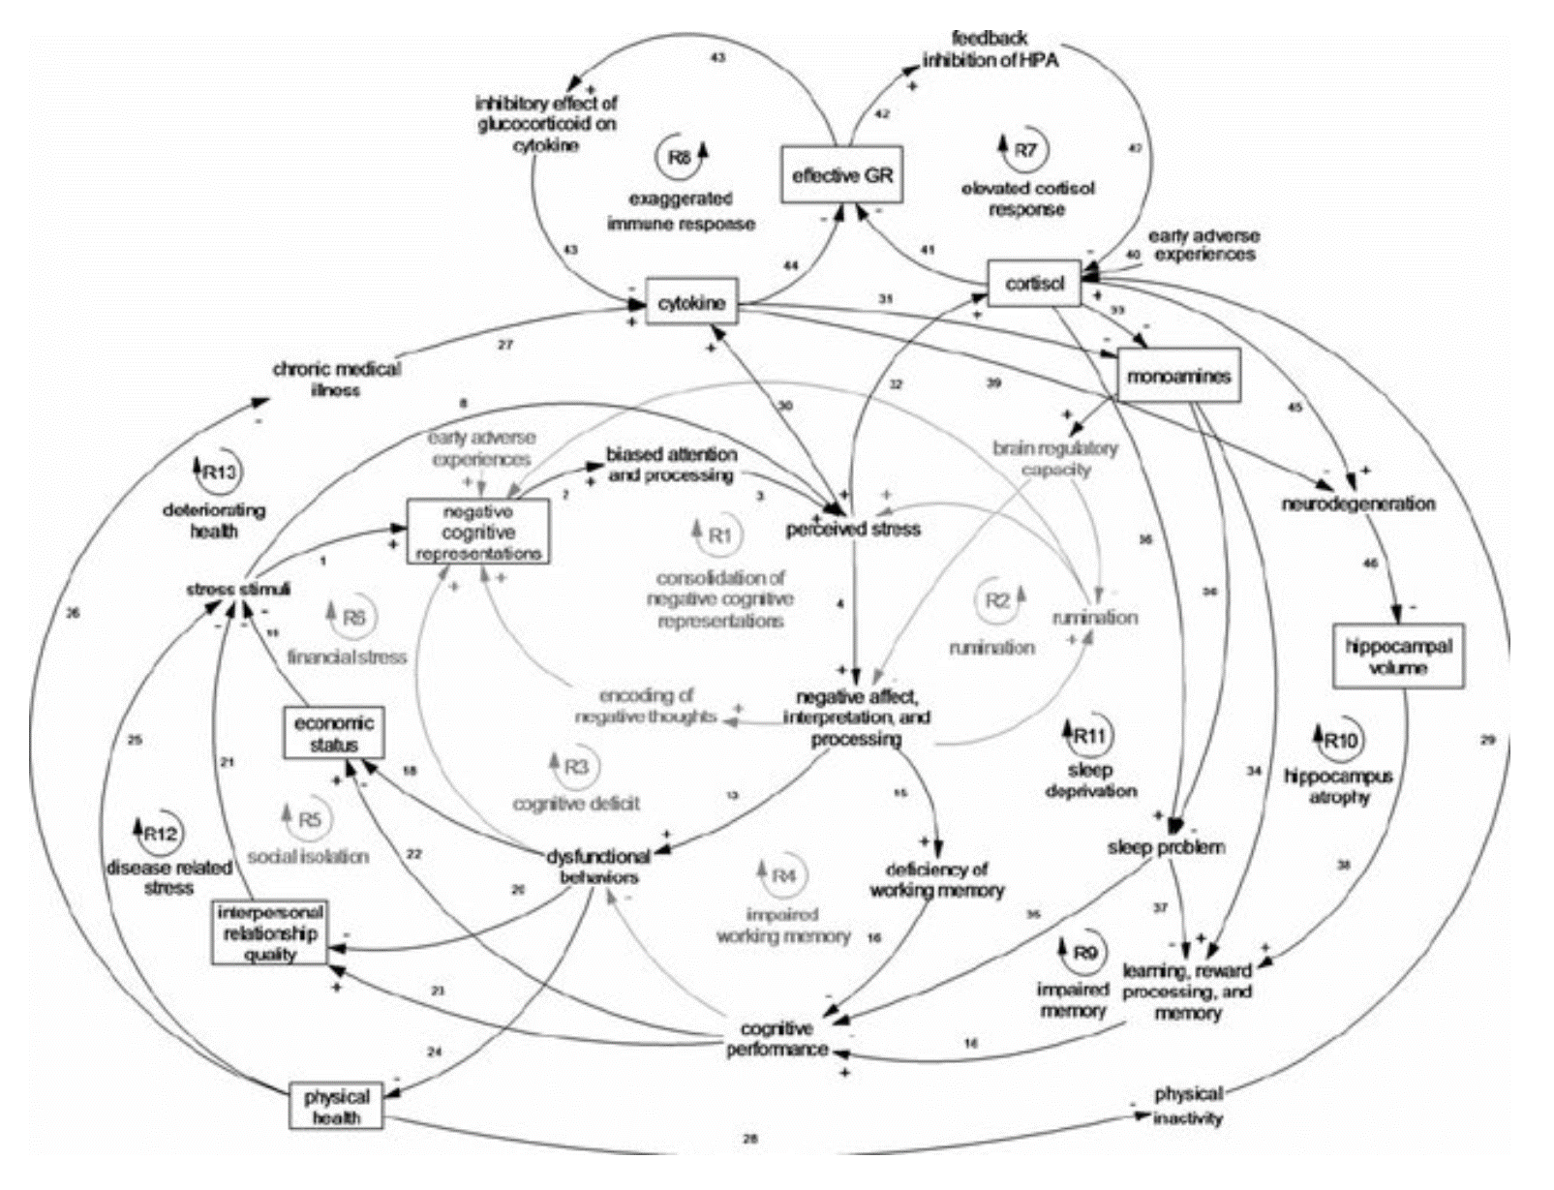
Fig. 4. Causal loop diagram of cognitive, social, environmental, and biological dimensions..
References for each link are represented by the numbers on the diagram and the reference list is available in Appendix C of the online Supplementary material. GR, Glucocorticoid receptors
https://www.researchgate.net/publication/285542261_Depression_as_a_systemic_syndrome_Mapping_the_feedback_loops_of_major_depressive_disorder/figures?lo=1

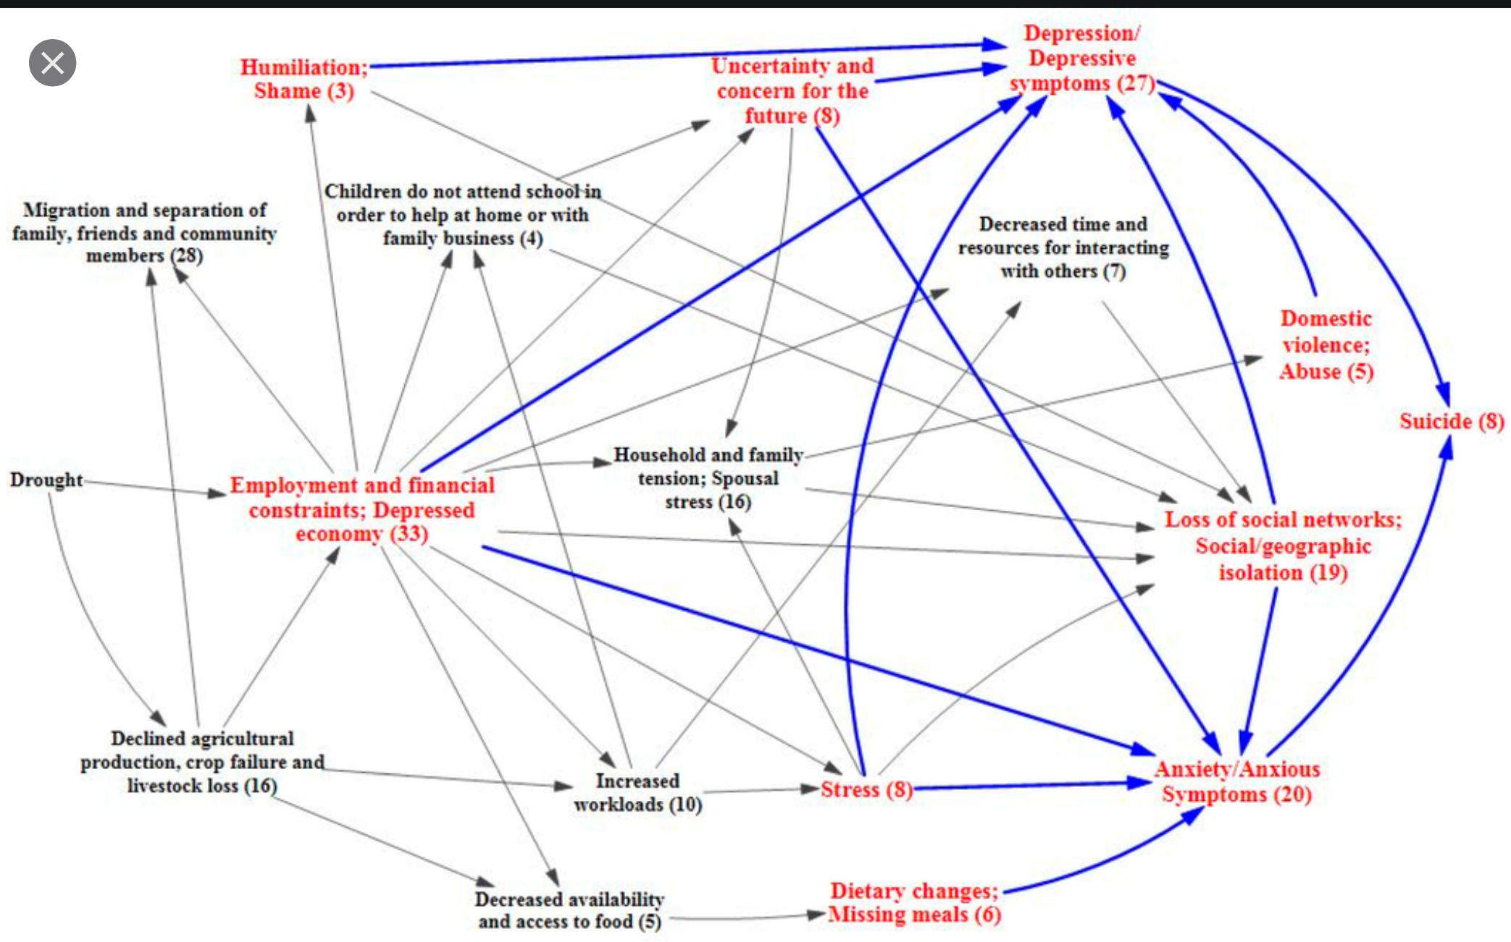
A hypothetical sketch of the factors which play in mechanisms leading from drought to depression and anxiety in a population.
The causal system involved in drought and mental health by Vins, Bell, Saha, and Hess (link).
Understanding Society: Causal diagrams and causal mechanisms
https://understandingsociety.blogspot.com/2016/02/causal-diagrams-and-causal-mechanisms.html
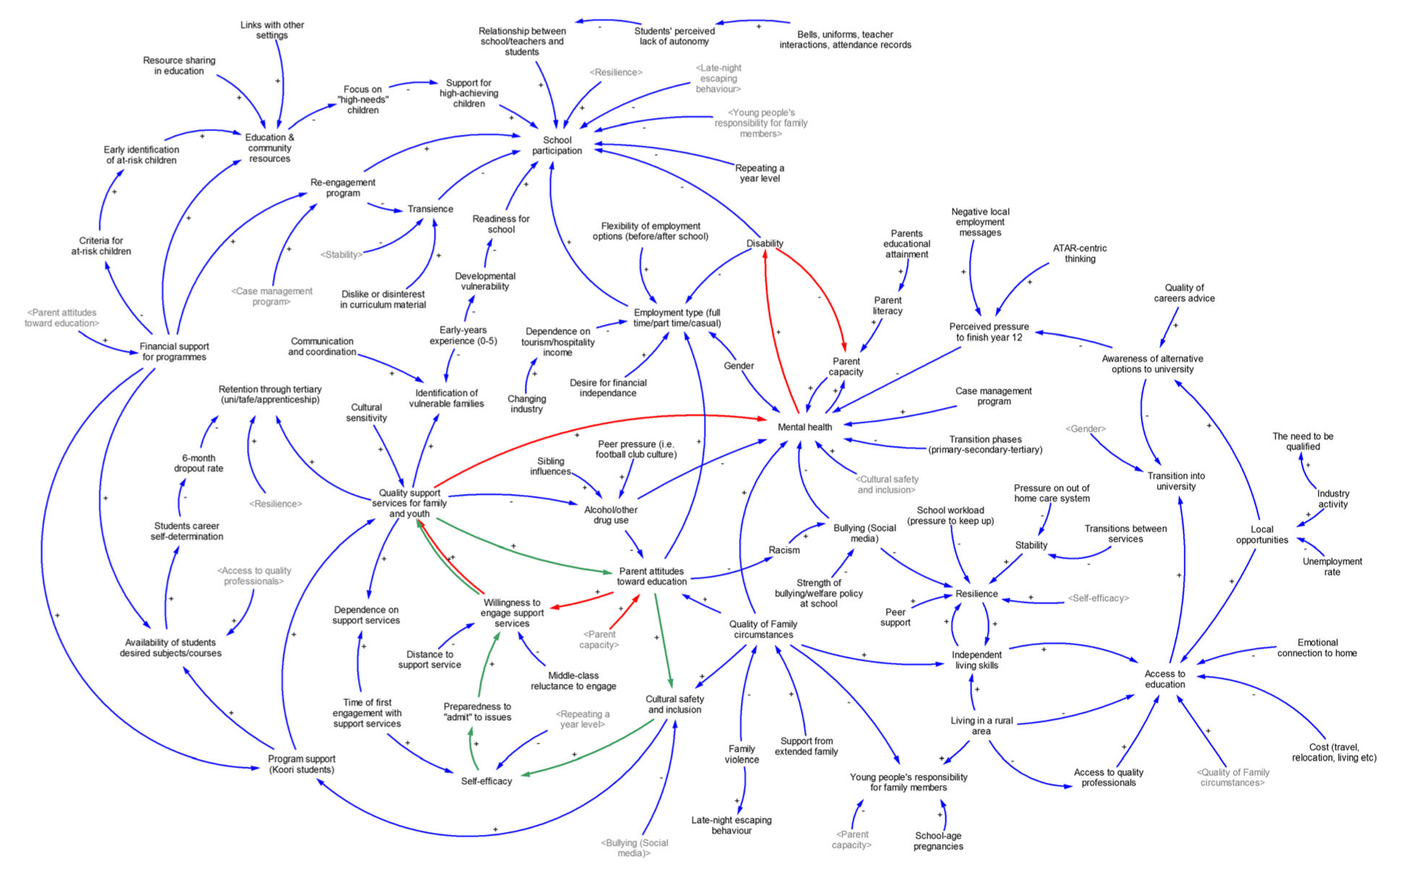
Figure 1 Causal loop diagram of determinants of high school completion, by theme after workshop 1
A Community-based Complex Systems Approach to High School Completion Matthew Kasman; Brynle Owen
Systems Research and Behavioral Science Syst. Res (2016
https://www.academia.edu/27483308/A_Community_based_Complex_Systems_Approach_to_High_School_Completion

~A2 Appendix 2. An example research proposal

UBLIS 575DS Name: Karen Wales

Excellent. If you do the study, publish it. If not, publish the literature review. It is outstanding.

Research Proposal

~Name and email address | Karen Wales kjwales@buffalo.edu
~Title | The effects of going fine-free at the Richmond Hill Public Library (RHPL) and recommendations on the future of fines at RHPL
~Abstract (max 300 words) | Data from the Richmond Hill Public Library will be extracted from the library’s integrated library system (ILS) to show customer behaviour in the year prior to and in the year following going fine-free. The data extracted will be compared to see if customer behaviour and access to services and materials is changed as a result of going fine-free. Customers will also be asked what their opinions are on fines. The results will be presented to the Richmond Hill Public Library Board as well as a recommendation on whether to become fine-free permanently or to reinstate fines.

Contents
0. Introduction to the guide | 1
1 Introduction and background. Purpose statement | 3
2 Literature review and synthesis | 5
2.1 Discussion of the topic area, specific topic, and motivation | 6
2.2 Blank | -
2.3 Theoretical / conceptual framework, variables, and research questions | 7
2.4 Research design. Research methods | 11
2.5 Findings | 14
2.6 Summary of what you learned from the lit review for your proposal | 17
3 Theoretical / conceptual framework, variables, and research questions | 18
4 Research design. Research methods | 19
4.1 Participants: Population and participant selection / sampling | 20
4.2 Time frame for data collection | 20
4.3 Data collection methods and instruments | 20
4.4 Data analysis methods | 20
4.5 Ethics. Approval of studies with human or animal subjects | 20
4.6 Difficulties, barriers, problems that might arise | 20
4.7 Limitations | 21
5 Results. Findings | -
6 Conclusions and implications. Applications (to design, to policy) | 21
6.1 Action implications
7 Appendices | 22
Appendix 1. Proposed survey | 26
8 References | 22
9 Administrative sections | 24

~1 Purpose statement. Introduction and background

~1.1 Purpose statement (topic sentence)

This paper will look at the effect of fines on Richmond Hill Public Library customers and their access to services and material and make recommendations regarding the future of fines at RHPL.

~1.2 Statement of the problem. research question, aim or purpose of the research.

To look at the effect of fines on RHPL customers and their access to services and material. Are factors such as customer good-will, number of customers, and access to services for vulnerable customers (customers with families, students, seniors, homeless, newcomers…) increased when fines are eliminated?

~1.3 What prompted your interest in the topic.

I have just written and presented a report for the Richmond Hill Public Library, where I work, to recommend to the Board that we go fine-free for 2021 (the Board already approved going fine-free for the remainder of 2020 as a result of COVID-19). As part of the report I recommended that we evaluate the results at the end of 2021 and bring another report back to the Board with recommendations regarding whether we should go fine-free permanently. The Board approved my report on September 22, 2020 and now I will need to put forth a detailed plan for evaluating the results of going fine-free so an analysis, report and recommendation(s) can be made at the end of 2021 on future fine-free status. This assignment seemed like a good opportunity to put course learning into real life practice.

~1.4 Background.

This study will follow the example of many studies reviewed in the literature but focus on a public library versus an academic one. Different factors are at play in a public library and, although many public libraries are now fine-free, there is no increase in published research on the effects of going fine-free in a public library. The practice of charging fines to library customers is a long held one but one that needs to be reexamined to see if customers are being adversely affected. Libraries need to decide if the financial gains and effect on behaviour achieved by charging fines is worth the potential loss of customers and good will. Is there a strong correlation between fines and a library’s overdue and lost book rate? Are fines the only recourse to retrieve the library’s material? The results of this study will cumulate in a report to RHPL’s library Board with recommendations on whether the library should go fine-free permanently.

~1.5 Expected outcomes, expected contributions. Theoretical and practical impact.
What it is significance or rationale?

The study has an effect on future RHPL policies that govern library customer usage. If, as posited by many libraries, some potential library customers do not use the library for fear of fines or cannot continue using the library due to fines the cessation of fines should increase the number of library customers. There is also the potential for greater customer satisfaction and side benefits such as increased program attendance.

What also needs to be observed is whether RHPL customers still return their material ion time for other customers to use or whether fines were a better compeller.

If customers overwhelming prefer the library to be fine-free there has to be enough, measurable, benefits to the library to offset the loss of fine revenue (something Boards and Municipalities want libraries to deliver). These benefits may include increased library customers and no changes to return and hold wait times

RHPL customers have a stake in the outcome. Those who tend to incur fines will no longer have to worry about financial penalty and may be more apt to borrow more materials. Conversely other customers may worry about the wait times for their holds or the impact on RHPL’s collections if customers choose not to return their material on time. RHPL’s Board and the City of Richmond Hill also have stakes in the outcome as the City may be asked for a bigger budget to offset the loss of fine revenue.

Theoretical significance / significance for the discipline
Add to the growing data on fine-free libraries, particularly in Canada where the trend is relatively new. Do marginalized and socioeconomically disadvantaged customers, as well as customers with children, and newcomers get greater access to services once fines are eliminated? If yes, are there other barriers to service that need to be looked at?
DS: Data could be interpreted from the perspective of rewards vs. punishment

Practical significance

Is the lack of fine revenue worth the perceived benefits of going fine-free?
Published results can be used to:
- decide if going fine-free is the right choice for RHPL and its customers
- help other libraries decide whether they should go fine-free
Improve customer access to services to marginalized and vulnerable customers
Learn about the effects of monetary penalization

~1.6 Why the research question can be answered by research?

Customer behaviour and resulting metrics will show the effect of going fine-free on RHPL customers. Comparisons can be made for pre and post going fine-free based on the data already collected by the ILS. DS: These data are the key to researchability.

~1.7 Brief characterization of the general type of study. See form on next page
XXX This is to come separately later

~2 Literature review and synthesis

~2.0 Overview

I found that while much has been written regarding fines not much actual research has been done on going fine-free in a public library setting. Academic libraries, as opposed to public libraries, have been the focus of the majority of the published research. In my review of literature, I found only six for public libraries and one of those is from 1983, although the authors published subsequent reports that I could not get access to (Bromberg, 2018; Crist, 2018; Depriest, 2015; Hansel, 1983; Monardo, 2019; Zhang, 2013). Of the six noted three are a result of Supporting Parents in Early Literacy Libraries (SPELL) research undertaken by the Colorado State Library where the main focus of the study was to support early literacy (Crist, 2018; Depriest, 2015; and Zhang, 2013). The rest of my literature review consists of academic library studies (Ajayi, 2005; Helms, 2019; McMenemy, 2010; Mitchell, 2005; Reed, 2014; Rupp, 2010; Sung, 2013; Wood, 2017; Yeung, 2010). In addition to the research noted above, I have found and read many articles involving public libraries going fine-free but they are mostly newspaper articles announcing another library going fine-free, bandying a few stats here and there, but not providing much of substance. These were not included in my review, as studies, or articles with more substance were used instead.

It should also be noted that I made a concentrated effort to use literature from the 21st century as with the advent of email and automated notices and similar technology results from older studies may not have the same validity. I also looked for Canadian examples and content but found newspaper and web articles of the sort previously discussed with the exception of one study done at a small Vancouver Island university (Reed, 2014). It seems to me that much of what has been done at the public library level has been reported only to the library board of the library in question. While often this information can then be discovered by going into individual library websites and searching for board reports, currently in Canadian libraries these reports are all to get the library board to agree to go fine-free in some way and do not yet have data on their subsequent results as the trend is still too new. Relooking at these reports in a few years after data is available would probably elicit more concrete information.

Below is a list of authors and titles reviewed:

Ajayi, A. (2005).
Students’ perception of fine increases for overdue library books in an academic library.
Journal of Librarianship and Information Science, 37(4), 187-193.
Bromberg, P. (2018).
Impact of going fine free. Salt Lake City Public Library. Report
Crist, D. (2018).
Removing Barriers to Access: Eliminating Fines and Fees for a Win Win for your Library and Teens: Discover approaches to eliminating fines and fees for youth in your library.
Young Adult Library Services, 17(1), 14–.
Depriest, M. (2015).
Removing barriers to access: eliminating library fines and fees on children’s materials.
Hansel, P. (1983).
Hard facts about overdues.
Library Journal, 108, 349-351
Helms, C. (2019).
Eliminating overdue fines for undergraduates: A six-year review.
Journal of Access Services, 16(4), 173–189
McMenemy, D. (2010).
On library fines: Ensuring civic responsibility or an easy income stream?
Library Review., 59(2), 78–81
Mitchell, W. (2005).
Using Rewards to Minimize Overdue Book Rates.
Journal of Access Services., 3(1), 47–52.
Monardo, J. (2019).
Long overdue: eliminating fines on overdue materials to improve access to San Francisco Public Library. San Francisco Public Library. Report
Reed, B. (2014).
Putting a Sacred Cow Out to Pasture: Assessing the Removal of Fines and Reduction of Barriers at a Small Academic Library.
The Journal of Academic Librarianship, 40(3-4), 275–280
Rupp, E. (2010).
Updating Circulation Policy for the 21st Century.
Journal of Access Services., 7(3), 159–175.
Sung, T. (2013).
Do Library Fines Work?: Analysis of the Effectiveness of Fines on Patron’s Return Behavior at Two Mid-sized Academic Libraries.
The Journal of Academic Librarianship, 39(6), 506–511
Wood, E. (2017).
If we charge them, will they come? Fostering positive relationships with students by remaining fine-free.
Yeung, M. (2010).
Library fines, trust games and reciprocity.
Reinvention: a journal of Undergraduate Research, 3(1).
Zhang, D. (2013).
SPELL research methodology and findings. Colorado State Library. Report
~2.1 Discussion of the topic area, specific topic, and motivation

The literature reviewed shows that the topic of fines is one rich in discussion but lacking in actual research. Libraries in North America are increasingly moving to a fine-free model but without much data to support the decision. In the literature review sections of the articles read the same authors were repeatedly cited (Depriest, 2015; Hansel, 1983; McMenemy, 2010; Mitchell, 2005; Reed, 2014; Rupp, 2010; Sung, 2013; Yeung, 2010) as there are few studies to refer to. I also used these same sources for my review.

Most discussion comes as a result of a library wanting to change their fine structure. They then turn to literature to find research to back their stance. There is also much discussion around the current trend in North America to go fine-free. As so many libraries are already fine-free those that currently charge fines are feeling pressured to do the same even though the literature has not definitively proven that fines have no merit. As a result, the same qualitative points are repeated as the reasoning to go fine-free – that fines do not change customer behaviour, it just penalizes them for it and that customers whose access to service is most impacted due to unpaid fines tend to be marginalized and those with young children, teens, newcomers, and seniors and whose income is lower.

More research into fines and the effects they have on customer behaviour is warranted to get a better picture and to ascertain if there are certain constants regarding fines and customer behaviour. This provides motivation to add to the lack of research in this area.

~2.2 Blank

~2.3 Theoretical / conceptual framework, variables, and research questions

Theoretical framework

There are many theories that can be applied to research involving fines the most popular being deterrence or punishment theory (Ajayi, 2005; Depriest, 2015; Hansel, 1983; Helms, 2019; McMenemy, 2010; Sung, 2013 and Wood, 2017) and fine as price theory (Hansel, 1983; Helms, 2019; McMenemy, 2010; Rupp, 2010; and Wood, 2017). Both of these theories speak to the traditional view that fines are an effective tool in libraries to ensure material is returned on time.

Positive reinforcement was best used in Mitchell’s (2015) study. The academic library used was already fine-free and prizes were drawn from all students who returned their library material on time. Depriest (2015) and Wood (2017) also discussed positive reinforcement for the timely return of library or in the context of removing fines for positive behaviour such as children reading to staff.

The most interesting in my review was Yeung (2010) who looked at fines in a totally different way to other studies. He looked at gender bias, and utility, trust and game theories in his research on fines. He wanted to know if elements such as trust had an impact on fines and why students chose to pay avoidable fines.

Theories noted in literature reviewed:
Borrower Perception of the library | Ajayi, N. (2005), Reed, K. (2014) and Zhang, D. (2013).
Cost vs return | Depriest, M. (2015); Reed, K. (2014) and Wood, E. (2017).
Deterrence/punishment theory/negative reinforcement | Ajayi, N. (2005); Depriest, M. (2015); Hansel, P. (1983); Helms, C. (2019); McMenemy, D. (2010); Sung, J. (2013) and Wood, E. (2017).
Fine as price theory | Hansel, P. (1983); Helms, C. (2019); McMenemy, D. (2010); Rupp, E. (2010); Wood, E. (2017); and Yeung, M. (2010).
Game theory | Yeung, M. (2010).
Gender bias | Ajayi, N. (2005); Yeung, M. (2010).
Reward theory/positive reinforcement | Depriest, M. (2015); Mitchell, W. (2005) and Wood, E. (2017).
Social theory | Wood, E. (2017).
Trust theory | Yeung, M. (2010).
Utility theory | Yeung, M. (2010).

Variables

Many different variables were analyzed in the studies reviewed.
- Circulation numbers (Ajayi, 2005; Bromberg, 2018; Depriest, 2015; Hansel, 1983; Monardo, 2019; Reed, 2014; and Sung, 2013), and
- overdue rates(Hansel, 1983; Mitchell, 2005; Monardo, 2019; Reed, 2014; and Rupp, 2010) and
- return rates (Depriest, 2015; Monardo, 2019; Rupp, 2010; and Sung, 2013)
were most often cited as the data obtained from these variables are at the core of the fine debate. Fine detractors say that circulation figures rise and that there is no discernable difference in overdue rates when there are no fines.
- Loan periods (Hansel, 1983; Mitchell, 2005; Reed, 2014 and Rupp, 2010) were looked at by many to see if changing them would encourage customers to return their material on time.
- Lost book charges (Bromberg, 2018; Depriest, 2015; and Rupp, 2010) were also compared to see if removing fines resulting in more material being charged as lost. This number may be misleading as many libraries charge material as lost earlier than when fines were being charged.

- Borrower category A breakdown of numbers by borrower category was also a popular variable (Ajayi, 2005; Helms, 2019; Mitchell, 2005; Monardo, 2019; Rupp, 2010; Sung, 2013; and Yeung, 2010). Most of the studies were at academic libraries and they wanted to know if behaviour differed depending on the type of borrower. Were undergraduates more prone to overdues than graduate students for example.

- Hold wait times. Surprisingly, hold wait times was a variable used by only one researcher (Bromberg, 2018) but a variable that I think is an important one when reviewing the effectiveness of fines particularly as one of the main reasons noted to have fines is to ensure that material is available to other customers who wish to use it too.
- The amount owed by customers was also an area researched by only one (Monardo, 2019). It would be interesting to see if there is any correlation between the amount owed in fines and a customer’s perception of the library. Are those with the most fines the ones that are most dissatisfied with library policies and most reticent to return to using the library? DS: These are variables.

Variables in literature reviewed:
Amount owed (average) | Monardo, J. (2019).
Borrower opinion | Ajayi, N. (2005) and Depriest, M. (2015).
Borrowers | Bromberg, P. (2018).
Borrowers owing debt | Monardo, J. (2019).
Borrower category (undergrad, graduate, faculty, adult, child, student…) | Ajayi, N. (2005); Mitchell, W. (2005); Monardo, J. (2019); Rupp, E. (2010).; Sung, J. (2013) and Yeung, M. (2010).
Borrowing privileges | Depriest, M. (2015) and Hansel, P. (1983).
Circulation | Ajayi, A. (2005); Bromberg, P. (2018); Depriest, M. (2015); Hansel, P. (1983); Monardo, J. (2019); Reed, K. (2014) and Sung, T. (2013).
Circulation (average in days) | Rupp, E. (2010).
Court/collection agency | Hansel, P. (1983).
Days overdue | Helms, C. (2019).
Economic stress (custom holistic measure. 5 variables used related to income and unemployment) | Monardo, J. (2019).
Education (level) | Yeung, M. (2010) and Zhang, D. (2013).
Fine impact (custom holistic measure. 5 variables used, including fines owed, customers blocked) | Monardo, J. (2019).
Fine (size of) | Rupp, E. (2010) and Yeung, M. (2010).
Gender | Ajayi, A. (2005) and Yeung, M. (2010).
Hold wait times (in days) | Bromberg, P. (2018).
Income level | Ajayi, N. (2005); Depriest, M. (2015) and Yeung, M. (2010).
Level of trust | Yeung, M. (2010).
Library use | Zhang, D. (2013).
Loan period | Hansel, P. (1983); Mitchell, W. (2005); Reed, K. (2014) and Rupp, E. (2010).
Lost book charges | Bromberg, P. (2018); Depriest, M. (2015) and Rupp, E. (2010).
New cards | Bromberg, P. (2018).
Notice frequency | Hansel, P. (1983) and Rupp, E. (2010).
Notices (including telephoning) | Hansel, P. (1983).
Outstanding debt totals | Monardo, J. (2019).
Overdue fine payments (annual) | Monardo, J. (2019).
Overdue fine transactions (annual) | Monardo, J. (2019).
Overdue rate | Hansel, P. (1983); Mitchell, W. (2005); Reed, K. (2014) and Rupp, E. (2010).
Population served & density | Hansel, P. (1983).
Renewals | Hansel, P. (1983).
Return rates | Depriest, M. (2015); Monardo, J. (2019); Rupp, E. (2010) and Sung, J. (2013).
Sufficiency of loan period (loan period - average circulation) | Rupp, E. (2010).

Research questions

I found that in each paper reviewed there was one main research question. This is the question I noted. Be aware that it is possible to have multiple research questions being asked in a research study. While each researcher or author had a slightly different approach to the topic the majority of the research questions posed related to borrower behaviour as it relates to charging fines or going fine-free (Bromberg, 2018; Hansel, 1983; Helms, 2019; McMenemy, 2010; Mitchell, 2005; Reed, 2013; Rupp, 2010; Sung, 2013; Wood, 2017; and Yeung, 2010). They wanted to know if changing variables relating to fines effected borrower behaviour, particularly as it relates to overdue behaviour. They also wanted to know how borrowers perceived fines and circulation policies relating to fines (Ajayi, 2005 and Zhang, 2013). Advocacy for going fine-free (Crist, 2018) and an overall look at the issues (Depriest, 2015) were also addressed in research questions reviewed.

Research questions in literature reviewed:
Advocacy | How can you advocate for the elimination of fines and fees for youth in your library? | Crist, B. (2018).
Borrower behaviour | What is the impact of going fine-free on hold wait times, checkouts, number of borrowers and new card registration? | Bromberg, P. (2018).
 | Which tactics used by different public library systems in North Carolina in the war against overdues were most effective? | Hansel, P. (1983).
 | After going fine-free for 3 years has there been any changes in overdue behaviour? | Helms, C. (2019).
 | Are library fines ensuring civic responsibility or an easy income stream? | McMenemy, D. (2010).
 | Would some kind of positive reinforcement system be effective in minimizing the overdue rate in our library? | Mitchell, W. (2005).
 | Has the removal of fines and other loan changes had an effect on borrower return rates, circulation numbers and borrower goodwill? | Reed, K. (2013).
 | What circulation policies will positively impact user convenience? | Rupp, E. (2010).
 | Do library fines actually make a difference in the patron’s return behaviour? | Sung, J. (2013).
 | If we charge them, will they come? | Wood, E. (2017).
 | Why do students choose to pay avoidable fines? | Yeung, M. (2010).
Borrower perception | What is the students’ perception of increases in fines imposed by the library? | Ajayi, N. (2005).
 | What are parents and families’ opinions on early literacy and library use habits? | Zhang, D. (2013).
Overview of issues | What research and information are there on the costs and benefits of library fines and fees? | Depriest, M. (2015).

~2.4 Research design. Research methods

The majority of the researchers I read wrote their own literature review, either as the entirety of their study, or, a portion of (Ajayi, 2005; Depriest, 2015; Helms, 2019; McMenemy, 2010; Monardo, 2019; Reed, 2014; Rupp, 2010; Wood, 2017 and Yeung, 2010). Quantitative data analysis was another popular method of research (Ajayi, 2005; Bromberg, 2018; Hansel, 1983; Helms, 2019; Mitchell, 2005; Monardo, 2019; Reed, 2014; Rupp, 2010; Sung, 2013; Yeung, 2010; and Zhang, 2013) as decision makers often require it or prefer it. Numbers often hold more sway and are seen as more definitive that qualitative data. Bromberg (2018) is a good example of the use of quantitative descriptive data analysis as he measures the mean for hold wait times, number of checkouts, number of borrowers and the number of new cards and compares them month by month in the two years prior to going fine-free and the year following.

Qualitative data was also elicited by use of customer surveys (Ajayi, 2005; Monardo, 2019; Yeung, 2010; and Zhang, 2013), staff surveys (Monardo, 2019), library surveys (Hansel, 1983), interviews (Monardo, 2019; Reed, 2014; and Zhang, 2013), emails (Reed, 2014) and focus groups (Zhang, 2013) and analyzed to help support researchers’ positions.

Methodology in literature reviewed:
Anecdotal evidence | Rupp, E. (2010).
Customer Survey/questionnaire | Ajayi, A. (2005); Monardo, J. (2019); Yeung, M. (2010); and Zhang, D. (2013).
Data analysis | Ajayi, A. (2005); Hansel, P. (1983); Helms, C. (2019); Mitchell, W. (2005); Monardo, J. (2019); Reed, K. (2014); Rupp, E. (2010); Sung, J. (2013), Zhang, D., (2013).
E-mails | Reed, K. (2014).
Focus group | Zhang, D. (2013).
Interviews | Monardo, J. (2019); Reed, K. (2014) and Zhang, D. (2013).
Literature review | Ajayi, N. (2005); Depriest, M. (2015); Helms, C. (2019); McMenemy, D. (2010); Monardo, J. (2019); Reed, K. (2014); Rupp, E. (2010); Wood, E. (2017) and Yeung, M. (2010).
Staff Survey | Monardo, J. (2019).
Survey of libraries | Hansel, P. (1983).

~2.4.1 Participants. Population. Participant selection. Sampling
Your text has also some mention of how data are collected. Move this to 2.4.3

All studies reviewed used library borrowers by extracting data from their library’s integrated library system (ILS) but some also obtained data through the use of borrower interviews (Monardo, 2019; Reed, 2014), surveys (Ajayi, 2005; Monardo, 2019; and Zhang, 2013), focus groups (Zhang, 2013) and emails (Reed, 2014). In addition, staff (Monardo, 2019; and Rupp, 2010) and other libraries (Hansel, 1983) were surveyed.

It appears that the researchers generally relied on voluntary participation for their participants. This was true for the 1300 students surveyed in Yeung’s (2010) study as well as in Hansel’s (1983) survey of North Carolina libraries. In the case of borrower transactional data, the data was taken from all borrower transactions recorded in the library’s ILS. Sampling only a portion of the borrowers at a given library would not be appropriate except when comparing the habits of different borrower categories as was the case of many of the academic library studies (Ajayi, 2005; Mitchell, 2005; Rupp, 2010; Sung, 2013; Yeung, 2010).

In some cases, the participants were chosen based on geographic area. The SPELL research (Crist, 2018, Depriest, 2015; and Zhang, 2013) used Colorado public libraries as the basis for their research for example and Hansel (1983) surveyed all public libraries in North Carolina for their study.

~2.4.2 Time frame for data collection

Helms (2019) had the longest time frame for her study at six years. Hansel (1983) gave data for three years. Many just have data for the year prior to going fine-free and for the following year as is currently planned for my proposal. Often more data can be given for years prior to going fine-free as the data needed is already in the library’s ILS and just needs to be extracted and analyzed. Reed (2014) noted data for up to nine years prior to going fine-free to show trends in physical circulation and fine revenue although she only had data for one year after going fine-free to use in comparison. Mitchell’s (2005) results were for 2 academic years.

~2.4.3 Data collection methods and instruments

Most of the data collected in the studies cited were transaction data retrieved from the library’s ILS. Data collected from borrowers was obtained through emails (Reed, 2014), questionnaires and surveys (Ajayi, 2005; Monardo, 2019; and Zhang, 2013) and focus groups (Zhang, 2013). In addition, staff were surveyed (Monardo, 2019; and Rupp, 2010) as well as other libraries (Hansel, 1983). DS: Mention staff in sampling.

~2.4.4 Data analysis methods

Quantitative analysis involves taking the raw data and turning it into something useful and comparable. Descriptive data analysis was used by most. Descriptive statistics such as average, frequency and percentage were used. Rates were determined and compared pre and post fine change to discern if there were any significant changes. The overdue rate was one used by many (Hansel, 1983; Mitchell, 2005; Reed, 2014; and Rupp, 2010) and was calculated as the percentage of a library’s collection that had not been returned at a certain point in time. It is closely related to the return rate which is the percentage of a library’s collection that customers have returned at a certain point in time (Depriest, 2015; Monardo, 2019; Rupp, 2010; and Sung, 2013). Then by using inferential analysis relationships and variances were determined to help researchers determine their findings.

Qualitative analysis in the literature involved analyzing content received from surveys, questionnaires and focus groups and looking for broad themes and repeated phrases to help determine the most common responses to questions and whether these responses can provide insights.

~2.4.5 Ethics. Approval of studies with human or animal subjects

This was an area that was not discussed in any of the literature I reviewed. Most used transactional reports as their primary means of obtaining data which have few ethical concerns as the data is not directly associated with specific customers. Those that conducted surveys, questionnaires, focus groups or interviews, where ethics would be a consideration, did not express any ethical issues in conducting them.

~2.4.6 Limitations

Data prior to making a change such as going fine-free may not be fulsome enough for those researching and comparing data. One author encountered some trouble when they discovered that the act of going fine-free and deleting all past fines meant that they could not get fulsome fine numbers for the years prior and had to rely on printed reports and other means to get the data needed (Reed, 2013). As previously noted a big limitation for studies on fines is the fact that so many other variables are at play and fines alone cannot account for the customer behaviour tracked and compared in fine studies. Detailed and precise data analysis should help to combat this limitation.

~2.5 Findings

Fines in libraries don’t exist in a vacuum they are closely connected to circulation policies dictating when overdue notices are sent, when a customer’s account is blocked or suspended, and a myriad of other variables. As a result, findings cannot be directly attributed to fines alone (Hansel, 1983; and Rupp, 2010) or positive reinforcement (Mitchell, 2005).

As with anything else in the fine debate, published results are mixed and do not definitively answer the questions associated with the debate. This is obviously a current and relevant debate that needs more study to provide more definitive answers. For those libraries that are trying to decide which side of the debate their library will fall on in the future there seem to be a combination of factors that need to be reviewed to make the decision. A library has to look at their current population and size (Hansel, 1983), the economic status of their customers (Monardo, 2019), what kind of relationship they wish to have with their borrowers, and whether the cost of enforcing fines is worth the revenue earned.

Some studies indicate that fines are effective either as a whole or just on some materials or age groups. Helms (2019) indicated that “overdue fines can indeed be an effective policy to induce the timely return of library materials”. She noted that fines remained on interlibrary loan material during their study and that, unlike other materials that now had no fines, the overdue rate for ILL remained consistent. Similarly, Rupp (2010) felt that fines on ILL and on recalled and reserve material were appropriate but not on the general collection. Many also note that fines on teen and children’s material should be reviewed as fines are a deterrent to families with children (Crist, 2018; Depriest, 2015; and Zhang, 2013).

Those studies that espouse going fine-free often use qualitative data to indicate the positives of being fine-free: increased goodwill amongst borrowers (Mitchell, 2005; Reed, 2014; Rupp, 2010 and Wood, 2017), increased trust in the library (Wood, 2017), happier staff (Reed, 2014, and Wood, 2017), and satisfied borrowers (Ajayi, 2005). Some note that their results indicate that borrowers are negatively affected by fines (Sung, 2013 and Wood, 2017).

Quantitative data results indicated that being fine-free can increase circulation (Ajayi, 2005 and Bromberg, 2018), and borrowers (Bromberg, 2018) as well as decrease the amount of lost material (Rupp, 2010) and the overdue rate (Mitchell, 2005 and Reed, 2014).

Many, like Hansel (1983) conclude that there are more questions than answers and that more study is needed.

Results in literature reviewed:
Borrower behaviour
Negatively affected by fines | Sung, J. (2013) and Wood, E. (2017).
Borrowers
Increased | Bromberg, P. (2018).
Satisfied | Ajayi, N. (2005) - with fines  Wood, E. (2017) – with no fines
Circulation
Decreased | Helms, C. (2019).
No discernable difference | Hansel, P. (1983) and Reed, K. (2014).
Increased | Ajayi, N. (2005) and Bromberg, P. (2018).
Fines
Are effective | Ajayi, A. (2005); Helms, C. (2019); McMenemy, D. (2010); Rupp, E. (2010) and Sung, J. (2013).
Are not effective | Hansel, P. (1983) and Rupp, E. (2010).
Should be increased | Ajayi, N. (2005).
Fine system should be changed | Yeung, M. (2010).
Gender
No bias | Ajayi, N. (2005).
Good will
Increased | Mitchell, W. (2005); Reed, K. (2014); Rupp, E. (2010) and Wood, E. (2017).
Hold wait times (in days)
No discernable difference | Bromberg, P. (2018).
Length overdue
No discernable difference | Rupp, E. (2010).
Increased | Helms, C. (2019).
Lost book charges
Decreased | Rupp, E. (2010).
No discernable difference | Bromberg, P. (2018).
New Borrowers
Increased | Bromberg, P. (2018).
Notices (pre-due & overdue)
Effective | Hansel, P. (1983) and Sung, J. (2013).
Other approaches could be equally effective | Sung, J. (2013).
Overdue rate
Decreased | Mitchell, W. (2005) and Reed, K. (2014).
No discernable difference | Hansel, P. (1983).
Increased | Helms, C. (2019); Mitchell, W. (2005) and Rupp, E. (2010). 4%
Staff
Happier | Reed, K. (2014) and Wood, E. (2017).
Trust
Strengthens | Wood, E. (2017).

Literature recommendations

I found that it was beneficial to not just look at the results of the literature reviewed but to also look at what the researchers recommended as a result. The recommendations were mixed. Even those who recommended that fines be eliminated or that their library should continue to be fine-free didn’t agree on whether it should apply to all material or all groups of borrowers. Crist (2018) felt fines should be eliminated for teens; Depriest (2015) felt that fines should be eliminated for both children and teens; Rupp (2010) recommends that there be no fines on the general collection; and Reed (2014) and Wood (2017) felt that fines should not be charged for all material and borrowers. Ajayi (2005), McMenemy (2010) and Sung (2013) recommended that fines be kept and Helms (2019 and Rupp (2010) recommend that there was merit to keeping fines on interlibrary loans and/or reserve material.

As fines are used as a means to ensure that customers return their material, and return it on time, researchers made other recommendations that they felt would achieve the same results. Rupp (2010) made several of these recommendations. He recommended that charges for lost material be assessed sooner, that the frequency of overdue notices be increased and that loan periods be lengthened to reflect the needs of customers. Hansel (1983) recommended that a first overdue notice should be sent within 14 days of the title becoming overdue and agreed with Rupp (2010) that loan periods should be lengthened. These recommendations could be used as variables for future study to see if what they recommend has the desired results.

Recommendations in literature reviewed:
Eliminate Fines/continue fine-free | Crist, B. (2018) – for teens;  Depriest, M. (2015) – particularly for teens and children;  Rupp, E. (2010). – for general collection;  and Reed, K. (2014; and Wood, E. (2017) – all.
Keep fines | Ajayi, A. (2005); McMenemy, D. (2010); and Sung, J. (2013)  Helms, C (2019; and Rupp, E. (2010) – for ILL  Rupp, E. (2010) – for reserve material
Charge lost/replacement fees earlier | Rupp, E. (2010).
Increase frequency of overdue notices | Rupp, E. (2010).
Lengthen loan periods | Hansel, P. (1983); and Rupp, E. (2010).
Send 1st notice within 14 days overdue | Hansel, P. (1983).

~2.6 Things learned from the literature review for the research proposal

As a result of my literature review I have learned several items of note:
- That multiple comparisons of data should be done as there may be unexpected relationships or results.
- I gleaned insights on what kind of questions to ask in the survey.
- That I should look closer at my variables. My chosen variables were confirmed by those reviewed in other studies but the research reviewed also made me ponder possible additional ones such as gender or borrower category. Unfortunately, at RHPL we no longer note gender in a customer’s record as it was thought that it is an uncomfortable question for some and not something that has to be in a customer’s record. Those customers who have been library members for longer than a few years still have gender noted as it was never purged but overall the practice of recording it and making inferences from gender data is no longer seen as beneficial given the current times. Borrower category may give added insights though. We only have child (0 – 13 years of age), student (13 through 17 years of age) and adult (18+) categories but it would be interesting to see the habits of students pre and post going fine-free particularly as one of our branches is a joint public library and secondary school library.
- That another study could, or should, follow this one based on the results discovered. If, for example, it is discovered that as a result of going fine-free students are more apt to keep material late what variable could be changed to help encourage them to return material on time? Would offering a reward such as that offered by Mitchell (2005) be a viable solution? The results from this proposal could then potentially morph into another study to see if changing another variable could result in the desired customer behaviour.
- All studies noted that overdue rates are affected by many, interrelated, variables. If results show that overdue rates increased when fines were removed there may be remedies other than fines, such as the length of the loan period (Helms, 2019), to get the desired results.
- That the results may show that fines may be effective on some material but not on others (Ajayi, 2005; Helms, 2019; Rupp, 2010). It doesn’t have to be all or nothing. Fines for interlibrary loan materials might be deemed effective but not for the general collection for example (Helms, 2019).
- If fines are deleted entirely from the ILS you may not be able to get the data needed to compare pre and post fine-free data (Reed, 2013). If we were to go that route we would need to be sure to mine the relevant data prior to making the changes.
- That a literature review of any new data on fine-free libraries in Canada be included for reference. The data found in this review may help to bolster results and recommendations given in the final report.

~3 Theoretical / conceptual framework, variables, and research questions

Proposed theories

- Borrower perception of the library
(DS: Too narrow as a theory. There might be a theory of customer satisfaction)
- Cost vs return
- Deterrence/punishment theory/negative reinforcement
- Fine as price theory

The theories chosen for my research proposal were cemented by my literature review. They are all ones that were popular with other researchers and paramount to the fine debate. Three of the four speak to whether fines are an effective tool for libraries to use to encourage their customers to return their library material on time. The fourth, borrower perception of the library, speaks to it as well but only if customers are asked how fines affect their perception of the library or if it changes their perception.

Although these theories are the framework of the research proposal some are not easy to quantify. Cost vs return, for example, is complex as it is not easy to determine how much staff time is taken to enforce and collect fines and whether that cost is worth the revenue generated by fines. Of course, fines are supposed to be a deterrent for not following the rules but unfortunately have become a source of revenue that libraries often count on to operate their library. What is certain is that we cannot definitively say whether fines alone are the reason that material is returned on time. Customers response to fines is also a big part of cost vs return and is not very easy to quantify. Do we lose customers because they feel that fines are too high or charged unfairly? Is this loss of customers worth still charging fines? As you can see there are many variables in play and they are all interconnected and so too are the theories at the basis of the variables used.
As previously discussed I considered the theory of gender bias but as I knew this was no longer included in our library customer records it would not be possible to do so as the data would not be complete. Reward theory or positive reinforcement theory is similarly not appropriate for this study although is a possibility for future study. Adding it to this study would involve too many independent variables and negate or make the results ambiguous.

Proposed variables

The variables I will be using are noted below and will be compared pre and post fine elimination (note that RHPL refers to borrowers as customers so the terminology has been changed from that used in the literature review to reflect our practice). I have added clarifying information for most of the variables to indicate how it may be used to show changes in customer behaviour after going fine-free or to indicate loss of privileges and library services. Independent variables are bolded for clarity
- Borrowing privileges
  - Nothing owed
  - Delinquent (<$25 owed)
  - Blocked (>$24.99 owed)
The data related to this variable helps to determine how many customers no longer have library card privileges as a result of monies owed. If a card is blocked not only are they not able to borrow from our physical collection but they are also unable to use our digital one (e-databases, e-books, and other e-resources such as Lynda.com or Brainfuse). This speaks directly to my main research question.
- Census code
This variable was added out of curiosity. Richmond Hill Public Library cards are free to all customers who live in York Region not just Richmond Hill residents as we have reciprocal borrowing with all other York Region libraries. As we note in our customer records the census code of the area they live, we can look at the rate of other variables by location and see if there is anything we can learn about our customer behaviour based on where they live or how far they live from the library. Is there any correlation in overdue rates based on how far a customer has to travel to return their material?
- Circulation
Does the overall number of materials circulated change in a fine-free environment? If there are no fines are customers more apt not to renew their material?
- Customer opinion
This variable will be addressed by the customer survey. The resulting information needs to be well couched in order for the Board to see it as relevant as some of the more concrete data. Appendix 1 is the draft version of the customer survey. The answers to the questions asked will be tabulated to add to our understanding of how fines effect customer behaviour.
- Customers
  - # overall
  - # of new
  - # who renew their card
  - Category
    - Child (0 – 12 years of age)
    - Student (13 through 17 years of age)
    - Adult (18+)
  - owing debt
    - # of customers
    - average amount owed
The data and reasons for collecting this data is pretty straightforward.
- Days overdue
If fines are an effective means of getting customers to return their material on time then the expectation for this variable is that material will be kept longer when there are no fines than when there were.
- Fine (size of)
  - Fines will be removed on all materials
  - This is the main independent variable and speaks to the heart of the research
Fines prior to going fine-free were: Children’s material $.25/day, adult material $.30/day, DVDs $2/day, and bestsellers $1/day. There was a $5 per title limit.
- Hold wait times (in days)
Like the overdue rate this variable speaks to the crux of the issue as supporters of fines believe that material is returned sooner if there are fines than if there are no fines.
- Loan period
This is a variable that will remain the same pre and post fine elimination. Loan periods do vary by item type and popularity but further study would be required to make this an independent variable.
- Lost book charges
  - Lost material will be charged at 4 weeks overdue after going fine-free.
Prior to going fine-free material was assumed lost at 6 weeks. Because this variable is changing as well as the size of the fine the results will not be able to be attributed to fines or fine elimination alone. This independent variable must also be considered when analyzing the results. This variable was changed to help make going fine-free more palatable to our Board.
DS: In the loan notice given to borrowers might note the replacement cost for the item (or state irreplaceable) in a nice way just have borrowers appreciate the value of the library, but also to impress on borrowers the importance of returning the item. Also, fines might be levied on items above a certain replacement value.
- Notice frequency
  - One more overdue notice has been added at 4 days overdue and the frequency of the notices were changed. The first notice is now at 4 days overdue, the second at one week, the third at 2 weeks, the fourth at 3 weeks and the final notice/bill at 4 weeks.
  - Previously there were 3 notices and then a final bill. The first notice was at 1 week overdue, the second at 2 weeks, the third at 4 weeks and the final notice/bill was at 6 weeks overdue.
This change will also potentially have an effect on customer behaviour and, again, was changed to help making going fine-free palatable to our Board. It is possible to get some granularity as to how many customers return material after receiving a particular notice but it is extremely hard to mine this data from the ILS as notices are sent daily.
- Outstanding debt totals
  - Average/mean of the amount of money owed by those customers who owe the library money for fines and/or replacement costs
The expectation is that this number will go down significantly with the elimination of overdue fines.
- Overdue rate
  - Overall % of material returned overdue
  - % of the overdue rate by item category
I added the item category to this variable as it is conceivable that some types of material are more apt to be overdue, perhaps due to a shorter loan period. DVDs and bestsellers, for example, have a one-week loan period while regular material has a three-week loan.
- Renewals
We do not have automatic renewals but allow most library material to be renewed up to 10 times if there are no holds on it. Will this number go down when there are no fines because our customers don’t see the need to renew?
- Return rates
What percentage of material returned is returned early or on time? RHPL wants

Two variables will be noted for information purposes from prior to going fine-free:
- Overdue fine payments (annual total of fines paid)
- Overdue fine transactions (annual total of fines billed)

Research questions

- Are factors such as access to services for vulnerable customers (customers with families, students, seniors, homeless, newcomers…), customer good-will, and number of customers increased when fines are eliminated?
- Do some borrowers behave differently than others at RHPL?

The first research question is the basis for the theoretical framework and variables chosen in this research proposal and is at the heart of the fine debate. Do fines penalize vulnerable customers and their access to library services? Should public libraries change their fine policies to encourage usage and customer goodwill?

The second research question was added after doing the literature review. As many of the academic library studies looked at borrower category to see if undergraduates and graduate students behaved differently I thought it might be interesting to see if our customers differed in their behaviour. Are students, for example, more apt to return material late or lose material or is there no difference between adults and students?
DS: A thought. Make an agreement with schools so that public library materials can be returned at the school library

~4 Research design. Research methods

The design of the research proposal was pretty logical and straightforward and follows the same structure as much of those reviewed in the literature review. While it was designed prior to doing the literature review the literature read confirmed that it was the right way to go. That said, I did decide to add a literature review to the research, as had been done in the majority of literature I reviewed for this proposal. I hope that there will be additional data from other Canadian studies and libraries at the time of the final report that can be included to help put the data in a current context. This was done, in part, in the initial report to the Board when we asked to go fine-free temporarily.

The main basis of the design is to compare data from RHPL’s ILS from prior to going fine-free to after going fine-free. The numerous variables in play can then be analyzed in various computations to see what conclusions, trends or differences can be ascertained and to then make recommendations based on them.

The customer survey was included to capture what our customers think about going fine-free. Are they happy that they no longer have to pay fines and are less likely to lose library privileges due to monies owed to the library, or, are they now frustrated because the material they want is not being returned on time?

Data analysis
Data, based on the variables already noted and discussed in some detail, will be compared from the year prior to the library going fine-free to the year after going fine-free. The data analyzed will be for all RHPL customers as there is no reason to only choose a sample of our customers. A sample would not give us the overall picture needed and the data is already collected through the ILS for all our customers so why wouldn’t we use all the data we have? This quantitative data from the ILS will be examined to see if there are significant changes as a result of eliminating fines. Qualitative data obtained from the customer survey will also be analyzed to see what customers think about the library going fine-free and whether they think that having fines or no fines has changed their behaviour in any way. The data analysis from both types of data will be used to determine the fine-free impact to RHPL customers and the results of the data will be reported in charts, tables and graphs and presented in the final report to the Board.

Customer survey
Customer feedback will also be elicited for their thoughts on going fine-free to see if they align with those conducting the study. The hope is that going fine-free will increase customer goodwill as fines are a main source of tension between customers and staff. Removing this source of tension will hopefully make the library more welcoming and increase library usage and thus relevance.

The survey will be administered online but customers who use the library’s wi-fi or computers will be directed to it as well to ensure as many of our customers as possible have the opportunity to complete the survey if they wish. Paper copies at service points are also being considered. The survey needs to be of optimal length and not take too long to complete as you want customers to answer all questions not stop because it has taken too long.

Literature review
A review of Canadian literature on effects of going fine-free will be included to give current context. Much of this data may be taken from Board reports from other libraries that have previously gone fine-free and reported their results.

~4.1 Participants: Population and participant selection / sampling
DS: move all text relating to how data are collected to Section 4.3

Except the survey, the data used will be transactional reports of all customers at RHPL and their overall habits pre and post going fine-free. Currently the number of active RHPL customers is 41,000. There will be no identifiable customer information used although it will also now be broken down by customer category. Upon reflection I wondered if the distance a customer needs to travel to go to a Richmond Hill library branch might have a bearing on overdue rate. (DS: Very good idea) As we note the census code for all our customer accounts we can use this field as a further breakdown of figures to see if it has any bearing.

The survey will be an online one where RHPL customers have the option to take the survey or not and which information they wish to share with us. (DS: Has its own sample. Sampling method is self-selection by respondent.) As previously noted, we will need to make sure that all our customers are informed of the survey, direct those customers who use our computers or wi-fi to the survey and possibly have paper copies of the survey too. This will help ensure that we get a better overview of all our customers and not just the ones who have their own Internet and computers. Those who have their own computers and Internet may be less likely to be impacted by an inability to pay for their fines than those with no access at home. This is why it might be advisable to have paper copies of the survey too.

~4.2 Time frame for data collection

Two years. One year of data from prior to going fine-free and one year after going fine-free. There is the potential to use additional data from prior to going fine-free as the data is there and just needs to be extracted from the ILS but I think that it would be better to have the same time frame of data from before and after eliminating fines. Further study can be done if the library continues to be fine-free. Alternatively, it may be decided to use an average of two years of data from pre-fine elimination to compare to one-year post as Bromberg (2018) did in his study.

The time frame for data collection in the ILS (DS: This is longitudinal) is easily set and can be changed even during the data analysis as more data can be added from prior to going fine-free. The timeframe for the customer survey (DS: This is cross-sectional) is not as easily set. The consensus when I Googled the ideal time seems to be to have it open for three weeks and then tabulate your results.

~4.3 Data collection methods and instruments

The library’s ILS, SirsiDynix’s Workflows, records and collects the bulk of the quantitative data needed on RHPL customers through transactional data. The transactional data corresponds to the variables previously outlined.

In addition, data will be collected via the Internet for an online survey of Richmond Hill Public Library customers. The survey will collect data via a questionnaire (proposed questions are noted in Appendix 1). The questionnaire will be administered and the results compiled using online survey software. The paper surveys potentially gathered and filled in will need to be entered into the software by staff so that all survey data is used.

~4.4 Data analysis methods

BCA reports will be used to analyze the quantitative data retrieved from the ILS. BCA parses the ILS data into usable, comparable reports and charts and graphs. It allows the data to be configured in many different ways in order to spot trends and to find any correlations that may not be readily apparent otherwise and also allows you to manipulate the data to calculate means and totals needed.

Some of the qualitative data obtained by the questionnaire will be analyzed quantitatively by adding up the number of specific answers to questions where customers choose from given answers. The answer to the final question has customers tell us their thoughts in their own words. The answers to these questions will be placed in general categories based on the responses given and analysis completed on the categories and judgements made on what the overall customer perception(s) may be. Depending on the number of responses given these responses may be noted verbatim in an appendix with other results.

Statistical analysis will be a big component of the analysis. Have the means of variables such as overdue rate, days overdue and others changed significantly due to fine elimination? Do the number of card renewals and new members go up? Are there unexpected results that need further study? Were there unexpected mediating variables?

~4.5 Ethics. Approval of studies with human or animal subjects

There are no ethical issues in the research being conducted. (DS: The borrower survey needs approval.) Data is either not associated with specific customers or is given voluntarily by the customers through means of a survey. An optional section at the end of the survey questionnaire asks customers if they wish to be entered in a draw and if they do to provide their contact information. This information, an email address, will only be used for the purposes given – to contact them if they gave won a prize. It will not be used to check their record in our ILS as the customer has not given us permission to do so and doing so does not further the purpose of our study.

~4.6 Difficulties, barriers, problems that might arise

- Other variables may affect the results such as additional renewals and increased frequency of overdue notices.
- There will only be data for one-year post going fine-free. As seen from the literature review results can be mixed and one year of data may not be able to show any definite trends that resulted from going fine-free. If this is the case it may be best to recommend continuing with the study for a longer time frame to gain more data.
- We might not get enough response from the customer survey. As customer goodwill is key to our main research question not having enough data would be very problematic.
- We also want a full cross-section of our customers so that the data we do collect is not skewed if we only get responses from customers filling in the survey from home for example we do not have the input from customers who do not have the Internet at home and who may fall into the vulnerable customer categories noted in our research question.

~4.7 Limitations

Time frame. There will only be one year of fine-free data. This may not be enough to make a definitive recommendation. The survey is also a potential limitation. It will need to be prominent on the website in order to encourage customers to respond to it. If it is not properly administered there may not be enough surveys completed to determine customer response to going fine-free and if they have changed their perception of the library as a result. In addition, as previously noted a mix of all types of RHPL customers should be surveyed (customers with children, customers who do not have Internet access at home, homeless customers, and customers who previously incurred fines). The amount of time that the survey is available to our customers may also be a limitation if the wrong time is chosen. It needs to be close to the end of the study so that customers have had the time to see the results of going fine-free but leave enough time to analyze the results before the final report is due.

~5 Findings

NA

~6 Conclusions and implications. Applications (to design, to policy)
Richmond Hill Public Library’s circulation policy will be revised as a direct result of the research findings. The results will be used to decide whether fines will be removed permanently or reinstated.

~6.1 Action implications

Literature review
- Does no harm.
- Staff time to read and review.
- Additional data learned from other Canadian studies, or libraries, will help situate the findings and recommendations of the report as well as give a snapshot or current thought on the use of fines.

Collecting data
- Does no harm. Customers are not being fined for overdue material, their responses to not paying fines are being studied and no personal data is being attached.
- Staff time to generate and analyze reports.
- Additional information and hypotheses may be garnered and learned from the study. There may be unanticipated results that lead to different hypotheses or additional study.

Surveying customers
- Does no harm. Customers do not need to participate if they do not want to.
- Staff time to craft survey and collate results. Possible cost for software/app used to survey customers.
- Unintended insights may result as a result of customer comments. For example, additional, viable, suggestions may be presented by customers that can be followed up or used as the basis for a different study.

Analyzing results
- Does no harm.
- Staff time.
- Unintended insights may result after data is analyzed. Additional information may be learned after when comparing RHPL’s results with other libraries who have gone fine-free.

Preparing report
- Does no harm.
- Staff time to prepare report.
- None readily apparent.

~7 Appendices

Appendix 1 – Proposed survey questions is located at the end of the paper

~8 References

Ajayi, A. (2005). Students’ perception of fine increases for overdue library books in an academic
library. Journal of Librarianship and Information Science, 37(4), 187-193.

Bromberg, P. (2018). Impact of going fine free. Salt Lake City Public Library.
https://www.dropbox.com/sh/pk77n53ujmsi2ec/AADvJVNQnt0hWKZmprErd_9sa?dl=-&preview=Impact+of+Going+Fine+Free+-+April+2018+Report.pdf

Bundy, A. (2012). In Australia’s first national year of reading, another reason why library
fines are not so fine. Australasian Public Libraries and Information Services,
25(2), 55–.

Crist, D. (2018). Removing Barriers to Access: Eliminating Fines and Fees for a Win
Win for your Library and Teens: Discover approaches to eliminating fines and
fees for youth in your library. Young Adult Library Services, 17(1), 14–.

Depriest, M. (2015). Removing barriers to access: eliminating library fines and fees on children’s
materials.

(2020). Fine free map. Urban Libraries Council. https://www.urbanlibraries.org/resources/fine-free-map

Flood, A. (2008) ‘‘For and against library fines’’, Books Blog – Guardian Online, 18
August. www.guardian.co.uk/books/booksblog/2008/aug/18/for-andagainstlibraryfines

Hansel, P. (1983). Hard facts about overdues. Library Journal, 108, 349-351.

Helms, C. (2019). Eliminating overdue fines for undergraduates: A six-year
review. Journal of Access Services, 16(4), 173–189. https://doi.org/10.1080/15367967.2019.1668793

McMenemy, D. (2010). On library fines: Ensuring civic responsibility or an easy income
stream? Library Review., 59(2), 78–81.

Mitchell, W. (2008). Using Rewards to Minimize Overdue Book Rates. Journal of Access
Services., 3(1), 47–52.

Monardo, J. (2019). Long overdue: eliminating fines on overdue materials to improve access to
San Francisco Public Library. San Francisco Public Library. https://sfpl.org/uploads/-files/pdfs/commission/Fine-Free-Report011719.pdf

Munro, N. (2020, August 6). Halifax Public Libraries eliminates overdue fines. Chronicle
Herald, The (Halifax, Nova Scotia, Canada), p. Provincial_A1,Provincial_A2. Available from NewsBank: Access World News: https://infowebnewsbankcom.gate.lib.-buffalo.edu/apps/news/documentview?p=AWNB&docref=news/17CB6C45EFC83168

Reed, B. (2014). Putting a Sacred Cow Out to Pasture: Assessing the Removal of Fines
and Reduction of Barriers at a Small Academic Library. The Journal of Academic
Librarianship, 40(3-4), 275–280. https://doi.org/10.1016/j.acalib.2014.04.003

Rupp, E. (2010). Updating Circulation Policy for the 21st Century. Journal of Access
Services., 7(3), 159–175.

Sifton. (2009). The Last Taboo: Abolishing Library Fines. Partnership., 4(1), 1–5.

Sung, T. (2013). Do Library Fines Work?: Analysis of the Effectiveness of Fines on Patron’s
Return Behavior at Two Mid-sized Academic Libraries. The Journal of Academic
Librarianship, 39(6), 506–511. https://doi.org/10.1016/j.acalib.2013.08.011

Yeung, M. (2010). Library fines, trust games and reciprocity. Reinvention: a journal of
Undergraduate Research, 3(1). http://www.warwick.ac.uk/go/reinvention-journal/archive/volume3issue1/yeung

Zhang, D. (2013). SPELL research methodology and findings. Colorado State Library.
http://spellproject.weebly.com/uploads/1/5/3/3/15331602/spell_research_methodology-_and_findings.pdf

~9 Administrative sections

~9.1 Personnel for the study

The study will use existing RHPL staff – Manager, Customer Services, technologies staff to generate reports from the ILS, and Manager, Communications.

~9.2 Resources required. If applicable, Budget. Very important in an actual proposal,

The only budget potentially required is for the survey if the survey platform used is not free. Otherwise wages for the personnel involved are already covered.

~9.3 Timetable.

The study will be conducted from September 2020 to September 2021. The metrics taken from the ILS will be from 2019 or, potentially 2018 and 2019 (to show average metrics prior to going fine-free) and then from September 2020 to September 2021 to show the metrics after going fine free.

~9.4 Data management plan

~9.5 Communicating the results

The results will be communicated to the Richmond Hill Public Library Board at the last Board meeting of the year in 2021. The Board will then vote on whether to follow the report’s recommendation(s). The report, and resulting vote, will be available for all to see and read on the library’s website (www.rhpl.ca ).

Example research proposal. Appendix 1 – Proposed customer survey

This survey needs more thought and revision. Once completed the order will be also be tweaked to obtain the best results. Upon consideration I decided that it would be good to have students fill in the survey as well if they wish, particularly as one of our branches is connected to a secondary school and is a school library as well as a public library. I think it would be good to offer a few library swag bags or Indigo gift cards as prizes for anyone who fills in the survey and wishes to leave us their contact information.

DS: In the actual survey form, put questions and answers in one line. As many questions as possible in one screen.

- What is your age?
  - 13 – 18 years if age
  - 18 – 65
  - 65+
- Have you ever had any library fines?
  - Yes
  - No
- Has your library account ever been blocked as a result of library fines?
  - Yes
  - No
- If yes, did this ever result in your being unable to borrow desired material because you were unable to pay them right away?
  - Yes
  - No
- Has owing fines ever prevented you from coming to the library or caused you to stop using the library?
  - Yes
  - No
- Do you have children?
  - Yes
  - No
- Did you ever limit the number of books or other library material you or your family borrowed due to the possibility of fines?
  - Yes
  - No
- Now that the library is fine-free do you borrow?
  - More
  - Less
  - No change
- Has your view of the library changed now that it is fine-free? Yes or No
- Is this change?
  - Positive
  - Negative
- Do you place holds on material?
  - Yes
  - No
- If yes, has there been a change in wait time for your holds since going fine-free?
  - Yes
  - No
- Is this change?
  - Positive
  - Negative
- In your own words please tell us what you think of the library’s fine-free policy? ____________

Optional: If you would like to enter our lucky draw for a library swag bag or Indigo gift card please provide a valid email address below. Otherwise the survey is completely anonymous.

Thank you!

