Course Notes Week 02

To skip to the next major section, find ~~ (tilde), do Ctrl-F ~~
In the Wildemuth chapter section, to skip to the next chapter, do Ctrl-F ~

~~Week 02 Overview

Brief introduction | The calendar has been changed for this week. Use the version below.  The theme this week is the importance of research for practice. Action research and Assessment are two areas you can get actively involved in using what you learn in this course  Lecture 02.0 provides an overall perspective, arguing that the claim of evidence-based practice is overblown and that the approach of evidence-supported practice is more appropriate to account for the role of research-produced evidence in the complex network of factors that influence planning, decision making, and executing actions.  Lecture 02.1 introduces Action research,  Lecture 02.2 gives a critical reflection on Assessment.  Action research includes Assessment as an integral component for continuous monitoring of action results and adaptation of action. But assessment is ubiquitous, particularly with the increasing emphasis on accountability, pervading all aspects of everyday practice. Of the two, Assessment is the one you will be involved with constantly in whatever job you hold.
This week's topics | . 1a The basic research ꟷ applied research continuum  . . 1a1 Basic research  . 1a2 Applied research  . . . 1a2.1 Research and Development (R&D)  . . . . 1a2.1.1 Participatory design  . . . . 1a2.1.2 Human-centered design  . . . . 1a2.1.3 Usability study  . . . 1a2.2 Action research  . . . 1a2.3 Evaluation and assessment research  . . . . 1a2.3.1 Formative vs summative evaluation  . . . . . 1a2.3.1,1 Formative evaluation  . . . . . 1a2.3.1,2 Summative evaluation  . . . . 1a2.3.2 Impact assessment research

Week 02 09-08 ꟷ 09-14
02.0 | $1 UBLIS575DS-02.0$1-CourseNotesWeek02  $1 UBLIS575DS-02.0$1-CDC-LogicModelGuide.pdf  $2 UBLIS575DS-02.0$2-WelcomeWeek02.pptx  $2 UBLIS575DS-02.0$2-Lecture02.0ResearchSupportingPracticePart0Introduction.pptx  $3 ►UBLIS575DS-02.2$3-Deliverable1ActionResearchAndAssessmentProposal.docx Due 09-14  UBLIS575DS-02.2$3-Deliverable1ActionResearchAndAssessmentProposalGuide.docx  $6 ►UBLIS575DS-02.0$6-LearningBlogWeek02.docx | r  o  r  r
02.1 | Research supporting practice. Part 1 Action research  $1 UBLIS575DS-02.1$1-ActionResearchInYourClassroomTNLI.pdf – practical, later  $1 UBLIS575DS-02.1$1-RacialMicroaggressionsInEverydayLife.pdf  $2 UBLIS575DS-02.1$2-Lecture02.1ResearchSupportingPracticePart1ActionResearch.pptx | o  o  r
02.2 | Research supporting practice. Part 2 Assessment  $1 UBLIS575DS-02.2$1-WhatIsResults-BasedAccountability.docx  $1 UBLIS575DS-02.2$1-Clear-Impact-RBA-Guide-Results-Based Accountability.pdf  $2 UBLIS575DS-02.2$2-Lecture02.2ResearchSupportingPracticePart2Assessment.pptx | r  o  r
Assign-ments due  09-14 | $3 ■UBLIS575DS-01.2$3-Assignment0PersonalIntroduction.docx  $6 ■UBLIS575DS-01.0$6-LearningBlogWeek01.docx  $3 ■UBLIS575DS-02.2$3-Deliverable1ActionResearchAndAssessmentProposal.docx | o  o  r

Everything below this line is optional.

~~Topic /chapter synopses and comments

1a2 | Applied research  Carried out to solve practical problems, rather than to acquire knowledge for knowledge’s sake. The goal of the applied researcher is to improve products and services. Research and development (R&D), action research, assessment research.
1a2.1 | Research and Development (R&D)  Uses the results of applied research to develop specifications for products and services. Often goes hand-in-hand with research, for example, researchers work on questions emerging from specific problems encountered by the engineers, hence Research and Development (R&D) {DS}  R&D usually refers to applied research in science, technology, engineering, and agriculture and the development of new products, including operating systems and other software. But the same process of interaction between research and application developing can be (and sometimes is) used for developing social or educational programs, procedures, policies, even laws.{DS}
1a2.1.1 | Participatory design  Working closely with potential users on the design of products, systems, user interfaces, etc.  Participants can be children.
1a2.1.2 | Human-centered design  Still working on that one
1a2.1.3 | Usability study  A usability study provides an assessment of the usability of a system or object or process, mostly applied to software systems, Web pages, and such
1a2.2 | Action research  Action research can be seen as taking the idea of Research and Development and applying it to social issues.  Action research collects data as processes happen in an organization or other environments, possibly change these processes to achieve desired goals, and collect data all along (some automatically), and analyze the data.  Or this pattern: Identify a problem, read literature about it, take action, monitor action with suitable metrics, document results, use for improving action. similar/equal to Result-Based Accountability.  Action research includes continuous assessment / evaluation.
1a2.3 | Evaluation and assessment research  Research methods (including sound definition of variables, methods for measuring variables, statistical analysis where applicable) applied to evaluation and assessment.  Note: Extensive observations and comments p. 8 - 10, entirely optional.
1a2.3.1 | Formative vs summative evaluation
1a2.3.1,1 | Formative evaluation  Serves the purpose of improving the design and implementation of a system, program, or program activity or the educational achievement of a person.  Decisions on doing things right.  It is conducted during development to ensure that the design of a system, program or program activity is feasible, appropriate, and works well for users before it is fully implemented. (In the case of educating/training a person: Is the person capable of working productively or being a good team member, etc.?)  It is also conducted during program implementation instances to ensure that the design works in the specific instance and make adjustments as needed.
1a2.3.1,2 | Summative evaluation  Answers the question how well does a given entity (person, organization, system, program, or program activity) work for a given purpose. The entity evaluated could be the final outcome of a process that included formative evaluation.  Decisions on doing the right thing.
1a2.3.2 | Impact assessment research  Estimates the likely consequences of a planned change. Such an assessment is used for planning and making choices among alternative policies – to make an impact assessment of building a dam on the environment; to determine the impact of building a major new highway on surrounding communities (air quality, housing, business).

~~Non-Wildemuth readings with abstracts

~Evaluation Guide. Developing and Using a Logic Model. 19 p.
Optional
CDC Division for Heart Disease and Stroke Prevention. State Heart Disease and Stroke Prevention Program
Abstract  from the document | The evaluation guide “Logic Models” offers a general overview of the development and use of logic models as planning and evaluation tools. A feedback page is provided at the end of this guide. We will appreciate your comments.  Logic models are tools for planning, describing, managing, communicating, and evaluating a program or intervention. They graphically represent the relationships between a program’s activities and its intended effects, state the assumptions that underlie expectations that a program will work, and frame the context in which the program operates. Logic models are not static documents. In fact they should be revised periodically to reflect new evidence, lessons learned, and changes in context, resources, activities, or expectations.

~ How to do action research in your classroom
Optional
Lessons from the Teachers Network Leadership Institute
By Frances Rust and Christopher Clark. No date. 20 p. https://teachersnetwork.org/tnli/Action_Research_Booklet.pdf
Abstract  From the document | Might be useful to use later, when you propose or undertake action research.  Action research is a rather simple set of ideas and techniques that can introduce you to the power of systematic reflection on your practice. Our basic assumption is that you have within you the power to meet all the challenges of the teaching profession. Furthermore, you can meet these challenges without wearing yourself down to a nub.  The secret of success in the profession of teaching is to continually grow and learn. Action research is a way for you to continue to grow and learn by making use of your own experiences. The only theories involved are the ideas that you already use to make sense of your experience. Action research literally starts where you are and will take you as far as you want to go.  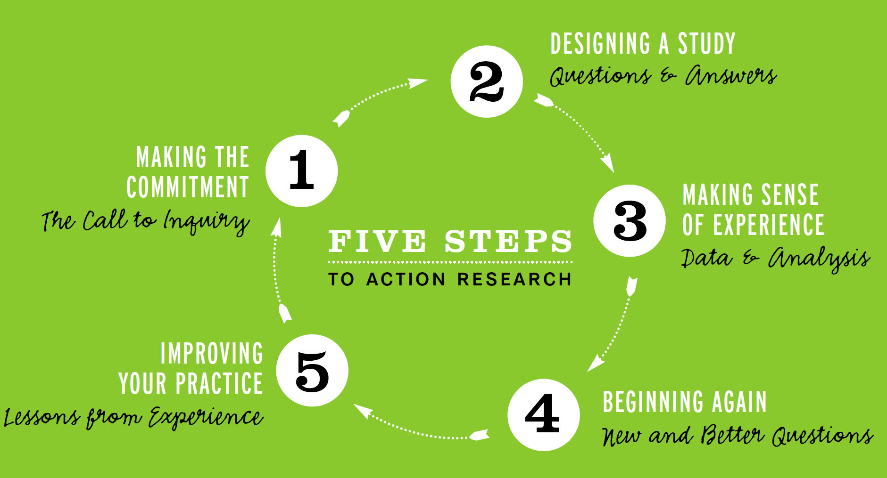  The remainder of this text consists of a series of exercises that guide you through exploring topics and issues important to you and your students. The steps of action research are simple and straightforward. As you work your way through the action research process, you will have chances to practice ways of writing, reflecting, analyzing data, and discussing your work with other educators. The techniques that we are about to show you have been found to be helpful in getting off to a good start in action research. But, eventually, it will be up to you to discover which tools of action research work best for you. Feel free to experiment.

~ Racial Microaggressions in Everyday Life. Implications for Clinical Practice.
Optional
D. W. Sue, C.M. Capodilupo, G.C. Torino, J.M. Bucceri, A.M.B. Holder, K. L. Nadal, M. Esquilin(Teacher’s College, Columbia University). American Psychologist, May-June 2007. 16 p.
https://www.cpedv.org/sites/main/files/file-attachments/how_to_be_an_effective_ally-lessons_learned_microaggressions.pdf
Abstract  Author abstract | Racial microaggressions are brief and commonplace daily verbal, behavioral, or environmental indignities, whether intentional or unintentional, that communicate hostile, derogatory, or negative racial slights and insults toward people of color. Perpetrators of microaggressions are often unaware that they engage in such communications when they interact with racial/ethnic minorities. A taxonomy of racial microaggressions in everyday life was created through a review of the social psychological literature on aversive racism, from formulations regarding the manifestation and impact of everyday racism, and from reading numerous personal narratives of counselors (both White and those of color) on their racial/cultural awakening. Microaggressions seem to appear in three forms: microassault, microinsult, and microinvalidation. Almost all interracial encounters are prone to microaggressions; this article uses the White counselor – client of color counseling dyad to illustrate how they impair the development of a therapeutic alliance. Suggestions regarding education and training and research in the helping professions are discussed.  Keywords: microaggression, microassault, microinsult, microinvalidation, attributional ambiguity

~ What is Results-Based Accountability 4 p.
Required
Abstract  Extract from the document | Performance Accountability  Organizations and programs can be held accountable only for the customers they serve. RBA helps organizations identify the role they play in community-wide impact by identifying specific customers who benefit from the services the organization provides.  For programs and organizations, the performance measures focus on whether customers are better off as a result of your services. These performance measures also look at the quality and efficiency of these services. RBA asks three simple questions to get at the most important performance measures:  - How much did we do?  - How well did we do it?  - Is anyone better off?  In answering these questions, a job training program might measure:  - The number of trainees in its program  - The ability of its trainers to explain concepts.  - The percentage of its trainees who obtain and keep a job.

~ The Results-Based Accountability™ Guide
Optional
Based on work by Mark Friedman. https://cdn2.hubspot.net/hubfs/2433936/documents/Clear-Impact-RBA-Guide.pdf
Abstract | Elaborates on the concepts introduced in What is Results-Based Accountability and specifies the steps in an RBA program

No Wildemuth chapters
Following pages: Extensive observations and comments on 1a2.3 Evaluation and assessment research copied from Dimensions of Research. Annotated. Complement lecture. Entirely optional

. . . 1a2.3 Evaluation and assessment research | There are no sharp distinctions in the semantic space indicated by terms assessment, evaluation, and some types of research. Some authors define assessment as a more or less factual description of a unit of analysis or situation and evaluation as ascribing a value based on that description. I can see the following types of studies.  A one-time snapshot of the state of some system, such as a classroom or a school, for example, analyzing students' GPA or students performance on standardized tests at one time. This could be used as a measure of a school's effectiveness in educating a given type of student. The term assessment is often used in this meaning. Such a study is a type of a descriptive study. The results of a descriptive study can be interpreted in a completely value-neutral way; whether the system described is good or bad is not an issue. In assessment, on the other hand, results are interpreted from a value or goal perspective; we want schools that help students learn. Assessments can be used for comparisons across systems or of the same system at different times. Such studies may not look at reasons for any differences observed. {DS}  Much evaluation has the purpose of determining the value of some system or activity not based on its intrinsic properties but based on what is does, its effects. This requires an analytic (explanatory) study, which often is more specifically an experimental or quasi-experimental study. The distinguishing feature is again that the results are considered from a values or goals perspective. For example, one student proposed a study of the effect of library access on student learning (as measured by the GPA); this study is an experiment with the aim of determining the value of a school library, presumably for the purpose of making decision about funding and possibly also on ways the library is run. {DS}  Evaluation Research: It addresses the question, “Did it work?” The process of establishing value judgment based on evidence about the achievement of the goals of a program. Evaluation research measures the effectiveness of a program, policy, or way of doing something. “Did the program work?” “Did it achieve its objectives?” Evaluation researchers use several research techniques (survey, field research).  Practitioners involved with a policy or program may conduct evaluation research for their own information or at the request of outside decision makers, who sometime place limits on researchers by setting boundaries on what can be studied and determining the outcome of interest.  {11}  Evaluation Research is a widely used type of applied research that addresses the question, “Did it work?” In other words, evaluation researchers actively engage in assessing the success or failure of a social program, organization, etc. There are two types of evaluation research, formative and summative. Both are usually used in conjunction with each other. {15}
. . . . 1a2.3.1 Formative vs summative evaluation | Continuum or both done in one assessment  Formative assessment is undertaken to improve what is being assessed.  Summative assessment is undertaken to decide on the use of what is being assessed or action regarding what is being assessed.  Examples:  Assessed: Person.  Formative: Results used to help the person improve (help a student learn better, change patient treatment)  Summative: Results used to decide on use of or action regarding the person (decide whether student should be promoted, whether applicant should be hired, whether person should return to work, whether person should be cleared for travel. whether patient should be cleared for surgery)  Assessed: Software or system, specifically usability  Formative: Results used to help improve the system (change an input process to avoid input errors, change wording to avoid errors or shorten time users take to figure out what to do, make sure Submit button can be seen without scrolling)  Summative: Results used to decide on whether to use the system  Assessed: Curriculum or learning unit  Formative: Results used to help the improve the curriculum (find places where necessary prerequisites have not been covered, find content that is not meaningful to students as presented, find places where better examples are needed)  Summative: Results used to decide whether to use the curriculum in a school given the characteristics of the student body or whether to use a learning unit for an individual student  Assessed: Policies and procedures for the circulation of library materials  Formative: Results used to help the improve policies and procedures to achieve the library's purposes, such as making materials available, increasing circulation, making sure children have books at home, minimizing staff time for circulation, generating good will towards the library. Types of improvements include deploying book mobiles, having multiple points for returning materials (such as in supermarkets), charging fines only for expensive items, a reward system for returning materials in time, giving some books away.  Summative: Results used to decide whether to adopt another library's policies and procedures.  {DS}
. . . . . 1a2.3.1,1 Formative evaluation | Formative assessment is undertaken to improve what is being assessed. {DS}  Formative Evaluation consists of built-in monitoring or continuous feedback on a program used for program management. {15}
. . . . . 1a2.3.1,2 Summative evaluation | Summative assessment is undertaken to decide on the use of what is being assessed or action regarding what is being assessed. {DS}  Summative Evaluation looks only at the final outcome. {15}
. . . . 1a2.3.2 Impact assessment research | Research estimates the likely consequences of a planned change. Such an assessment is used for planning and making choices among alternative policies – to make an impact assessment of building a dam on the environment; to determine the impact of building a major new highway on surrounding communities (air quality, housing, business). {11}  Evaluation / assessment deals with actions or systems that are going on or have been completed  Impact Assessment deals with actions or systems being considered to provide information for decision making. {DS}  The purpose of Social Impact Assessment is to measure the likely consequences of a planned change. Areas assessed in impact studies include:  1. Community Service  2. Social Conditions  3. Economic Impact  4. Demographic Consequences  5. Environment  6. Health Outcomes  7. Psychological Well Being  {15}

