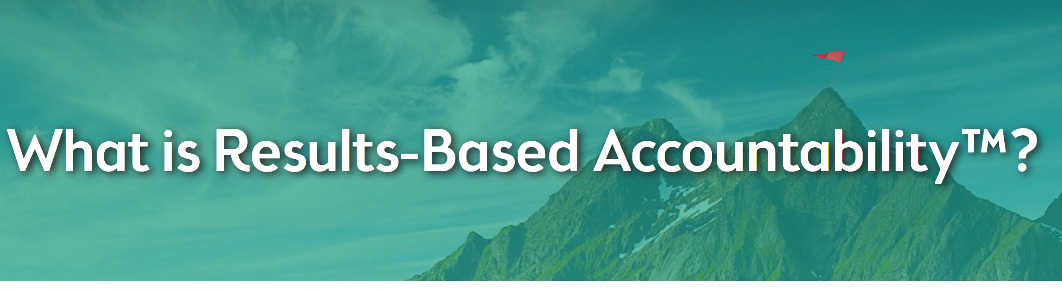

From https://clearimpact.com/results-based-accountability/

Results-Based Accountability™ is a disciplined way of thinking and acting to improve entrenched and complex social problems. Communities use it to improve the lives of children, youth, families, adults. RBA is also used by organizations to improve the effectiveness of their programs. Developed by Mark Friedman and described in his book Trying Hard is Not Good Enough, RBA is being used in all 50 United States and in more than a dozen countries around the world to create measurable change in people’s lives, communities and organizations.

What’s different about Results-Based Accountability™?
RBA uses a data-driven, decision-making process to help communities and organizations get beyond talking about problems to taking action to solve problems. It is a simple, common sense framework that everyone can understand. RBA starts with ends and works backward, towards means. The “end” or difference you are trying to make looks slightly different if you are working on a broad community level or are focusing on your specific program or organization.

The population versus performance distinction is what separates RBA from all other frameworks. It is important to understand because it determines who is responsible for what. Population accountability organizes our work with co-equal partners to promote community well-being. In contrast, Performance Accountability organizes our work to have the greatest impact on our customers. What we do for our customers is our contribution to community impact.

Creating Community Impact with RBA
Community impact focuses on the conditions of well-being for children, families and communities that a group of leaders are working to improve. For example: “Residents with good jobs,” “Children ready for school,” or “A safe and clean neighborhood”. In RBA, these conditions of well-being are referred to as results or outcomes.
It is critical to identify powerful measures to determine the progress a community is making towards achieving community well-being. For communities, the measurements are known as community indicators and are usually collected by public agencies. A community wanting to have residents with good jobs may look at “turning the curve” on the unemployment rate.

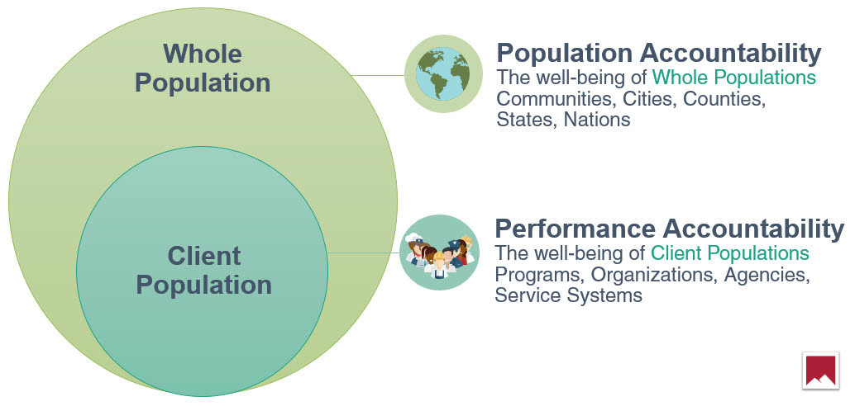

Performance Accountability
Organizations and programs can be held accountable only for the customers they serve. RBA helps organizations identify the role they play in community-wide impact by identifying specific customers who benefit from the services the organization provides.
For programs and organizations, the performance measures focus on whether customers are better off as a result of your services. These performance measures also look at the quality and efficiency of these services. RBA asks three simple questions to get at the most important performance measures:

- How much did we do?  - How well did we do it?  - Is anyone better off?  In answering these questions, a job training program might measure:  - The number of trainees in its program  - The ability of its trainers to explain concepts  - The percentage of its trainees who obtain and keep a job. | Improve performance with  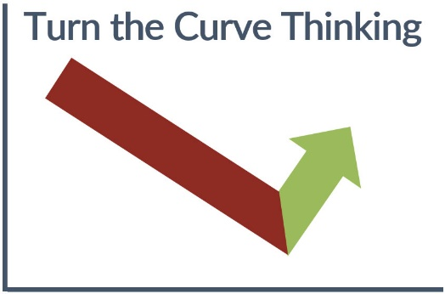

Check out a complete list of example performance measures here.
https://clearimpact.com/results-based-accountability/example-performance-measures-can-use-program-service/
DS: The examples provided in the Web page are very useful.

Turn the Curve Thinking
Once you identify the most powerful measure(s) to improve, RBA provides a step-by-step process to get from ends to means. This process is called “Turn the Curve” thinking.

The following pages are from https://clearimpact.com/results-based-accountability/turn-the-curve-thinking/

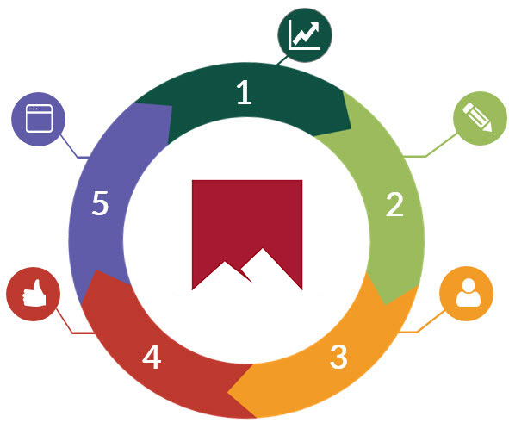 | Step 1: Graph the measure you have chosen including a history and a forecast of where you think this measure is going if you do nothing differently. The Clear Impact Scorecard can assist in the process. The Scorecard automatically graphs the data for each measure in the software.  Step 2: Analyze the “story behind the data”. This involves analyzing the factors that contribute to the data history and forecast. It is a very important step that is often ignored in other accountability structures. This is similar to a diagnosis from a doctor prior to treatment. It is important to dig deep as you look at the data to identify root causes that underlie the status of conditions in your community and/or organization.

Step 3: Identify existing and new partners who have a role to play in improving the data Whether you are addressing changes within an organization or on a broader community level, partners are critical to ensuring success. Think of the key partners that can help you to address the most vexing factors in order to make lasting improvements. Determine the specific actions that partners can take to help you address “turning the curve”.

Step 4: Brainstorm what works to address the contributing factors and “turn the curve”? The RBA process is very concerned with developing new and innovative approaches to improving indicators and performance measures. This can be accomplished by allowing for free-flowing brainstorming of what works to address the story behind the data and improve measures. Give people the freedom to suggest “off the wall” and outrageous ideas as well as researched best practices. Also include at least one low-cost/no-cost idea. Maintain focus on addressing the contributing factors. When a sufficient amount of ideas are generated; have the group focus on prioritizing the ideas for an action plan. These priority ideas should have enough leverage to “turn the curve” of the specific measure you are addressing. You also now must consider the feasibility and affordability of the ideas and the values of your community and organization.

Step 5: Develop and implement a comprehensive action plan. For real change to happen, the ideas generated in Step 4 must be made into specific, implementable strategies and actions. Each action plan must identify the steps to complete; who will be responsible for completing them and a timeline. This process is meant to be iterative by continuously reviewing the change in the data and adapting the plan as needed.

Why use Results-Based Accountability™?
RBA improves the lives of children, families, and communities and the performance of programs because RBA:
- Gets from talk to action quickly;
- Is a simple, common sense process that everyone can understand;
- Helps groups to surface and challenge assumptions that can be barriers to innovation;
- Builds collaboration and consensus;
- Uses data and transparency to ensure accountability for both the well-being of people and the performance of programs.

Free E-Book: The Results-Based Accountability Guide
Box\575DS\Week02\UBLIS575DS-02.1$1-Results-Based Accountability - Overview and Guide.pdf

Download the Results-Based Accountability Guide to learn how the RBA framework can help you develop baselines and use them to make data-driven decisions.

The RBA Guide is a step-by-step roadmap to learn how to lead or facilitate a group in the use of RBA decision making that will help you learn how to:

- start with ends and work backward towards means
- get from talk to action quickly
- follow a simple, common sense process
- build collaboration and consensus
- use data and transparency to ensure accountability

Reference:

Friedman, Mark 2015

Trying hard is not good enough. How to produce measurable improvements for customers and communities. 10th Anniversary Edition [3. ed.].

PARSE Publishing; 2015. 186 p.
ISBN-10 : 1516971620 ISBN-13 : 978-1516971626

Friedman, Mark 2015

Turning curves. An accountability companion reader. .

PARSE Publishing; 2015. 158 p.
ISBN-10 : 151919935X ISBN-13 : 978-1519199355

