SYLLABUS
LIS 503: Systems Administration in a Networked Environment
Department of Library and Information Studies (LIS)
Fall 2015 Monday, August 31, 2015 to Friday, Dec. 11, 2015 Class day: W
3 credits – Online Course

Instructor Information
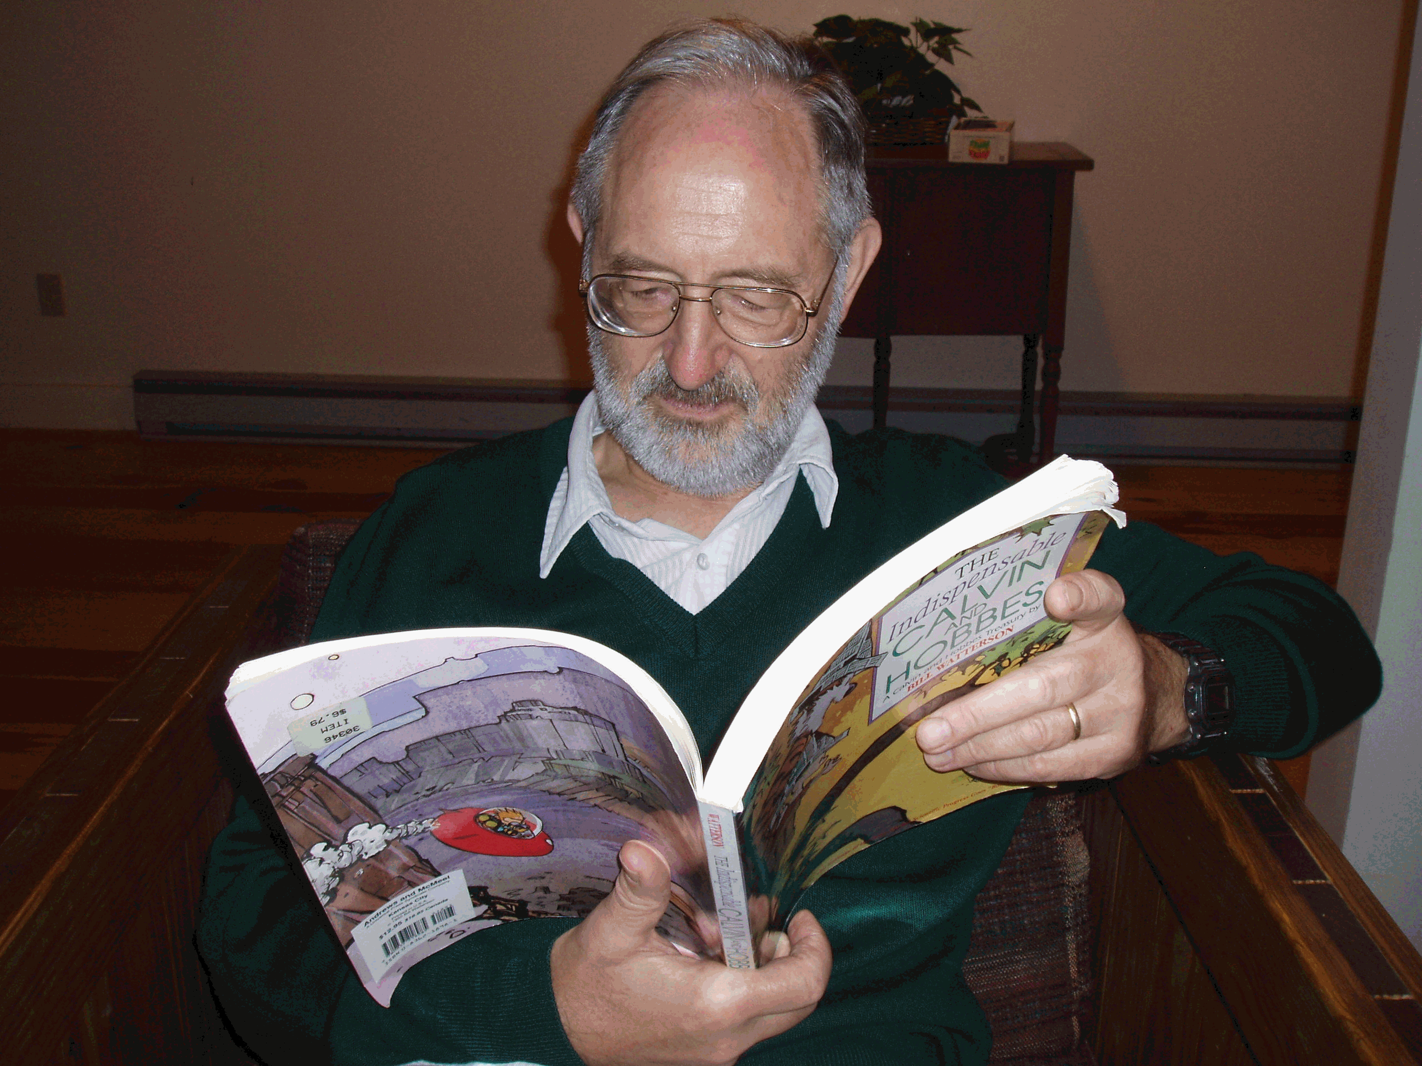
Instructor: Dagobert Soergel
Office: 522 Baldy Hall, Buffalo, NY 14260]
E-mail: dsoergel@buffalo.edu Skype: dsoergel
Phone: Cell 703-585-8240 any time 10a – 11p or set up appt by email
Office Hours: By Appointment

Course Description

Catalog. Introduces the principles of the installation, maintenance, and administration of client-server systems and related technology. The course covers major platforms including Linux, Windows and Mac OS. Topics include file systems, user account management, backups, disaster recovery, security, logging, local area network, domain name service, web hosting, performance analysis, policies, and ethics. Prerequisite: LIS 506 or instructor permission
Instructor. Introduces basic principles of computer systems administration: Create and maintain the infrastructure that enables smooth accomplishment of individual and collaborative work and all other functions of the enterprise that are or could be supported by computers. Gives students the skills to learn about any particular platform and other technologies so that they can realize these principles through implementation in any environment.
Note Platforms come and go,basic principles endure.

Course Objectives

After taking this course, you will (or should):
- Be able to assess and understand the work and functions in an enterprise that are or could (should) be supported by computers.
- Understand the components of computer infrastructure, including users' computer knowledge and skills.
- Be able to learn the specifics of external services, hardware, and software and to assess these components as to how well they serve enterprise needs, sufficiently for Objective 4.
- Be able to participate in system administration tasks (after additional learning).
- Be able to manage the tasks of the systems administration team, balancing daily troubleshooting with medium- and long-term development of improvements.
- Be able to talk knowledgeably to system administrators and have the foundation on which to build a career in system administration.

MS in Information and Library Science Program Goals

This course addresses Goals 2, 3, and 4 of the UB MS in Information and Library Science Program Goals:
- Graduates demonstrate an understanding of library and information studies, including its historical roots, as well as the creation, representation, organization, dissemination, and use of information.
- Graduates demonstrate an understanding of the domain knowledge and a mastery of skills required in diverse information environments.
- Graduates demonstrate professional competences, including leadership, critical thinking, communication, collaboration, reflective practice, and ethical adherence.
- Graduates are able to apply an understanding of the library information professions and the roles, responsibilities, and professional dispositions (i.e., values, attitudes, behaviors).

Method

- Readings from a comprehensive textbook, supplemented with a few lectures
- Weekly learning blog (required) and discussion (you need to post at least one comment each week)
- Practical assignments
- A reflective paper at the end

Course Technologies

All materials and assignments will be on the course website www.dsoergel.com/lis503

The collaboration platform Slack. You will be invited to join

Individual or group conferences through phone or Skype as requested.

Computer Requirements:
Reliable access to the Internet on a computer capable of accessing the Internet is required.

Required Knowledge and Skills

Successful completion of LIS 506 Information Technology is required.

Required Text and Materials

Required Texts and Supplementary Materials
Limoncelli, Thomas A.; Chalup, Strata R.; Hogan, Christina J. 2007
The Practice of System and Network Administration, 2nd Edition. Updated and Revised.
Addison-Wesley Professional (July 15, 2007). 39, 1011 p.
ISBN-10: 0321492668
ISBN-13: 978-0321492661
The beginning part of the third edition (draft) was sent out as a pdf.

Course Assignments and Grading Policy

Assignments are listed in the calendar. They are (or will be) available on the course website.

As indicated under methods above, the following are required:

- Weekly readings from the textbook and learning blog postings (instructions on the course website)
- Participation in online discussions (at least one comment each week)
- Two or three practical assignments
- A substantial reflective paper on what you learned in the course and how your are planning to use what your learned, due at the end of the course.

Grading:
Grading is not based on a point system but on a holistic assessment of the student's understanding and achievement of course objectives based on all available evidence. The reflective paper is a major opportunity for the student to demonstrate understanding.

Important General Information (not specific to this course)

Accessibility Services and Special Needs: If you have a disability and may require some type of instructional and/or examination accommodation, please inform me early in the semester so that we can coordinate the accommodations you may need. If you have not already done so, please contact the Office of Accessibility Services (formerly the Office of Disability Services) University at Buffalo, 25 Capen Hall, Buffalo, NY 14260-1632; email: stu-accessibility@buffalo.edu Phone: 716-645-2608 (voice); 716-645-2616 (TTY); Fax: 716-645-3116; and on the web at http://www.buffalo.edu/accessibility/. All information and documentation is confidential.

The University at Buffalo and the Graduate School of Education are committed to ensuring equal opportunity for persons with special needs to participate in and benefit from all of its programs, services and activities.

Academic Integrity: It is expected that you will behave in an honorable and respectful way as you learn and share ideas. Therefore, recycled papers, work submitted to other courses, and major assistance in preparation of assignments without identifying and acknowledging such assistance are not acceptable. All work for this class must be original for this class. Please be familiar with the University and the School policies regarding plagiarism. Read the Academic Integrity Policy and Procedure for more information. Visit The Graduate School Policies & Procedures page for the latest information at http://www.grad.buffalo.edu/policies-Procedures/Academic-Integrity.html.

University Services: Students enrolled in distance education courses will have access to services traditionally provided in person; i.e. libraries, labs, academic advising, career services, financial aid counseling, personal counseling, disability services, and other student services as appropriate.

All existing UB policies, i.e. grading, course evaluation, and admission criteria apply to all activities bearing UB academic credit, including distance education.

Software: UB provides free licensing of major software packages for UB students, including Microsoft Office and Symantec Antivirus. Please visit http://www.buffalo.edu/ubit/service-guides/software.html for more information.

My Virtual Computing Lab: Learn how to access the most popular UB-licensed software in the Cybraries and Public Labs directly from your personal computer. These programs are served “from the cloud” and are available on or off campus at any time. With My Virtual Computing Lab you can access: Adobe Acrobat Pro, Adobe Dreamweaver, Adobe Photoshop, Microsoft Office, Minitab, SPSS, and more. Find more information at:
http://www.buffalo.edu/ubit/service-guides/software/my-virtual-computing-lab.html

Library: As a registered University at Buffalo student you have full access to UB Libraries (http://library.buffalo.edu) and online resources available through the libraries. There are many full text article databases. There are resources available under “Get Help” “Student Support” to assist you in using the library.

Christopher Hollister, MLS, Associate Librarian, is the GSE Librarian. He has offices at 524 Lockwood Library and is available by phone: 716-645-1323; fax: 716-645-3859; and email: cvh2@buffalo.edu and is available to help.

Course Evaluations: At the conclusion of the semester you will receive an email reminder requesting your participation in the Course Evaluation process. Please provide your honest feedback; it is important to the improvement and development of this course. Feedback received is anonymous (unless you provide your name in the comments section) and the instructor does not receive copies of the Evaluations until after grades have been submitted for the semester.

From Simon Loh. Introduction To System Administration
http://www.slideshare.net/simonling99/systemintroduction-to-system-administration
Professional Certification
- Professional certifications in computer technology are non-degree awards made to those who have achieved qualifications specified by a certifying authority.
- Depending on the particular certification, qualifications may include completing a course of study, proof of professional accomplishments, achieving a specified grade on an examination or some combination thereof.
- The intention is to establish that an individual holding a certification is technically qualified to hold certain types of position within the field.

Linux Professional Institute Certification (By LPI) ($170 - $260)
LPIC-1. Junior Level Linux Professional- Fundamental System Administration
LPIC-2. Advanced Level Linux Professional (LPIC-2) - Small & middle size site
LPIC-3. Senior Level Linux Professional - Active Directory & Enterprise http://www.lpi.org/en/lpi/english/certification/the_lpic_program
Ubuntu Certification ($34)
Ubuntu Certified Professional
http://www.ubuntu.com/training/certificationcourses http://www.ncsacademy.com/ordercertification.cfm?pid=55
Oracle Certification
Oracle Certified Associate (OCA) - Solaris 10/11 Operating System
Oracle Certified Professional (OCP) - Solaris 10/11 Operating System and Clustering
Oracle Certified Expert(OCE) - Solaris 10/11 Operating System
http://education.oracle.com/pls/web_prod-plq-dad/ db_pages.getpage?page_id=141
Oracle Provides Certification for Database Administration (DBA) (OCA, OCP and OCM) and
Linux Administrator (OCA and OCP)
Solaris Operating System Certifications(Oracle)
Sun Certified Solaris Associate
Sun Certified System Administrator for the Solaris Operating System
Sun Certified Network Administrator for the Solaris Operating System
Sun Certified Security Administrator for the Solaris Operating System
IBM Certification
IBM Certified Database Associate
IBM Certified Database Administrator
IBM Certified Advanced Database Administrator
IBM Certified Specialist
IBM Certified Advanced Technical Expert
IBM Certified System Expert
http://www-03.ibm.com/certify/certs/index.shtml
HP Certification http://www.hp.com/certification/quick_access_crede ntials.html
Cisco Career Certification
Cisco Certified Network Associate (CCNA)
Cisco Certified Network Professional (CCNP)
Cisco Certified Internetwork Expert (CCIE)
Cisco Certified Design Associate (CCDA)
Cisco Certified Design Professional (CCDP) http://www.cisco.com/web/learning/le3/learning_career_certifications_and_learning_paths_

optional Information about the instructor

Dagobert Soergel is Professor, Department of Library and Information Studies, Graduate School of Education, University at Buffalo since 2009, Professor, College of Information Studies, University of Maryland, 1970 – 2010, and Professore Onorario, Dipartimento di Ingegneria e Scienza dell'Informazione, University of Trento since 2007. He has been working in the area of classification (taxonomy, ontologies) and thesauri both practically and theoretically for over 50 years. He is the author of the still-standard text- and handbook Indexing Languages and Thesauri. Construction and Maintenance (Wiley 1974) and of Organizing Information (Academic Press 1985), which received the American Society of Information Science Best Book Award, and more than 100 papers and presentations in the area of classification / ontologies and more broadly in information science. He has taught courses at several universities in the US and Germany, and has been offering a long-running tutorial on Knowledge Organization Systems (KOS) in Digital Libraries at the European Conference on Digital Libraries (ECDL) and at the Joint Conference on Digital Libraries (JCDL) in the US. He was the chief architect for several thesauri, including the Alcohol and Other Drug Thesaurus and the Harvard Business Thesaurus. He has written about the future of digital libraries and led the editing team for the EU-funded DELOS Network of Excellence in Digital Libraries response to the European Union call for online consultation. He was a member of the Working Group on the DELOS Digital Library Reference Model. 1997. Recent publications include three papers in the Journal of the American Society for Information Science and Technology on the nature of relevance, on sensemaking, and on the topicality of art images. Dr. Soergel received the highest award of the American Society for Information Science, the Award of Merit and in 2009 the Contributions to Information Science (CISTA) Award of the Los Angeles Chapter of ASIST. He received the Governor's Award for Volunteering Excellence (Virginia). Gold Medal, 1993.
Items cited http://etoh.niaaa.nih.gov/AODVol1/Aodthome.htm
www.dlib.org/dlib/december02/soergel/12soergel.htm
www.delos.info/files/pdf/events/brainstorming_dec05/DELOSBrainstormingReport_Final.pdf

More information about the instructor:
GSE Faculty Spotlight www.dsoergel.com/ublis571-0.0-1Reading1GSEFacultySpotlightSoergel.pdf
Short CV www.dsoergel.com/ublis571-0.0-1Reading2SoergelCVShort.pdf
Full CV www.dsoergel.com/ublis571-0.0-1Reading3SoergelCVLong.pdf

optional Teaching Statement

"There are those who look at things the way they are, and ask why?
I dream of things that never were, and ask why not?"
George Bernhard Shaw as paraphrased by Robert F. Kennedy.

Guiding principles. I endeavor to inspire students to look beyond present practice – which, of course, they need to understand – to what could be, so they can become true leaders in the field. Second, I guide students to an understanding of basic, often timeless, concepts and theories – always illustrated by examples and assignments that connect to practice – so that they have a firm foundation both for lifelong learning and for critically examining present practices and reinventing them as needed to better serve users. Thirdly, I imbue students with a spirit of user orientation, so that they bring an understanding of user tasks, sense-making processes, and resulting requirements to everything they do, from structuring classifications and designing Web sites to indexing to formulating queries to presenting results. In all of this I make students think.

Implementing these principles requires careful structuring of course materials – often creating a new conceptual framework – and good document design. It also requires guiding students to their own discovery of ideas. For this purpose I often conduct interactive sessions in front of a blackboard on which a framework evolves step by step from student contributions. Face-to-face class sessions with lecture, discussion, and in-lecture exercises supported by extensive lecture notes on paper have served me well in pursuing my teaching goals, but I have also developed online materials that recreate the interactivity to the extent possible.

I pay great attention to choosing good examples students can relate to, especially examples that illustrate several concepts and principles, so that students do not need to get familiar with a new example every time a new concept is introduced and, perhaps more importantly, so students can see how several concepts work together in practice.
Short version: If you are comfortable with it, please call me Dagobert.

Long version, optional:

On learning communities, power structures, and name customs

I propose, but do not impose, use of first names all around. So I am happy and prefer to be addressed as Dagobert, but if a student is more comfortable with Dr. Soergel, I will answer to that also.

Here are some relevant thoughts. At its best, a course is a learning community. We are all here to learn, but learning does not mean to listen to and accept the word coming down from on high, it means to analyze critically, to critique, to challenge, to dispute, to discuss, to share viewpoints and ideas. There are differences in what each member brings to the table; each member of the community has a stock of knowledge and a unique set of experiences; of course some are more knowledgeable or experienced than others, but everybody contributes and everybody takes away.

Such a learning community thrives best in a social structure that values and embodies equality and mutual respect. (This is also why I feel very strongly about student participation in academic governance.). Make no mistake, language has a powerful influence on social structure. In many cultures, structures of kinship, power, and authority are ingrained into people's minds through the use of language. The custom of students addressing the instructor as Dr. X but the instructor addressing students by their first name is a case in point. When I grew up in Germany, the general mode of address outside the circle of family, relatives, and close friends was "Sie", equivalent to using last names. Starting in 10th grade, teachers addressed students by their last name or Sie. Formal, but equal. In the US of today, use of first names is commonplace, even among strangers. This makes the custom of inequality in the mode of address, still widely practiced in academia, even more grating. There are variations from unit to unit and from discipline to discipline. In computer science (as in high-tech companies) using first names all around (from chair to students who just started) is the norm.

